Title:
The contribution of commuting to total moderate-to-vigorous physical activity
Background: Commuting to and from work can increase moderate-to-vigorous physical activity (MVPA) and increase adherence to physical activity guidelines; however, there is lack of evidence on the contribution of different modes of commute and continuous stepping bouts to physical activity while commuting. Also, many commuting studies employ the use of self-reported physical activity measures.

Objective: The aim of this study was to objectively determine the contribution of MVPA during commuting to total MVPA, using cadence to define MVPA and to explore how the length of stepping bouts affects adherence to physical activity guidelines.

Methods: Twenty-seven university staff wore an activPAL™ activity monitor for seven days and kept an activity diary; the activity diary collected information of commute times and modes of commute. The activPAL™ quantified the cadence and length of stepping bouts. MVPA was defined as stepping with a cadence of more than 100 steps/min. Statistical tests were carried out to determine if there was any relationship between commute time spent in MVPA and total MVPA

Results: The average total time per day spent in MVPA was 53.1 (±30.2) minutes, with commuting contributing 33% or 17.7 (±14.7) minutes. Walking (32.2 (±9.6) minutes) and mixed-mode (27.2 (±15.3) minutes) commuters spent more time in MVPA than car commuters (9.1 (±8.3) minutes). Seventeen of the 23 participants achieved more than 30 minutes of MVPA per day, with five achieving this in their commute alone (Figure 1). At a cadence of over 110 step/min, there was a far greater proportion of stepping during commuting compared to other cadence bands (Figure 1). Stepping bouts of greater than 210 seconds were only undertaken whilst commuting, with a higher number of steps accumulated in bouts over 300 seconds (Figure 2). A significant positive association was found between commute time spent in MVPA and total MVPA (p<0.001).

Figure 1: Cadence Distribution of commute and non-commute steps
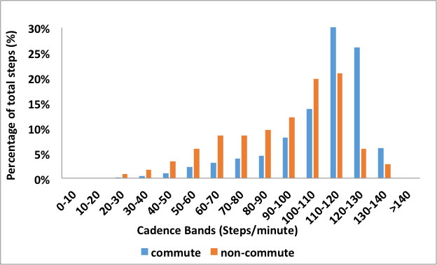

Figure 2: Stepping bout distribution of commute and non-commute steps
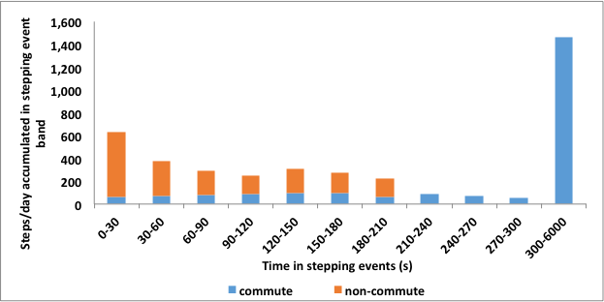
Conclusion: Commuting can be a major contributor to total MVPA, with the mode of commute having a significant role in the level of this contribution to total MVPA.

Implication for Practice and Policy: Public health messages should encourage active or mixed-mode commuting and focus on changing commuting habits so as to improve physical activity.

