Title:
Trunk inclination during walking in people with knee osteoarthritis
Abstract:
Introduction: An increase in sagittal trunk inclination (forward lean) during walking will create an anterior shift in the centre of mass position and this will lead to corresponding changes in lower extremity joint moments. For example, it has been shown that people who habitually walk with increased trunk inclination exhibit an increase in the magnitude and timing of the hip extensor moment [1]; a change which is likely to be accompanied by changes in hamstring activation.
Previous research has demonstrated that people with knee osteoarthritis (OA) stand with increased trunk inclination [2] and also exhibit altered lower extremity joint moments during walking [3]. Given the changes which will accompany increased trunk inclination, it is possible that the previously observed biomechanical characteristics of people with knee OA may be the result of differences in upper body position during walking. However, to investigate this idea, it is first necessary to understand whether there are clear differences in trunk inclination during walking between healthy people and individuals with knee OA.
Research Question: What is the differences in trunk inclination during walking between people with knee osteoarthritis healthy individuals?
Methods: Kinematic and force data was collected during walking from 10 participants with knee OA and 10 healthy subjects. Participants with knee OA were instructed to walk at their self-selected speed and healthy participants instructed to walk at a speed which matched the knee OA subjects. Mean ages, weights and heights were almost identical between the two groups. A trunk segment was defined using markers placed over the greater trochanters and the acromions and tracked using markers placed over the jugular notch, T2 and T8. Following data collection, an ensemble average trunk inclination was derived for each participant and the mean inclination calculated over the period 15-25%. This period was selected as it corresponds to the period of maximal knee loading. Trunk inclination was compared between the two groups using independent t-tests.
Results: The mean trunk inclination in the knee OA group was 4.5°, which was 2.3° greater than the mean of the healthy participants (Figure 1). However, this difference was not significant (p=0.17).
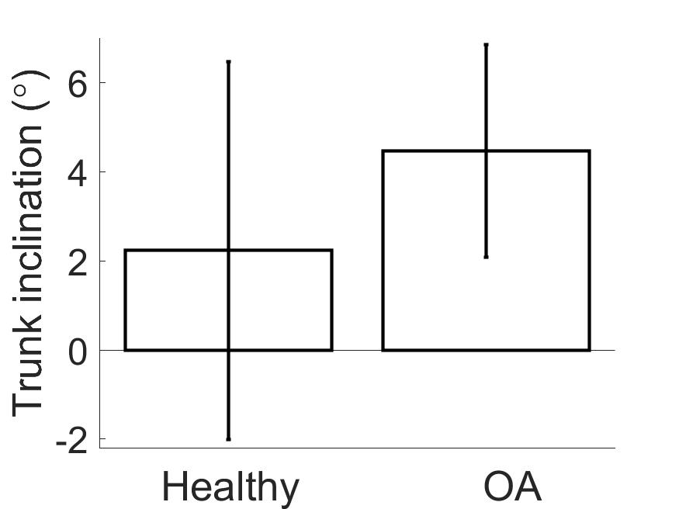
Figure 1: Mean (SD) trunk inclination for healthy participants and those with knee osteoarthritis
Discussion: In their recent study, Turcot et al. [2] observed people with knee OA to exhibit an average of 2.9° more trunk inclination than a healthy control group. Although this difference (in standing) is similar in magnitude to the difference observed during our study (in walking), our data did not achieve statistical significance. Nevertheless, there were only a small number of participants in this present study (n=10 each group) and therefore further (ongoing) work is required to establish if this trend of increased trunk inclination is a true characteristic of walking in people with OA.
References:
[1] Leteneur et al. 2009. Clinical Biomechanics 24:190-195.
[2] Turcot et al. 2015. The Knee 22:517-21.
[3] Liu et al. 2014. Journal of Biomechanics, 47:445-50.

