The Influence of Modern Architecture in Transforming Iraqi
City Identity
Hamed Hyab Samir and Dr. Yusuf Arayici
School of Built Environment, Salford University, Manchester M5 4WT, United kingdom
Email: H.H.Samir@edu.salford.ac.uk , Y.Arayici@salford.ac.uk
Abstract
Many Iraqi cities are losing their character and becoming more ambiguous. Basra is the second main city in Iraq after the capital Baghdad; it is the most important economic, cultural, touristic city in Iraq. A city distinguished by its architectural style and identity. However, this identity was threatened many times by external and internal factors leading to distortion or obliteration of the city such as a colonial influence in the early 20th century, modernity movement, policies of old governments, and the three recent wars in 1980, 1991, 2003, have led to a significant effect on society and demography of the city.
After 2003, many of the investment companies in different sectors entered Basra city to carry out different projects. These companies adopted foreign, alien designs, which reflect their ideological culture. However, it was far from a city spirit, didn’t respect the city's history and identity, and didn’t care for the culture and traditions of the city.
The aim of the paper is to justify the need for an urban design strategy framework that should guide authorities and professionals for maintaining architectural identity in Iraqi cities while enabling modernization. It adopts the case study research with comparative analysis to measure the influence of modernity on the Basra city identity. The findings achieved in the research so far illustrate that the global modern architecture has played an important role in the transformation of the Basra city identity. Therefore, there is a need for the development of an urban design strategy framework to produce urban design solutions that should consider maintaining identity while enabling modernization.
Key words: Identity, architecture, modernity, Basra, Iraqi cities.
Introduction
Architectural identity issue has become a real global concern, especially in the last three decades. Many cities have started losing their character and becoming more and more ambiguous. The identity is the mixture of similarities and differences, which generates a sense of distinctiveness for the identity of individuals, groups, and societies by distinguishing themselves from others. Identity is the basis for sense of belonging; it is the way that people could associate themselves as member of communities and groups (Adam, 2012).
Architecture is part of the identity phenomenon so the impacts of changes in buildings and places on communities are critical to maintain the identity. Architectural identity is a cultural phenomenon that could help integrate the social life progression and dialogue from past to the future (Humeyra, 2012). Architectural identity formation could be achieved through interaction between many historical collective factors.
Change in modernity is very common. Hence, change is the human intervention to shift the mores of cultural structure (Heynen, 2000) and architecture is also cultural structure. Subsequently, architectural identity is influenced by this change. There are two types of architectural changes; the first is preservation changes which could be leading to the stability of phenomena generation and, the second type destructive changes which are trying to generate new types of phenomena (Jorge and Nuno, 2012). As Amos Rapoport (1999) says that it is not logical after modern developments if we revive the traditional systems because the originality will be lost or if we full change toward contemporary systems so the result will be a huge waste for communities. Therefore, the hybrid case of communities will continue, as a mixture of traditional and contemporary systems, it will be close to a traditional image sometimes while other times will be closer to a modern image. Frampton (1987) mentioned that critical self-consciousness which involves individuals and groups who borrows from other cultures, so they try dismantling, understanding and adapting with the new, according to their conceptualization and the values systematic. It is a natural issue for communities that seek to conserve their identity. Thus, when searching for architectural identity, one should expect to find several overlapping identities.
What is Architectural Identity?
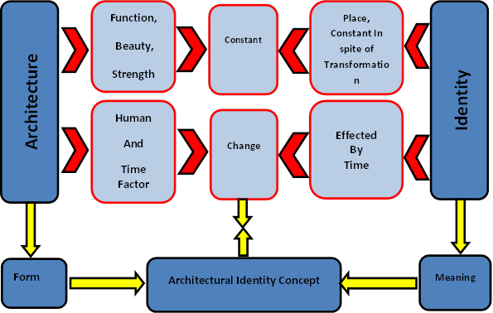
Architecture is phenomena of mixing of art and emotions; it is a harmonies issue and creating the “pure spirit” (Vogler, 2006). It is a one of the cultural productions but the problem that it is a tangible product while others are not, in addition it's more stable and remains than the others, especially when the culture changes, which give architecture the ability to express history. Because of that there is a profound interconnection between identity and cultural meaning of the places, so it not easy to measure it. According to Thompson, (1996) architecture is the best way to give identity for people and cities because it describes and reflects the lifestyle for local communities. Determination of architectural identity is not only done by architect, but rather, many others local factors shared by the community in the formation and design process such as the socio-cultural interpretation of the built form by the local people in addition to the built environment contextual conditions. The formation of identity process always builds on previous symbolic images or source of inspiration and never starting from scratch, these are considered as the bedrock of identity formation.
Figure 1: Relation between identity and architecture (Time and Place)
Currently there are two techniques to maintain the local identity in modern architecture, which are the spirit of place and symbolic identity. Spirit of place is related to site- specific design while the symbolic identity is about the architects’ personal discovery of local symbolism. Both of them can be used either independent or in mixture (Robert Adam, 2012).
Sometimes, special skills of new architectural design process could introduce a new identity, while at another time an ancient identity which was lost but still strong in the place memory may be recovered through the design process; memory of place may be used by new architecture as a starting point to develop a new identity by introducing new functions. Develop and transform the symbols of the built environment by architects contribute to the formation of the identity for people and communities. So, they have a unique responsibility to do that (Robert Adam, 2012).
The two main references that could be used in architecture to form identity: These are time and space. Time is connected to history while space connected to geography. Time is associated with the concept of tradition and appears as rooted from the past while space provides the physical construction assets that reflect the contextual background of identity. However, the claim today is to make design from a global perspective with no or little consideration of local values and identity figure (1).
What is Modernity in Architecture?
Modernity is the period that expresses historical transformation by linking the historical events, people and ideas through a number of disciplines, periods and locations to build the present meaning (Simon, 2005). It is the movement that gives a particular quality for the present to distinguish it from the past which point the way to the future (Berman 1994). Modernity is a break with traditions and rejects all the heritage of the past. It may also mean the process of selecting elements of other civilizations or cultures, which are different from them. For Habermas modernity is a civilized phenomenon has a numerous forms and logical context with several meanings (Afaya, 1998).
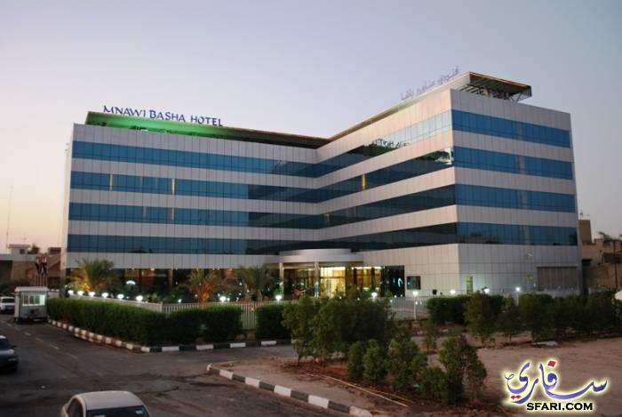
According to Habermas, the Modernization theory is modern forms analysis and assessment in social life. He described that modernity is more than a period. It indicates to the set of different conditions such as social, political, cultural and psychological, which are shaped through historical events (Finlayson, 2005). In architecture, modernism is a term, which describes any new work trying to distort the previous relations and rules of traditions (Stern, 2009), while (Berman, 1994) explains modernity as a non-continuation or alteration of past. It’s a new style of power, which could achieve as a new form of human self-conscience. Ibelings (1998) clarifies that the aim of the new modernity is to use separate buildings programs, out of time and place by using technology of globalization in order to change, transform and built an appropriate environment, which reject a cultural background.
Figure 2: Modern Architecture in Basra City (Mnawi Basha Hotel)

The Case Study: Basra City
Basra chosen as an appropriate target for this study because of the following points:
- Historically, Basra is the first city established by Muslims outside the Arabian Peninsula, thus it owns an important historical character making it more significant with a distinct civilization and heritage.
- Basra is currently classified as the second Iraqi city after the capital Baghdad, in terms of population and the importance.
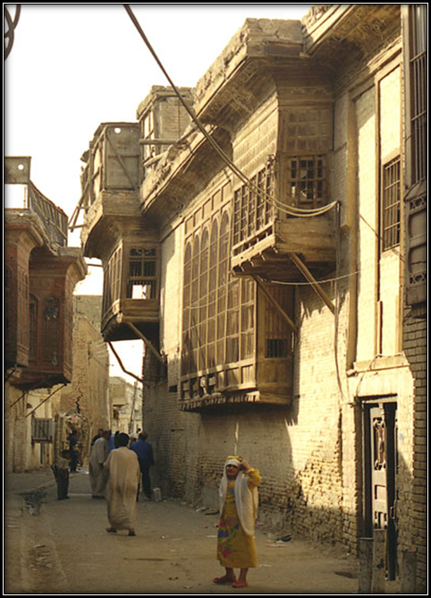
- Economically, Basra is the economic capital of Iraq because it contains a multiple fortune; it is a richest oil city in Iraq and one of the richest cities worldwide for oil production too, and this led to:
- The presence of oil and spread of oil fields around the town influenced on land use plan of the city, where there is a many forbidden areas and other reserved, this led to restricting the expansion of the city, at the same time, the large population growth that happened during this period has created an enormous momentum in the old city center. This influences on city planning and its capacity, thus impact on the traditional city identity.
- The oil presence is considered an important attraction factor for workers, therefore the city suffered intense immigration from other regions, especially neighboring regions, to obtain job opportunities, and this in turn has led to a change in the habits and traditions of society, as well as social relations, this led to a social transformation and then to the transformation the architectural identity of the City.
Figure 3: Traditional neighbourhood in the Iraqi cities
- Basra is the only Iraqi port of the Arabian Gulf. Thus, as with other coastal cities, it’s always in the case of direct contact and on-going interaction with other civilizations through friction with the foreign community it affects and is affected by others.
- The strategic site of the city, where it is a border town with three countries that has led to cross-pollination between Basra society and the society of other neighboring communities of habits, traditions and conventions, which in turn has been reflected in social, cultural and architectural city identity.
- Basra city is considered as a magnet for tourists, because it contains historical monuments, in addition to the attractive tourist areas with varied topographical regions, which have attracted visitors and tourists to city. Therefore the identity of the city has a great role to play in enriching this aspect.
- Frequent wars have plagued the city, starting from the First World War to the Second World War and concomitant of foreign occupation, in addition to the three last wars which are clearly reflected in architecture, culture, demographic and social life of the city, all of which have had a dangerous impact on the social, cultural and architectural identity of Basra.
- Multiple and large numbers of investment companies and projects, which entered the city after 2003, especially foreign companies. They often do not respect and don't care for the privacy and identity of the city. Projects with alienated kind and design styles, which are far beyond the spirit of the city and do not reflect cultural identity. Based on all of the above, Basra is considered as a commercial, national, economical, artistic and historical center. In addition, the pluralism of the city makes it a gathering place for multiple cultural, social and architectural identities, which makes the identity of the city threatened and unclear. Furthermore it requires further research and study.

City Identity in Urban Design Practice in Iraq
Since the early of past century, most Middle East countries started use modern architecture while ignoring the local architectural identity. Architectural identity could be as a clear tool for political system of any country. The western colonization power had forced the Middle East countries during the colonization period to adopt their cultures and traditions (Al-Sultany, 1982). During the past century, many factors such as colonial, technology development, new materials of building and construction, oil discovery and westernized lifestyle had a major impact on Iraqi cities identity. The discovery of oil in Iraq in 1927 was one of these major transitions, which led to huge transformation in all life aspects such as economic, social, cultural, and architectural. These factors resulted in creation of a modern architectural identity, not related to the traditional, cultural and local built environment and allowed intrusion of foreign traditions without any filtration.

Modernity in Iraq has been a very significant issue of urban development. The contrast between modernity and local traditions and values in the second half of the 20th century became a clear truth in the social life of most Middle East cities. Loss of local identity and spiritless modern development became the main characteristics of the cities.

Wilson, the first British colonial architect named in Iraq as the head of the Public Works Department, He spoke of “the tremendous influence that architecture can have on public life generally but especially on education. Iraq has been the home of a certain style of architecture, which has influenced the rest of the civilized world. However, present circumstances need a new style of building. It is hoped that it will integrate the best of the traditional decorative features. It is also intended to use natural building materials available in the country, so that what is built may truly become an Arab Renaissance” (Caecilia, 2006).

The lack of public awareness was the main reason led to transformation, which were unconsciously moving inside society and changing the local built environment, and consideration of transformation as a kind of liberation form rather than as a problematic one. The rush towards modernization without filtering process was a problem more dangerous than modernization itself. The full idea of architecture with identity will be achieved when the modernity viewpoint towards traditions and past is changing because it is considered all of the historical and traditional set of values should be retired. Therefore, since 1970 most architects around the world have found that it was crucial blunder since their bases of architecture were formed for half of the century and then they began to compensate it by taking inverse steps (Manzoor, 1989).
Figure 4: Identity Transformation in the Iraqi Environment
Identity Transformation

Filtering processes (cultural Resistance)

Modern identity
Identity
Conservative

Attitude toward Identity

Form
Meaning
Liberal

Risks
Advantages
Modernity
Attitude toward Modernity

Rejecting

Supporter

Generally, all Iraqi cities, and especially Basra, there hasn’t been enough studies on identity and architecture. However, Basra and other cities have been suffering considerable social, economic, and cultural change and dramatic transformation in the architecture and urban built environment (Ali, 1988). Modernization of the city has not given enough attention of local environmental factors such as social, traditions, habits, values, climate and characteristics of the place. In addition to ignoring the history of the city, the three wars in Iraq that were in 1980, 1991 and 2003 should be seen as the dramatic historical incidents, which influenced on Basra city culturally, socially and architecturally. All these led to loss of the local identity of the city. Due to the lack of studies that deals with the architectural identity of Basra (Bazi, 1989), many attempts of architects have been failed to acquire positive impact on the local identity.
Challenge of Basra City Architectural Identity
Basra is a city distinguished by its architectural style and identity, which has made and developed over the time (Bazi, 1989). However, this identity is now prone to deterioration and its unique style prone to extinction. This is Because of the lack of studies to clarify the characteristics of architectural identity in the traditional architecture of the city and benefit for the future design to maintain city architectural identity.

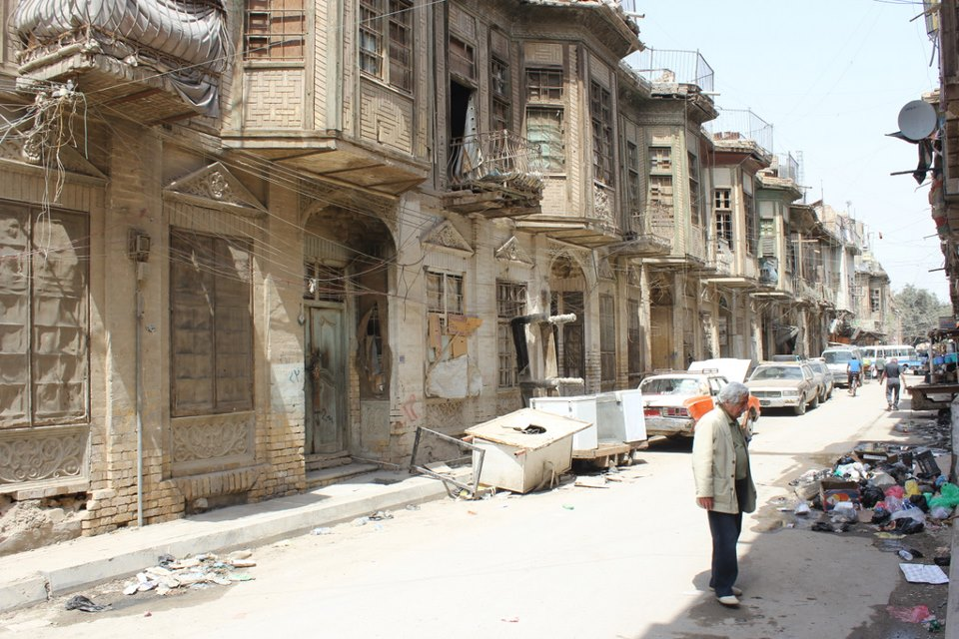
Basra’s identity was formed by history, tradition, habits, topography and the climate of the city. In addition to features of Arabic Islamic cities, the cross-pollination with other civilizations through trade or colonial, which has given the city a particular feature that has distinguished it from other cities (Ali, 1988), this identity was threatened many times by external and internal factors at certain times with certain circumstances to transform, distort or obliterate or blunt it, firstly by Ottoman period, British colonization, modernity, and finally globalization. In addition, there are many internal factors such as the policies of previous governments, and the three recent main wars in 1980, 1991, 2003, which led to a significant effect on society and demography of the city. As well as this disappearance, most of the architectural city landmarks were lost due to the dereliction and destruction that occurred during war periods, figure (5).
Figure 4: Neglect of Architectural Identity in Iraqi Built Environment
After 2003 many investment companies entered Basra city with a variety of disciplines to carry out different projects in various aspects. These companies adopted foreign, alien designs, which reflect their ideological culture. However, it was far from the city’s spirit and did not respect the city's history and identity. Moreover it did not care for the culture and traditions of the city, which represents a real dangerous threat for the architectural city identity in particular, and culture identity in general. Because of that, modernity and globalization are necessary in present times. Hence, all people and cities worldwide cannot dispense it. Because Basra city is in significant need of rebuilding and urban regeneration projects especially after the destruction that happened in the city during the wars periods, it is often a necessity after major war when rebuilding a city to focus on new development. Therefore, there is a need to have a framework of guideline that can be utilized in current and future design considering local identity while enabling modernization.
Transformation of Architectural Identity in Iraq
The Arab community was suffering from civilizational isolation, then opened up for the world after the First World War, and connected with different civilizations. This impacted on the overall existing civilization and architecture in particular, as a huge number of imported civilization elements had affected the overall architectural character (Makiya, 1982). Connection, and the large number of the newly acquired elements, led to dominate a clear impact on this civilization, especially in architecture, which was the main reason for transformation to modernity that broadly and clearly used in Arabic culture. This was gradually changed to focus on traditional building of the past and was mixed with modern design, which was strange for the local identity, architectural characteristics, cultural heritage, and historical roots. The rationality of modernity failed to protect the old, so mingled with it (Al-Naem, 2001). There were three trends for Western culture’s influence on the Arab architectural region styles, these are explained below:
  - Many of the Arabic people have been affected by Western thought, since the artistic imagination succeeded to persuading Arab community, that the modern classic Western style is an integral part of the Arabic culture.
  - The second trend had a significant impact for the first architects, who were aware of the negative impact of modernity on the Arab city urban fabric, which focused on the traditional fabric. With the influence of this belief, the traditional build was the essential reason for the spread of identity when they refused public architecture.
- Another group of Arab architects started to refuse this mechanism, which involved mixing between their communities and Western ideas. It was necessary to introduce traditional Architecture in a modern movement, which tried to distinguish parts of the city such as the old places, museums, and public squares, in order to associate the people with originality (Jadraji, 1995).
Iraqi urban environment was also affected by this foreign intellect during the British occupation, the output of architectural identity had been influenced at an urban level according to civilization trends, which imported and used new technologies in construction. Civilizations overlap creates opportunities for the emergence of thought trends on an architectural output level as a reaction to this overlap (Al-Sultany, 1982).

Intellectual Trends of Modern Architecture in Iraq and Challenges
Global trends and Western architectural ideas were more common in the fifth decade of last century in third world countries, but it did not continue. Revolutions that happened in the world and a search for privacy and the tendency toward national, political and economic independence, led eventually to a rejection of the modern style for architecture, to meet people’s ambitions and aspirations to achieve a better future, and emphases the civilization and cultural bases at the same time (AL-Mullah, 1988). According to the new considerations, the concern of some architects became not to imitate and convey prevailing values in a particular country, or re-copy famous and common architectural compositions. Nor was it to transform it for variety climate, nature, and demographic sites, or different historical values and characteristics. Instead it was to associate with local architectural heritage in order to derive positive elements and recreate it with a contemporary form to keep up with the present and go on for the future (Al-Sultany, 2000). So, some ideas emerged in Iraq, which supported cultures and global arts and what a new in the field of environment. According to that, the architectural intellectual trends that emerged in Iraq as a reaction to external influences were as the following:
- Intellectual trend that supported the foreign currents, especially those who supported the tide of modernity, since philosophy of the current time depends on function. Symbolic and aesthetic aspects achieved in this approach were as a result of the relationship between form and function in modernity, while the need for the symbolic and aesthetic was increasing for postmodernism supporters.
- Intellectual trend that adopted linking, the new with the old, through copying heritage elements. The symbolic aspect is more important, due to deriving the traditional elements from urban environment.
- Intellectual trends that mimic the old elements, and transfer them to a new frame with a clear climate need for this trend, while symbolic aspects were abstract, so it was achieved within a semantic level, As well as this, there was a full achievement of the aesthetic aspect within a semantic level, due to the use of abstract thought (Al-Sultany, 1984).
Iraqi architectural identity passed through transformation processes, due to the change of form and content of architectural products, which were caused by many attempts by architects and urban designers, as well as this, the effect of foreign thought when many foreign architects arrived in Iraq, which supported the change processes, in addition to the political instability of the country (Shirzad, 1987). The existence of the Architectural currents (modernism and postmodernism) led to emergence of architectural cultural resistance, as a reaction to this existence and the transformations that happened. The architectural trends were as a result of internal transformations, which have taken place within the urban environment at structural and semantic level (Al-Sultany, 1984).
creating and formation of new built environment with all of its elements and its relationships, led to internal transformation, when interaction happened between the new built environment and the natural cultural factors of Iraqi urban environment, so trends appeared depend on the degree of distance from the traditional environment (Shirzad, 1987). As a result, supporter trend was further away from locality and closer to modernity, while the imitation trend was taken from traditional environment elements. There was a third approach, which was taken from mixing traditional elements with modern through new style, this approach was very close to postmodernism's current in the Iraqi environment(Al-Sultany, 1985).

Comparison between traditional and modern identity:
The paper uses comparative analysis method to discover the differences between old and new architectural identity in Basra city. This method gives possibility for analyzing most design components such as form, space, relations and materials used. It is can be possible to analyze the influence of modernity, globalization and others new movements on the local identity. Moreover this method gives also more understanding for problems and solutions in urban design.
There are a number of factors used to compare traditional and modern architectural identity in the Iraqi built environment. These are elaborated below.
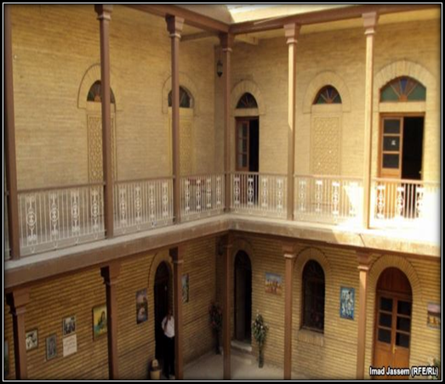
- Privacy: The issue of privacy was always an important component in Arabic Islamic city design. Privacy is fundamental factor in developing the identity of the built environment. The need for privacy is one of the important desires for human beings. The meaning of privacy in the global society is completely different from the meaning of privacy in the Iraqi society. Therefore, the concepts and principles applied in modern designs were not based on local conditions. The modern designs have ignored local people's needs, habits, customs, religion and social structure, where the privacy remains very important for Iraqi society, especially designing of houses (Losing the courtyard, large windows, and high-rise buildings nearby), which failed to meet the households' need for privacy, figure (6).
Figure 5: Privacy in Iraqi Traditional House

- Social relationships: Current changes in architecture are not only affecting the appearance of buildings but also the social and cultural life of people. Concept of neighborhood, as it was known in the traditional city, missed in the modern districts because of big plots, high fences, wide streets, and busy lifestyle. The traditional neighborhood, where people enjoy social life with others, working, studying, shopping, and socializing with others is not found in modern districts. Social relations between people became weaker and people enjoy spending times in malls and hotels even meeting their friends there instead of their own houses. Dependence on the car as the main unit for city planning lead large scale environment does encourage human interaction figure (7).
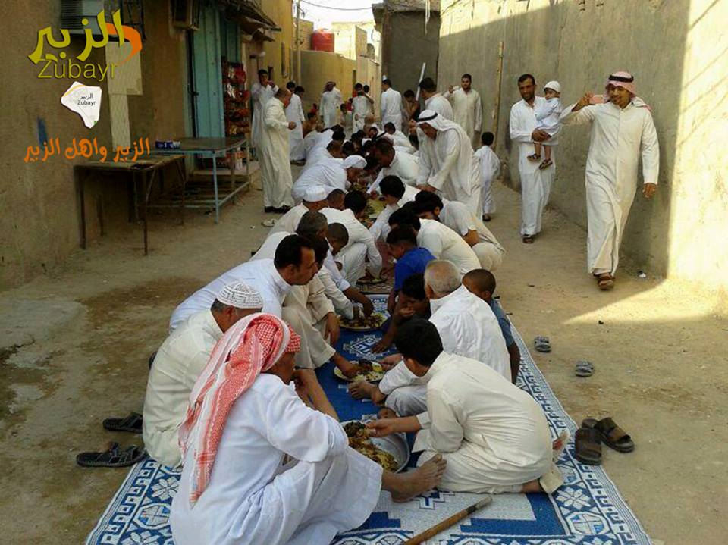
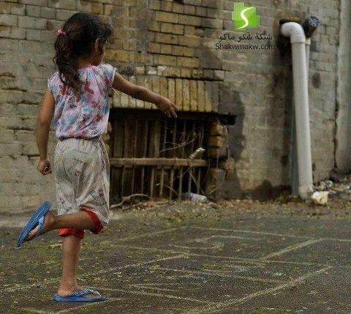
- Safety of environment: The good architecture would satisfy the necessary needs of its users such as safety and reasonable degree of freedom of living and movement. The lack in safety resulting from bad planning of streets and heavy traffic discourage residents, especially children, from contacting each other. Living in traditional areas and communities is very safe. Streets in their neighborhoods were empty of cars and also courtyards in their houses provided safety for their family, especially children, while planning of streets in modern areas giving priority to cars without enough care to pedestrian safety. Safety in the traditional city was as a result of design concepts and principles used in the neighborhoods, which restricted car access and provide safe courtyards and the social, cultural and economic harmony between residents, figure (8).
Figure 7: The Social Relationships in Iraqi Neighborhood
Figure 8: The safety of Traditional Environment
- Belonging: Sense of belonging depends on many factors such as, length of residence in the place, social relations, and availability of place facilities.in general, the traditional environment provide to people strongest level of belonging to the place.
- Place Memory: the ability of residents, who live in the traditional districts to notice, understand, and remember their built environment better than in modern districts , as well as they have ability to link their physical architectural production to their cultural norms.
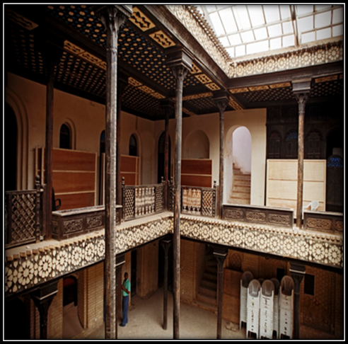
The courtyard in houses in traditional areas was using for multi functions. Firstly, it is private interior meeting space for family members, secondly the courtyard provide a suitable climate especially in summer in Iraq, thirdly provides a safe place for children to play, as shown in fig(9).
Figure 9: Courtyard in Iraqi Traditional House
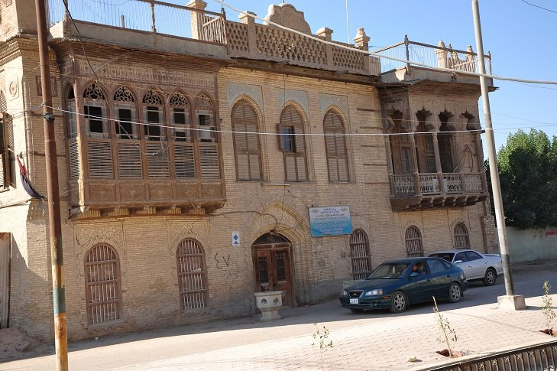
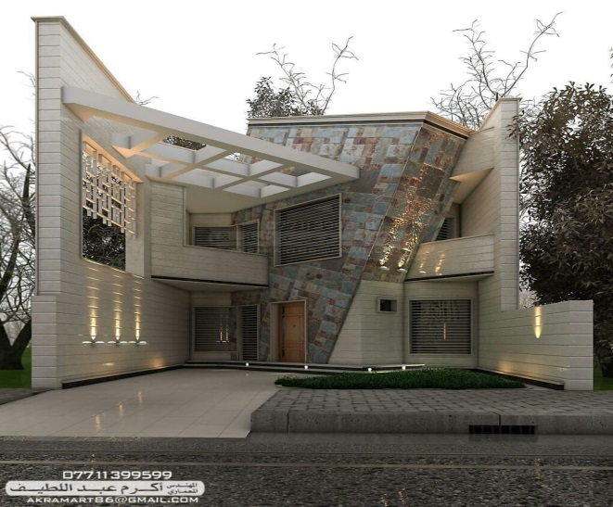
At the contrary, in modern areas the interior courtyard transfers to outdoor space where privacy is missing, especially in regard to visual aspect since many high neighboring buildings. In addition, the courtyard provides relationship between family members, which are lost in contemporary houses. Using new buildings materials and disappearing of courtyard in houses in contemporary areas made people looking for new solutions for climate problems.
Figure10: Traditional house in the Iraqi city
Figure 11: Modern house in the Iraqi city
Privacy reflected also in external elevation of houses in the traditional areas by using solidity in the ground floor while the first floor has a window with wood screen ((Shanshoul)) figure (10). While in contemporary areas, the house elevation is transparent and has large windows, which does not provide enough privacy for family. Figure (11)
Regarding to social relationships, the traditional neighborhood have strongest relations more than contemporary. Because of streets in traditional areas are narrow, which is not suitable for cars. Therefore, local people can have many opportunities to contact with each other. However, in contemporary areas the wide streets and the high buildings did not encourage people to build strong ties with their neighbors, and don’t encourage them to meet each other.
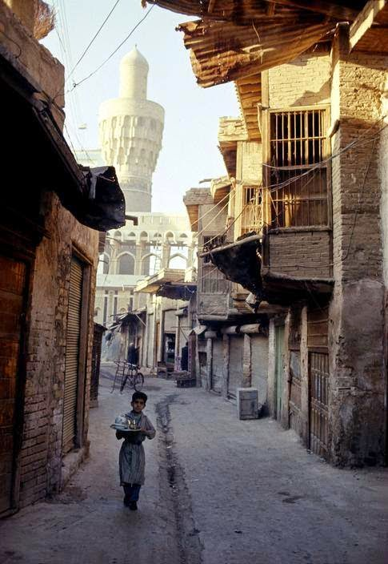
One of the main weaknesses in contemporary areas is the loss of landmarks of the city, which led to the loss of the place memory, while the traditional areas are rich with the multi landmarks. Therefore, the place memory enriches the local people’s identity. The landmarks available in traditional areas support the people who live in these areas to build a strong memory while in contemporary areas disappearing of landmarks has led to weak a memory for people who they live in these areas. Figure (12)
Figure 12: Landmark in traditional environment
Conclusion:
The previous available studies about Basra city could be classified as historical, descriptive, and exploratory studies, which were not analytically useful studies to clarify characteristics of architectural city identity so that they cannot be used in urban design applications on the field. It is, therefore, essential that any future development should be informed by an understanding of these problems and shortcomings. The motivation of conducting the studies on the traditional architectural identity and assessment of its characteristics is to find the way to transfer or recreate the useful logical principles in order to maintain local identity. This is not done by the blind imitation and copy of its appearance, but through the conscious and deep understanding of esoteric principles of identity. Therefore, there is a vital need to develop a framework to guide professionals in producing urban design solutions, which will consider maintaining identity while enabling modernization. This framework should be based on i) understanding the concept of identity in architecture, ii) aspects of environmental and social, cultural identity, such as privacy, safety, belonging, and place memory and iii) analyzing traditional and contemporary identity.

Reference:
Vogler, Andreas (2006), Genius Loci in the Space-Age, 1st Infra-Free Life Symposium, Istanbul –December.
Thompson, J.B. (1996). Tradition and Self in a Mediated World. In: Heelas, P., Lash, S., & Morris, P. (Eds.), Detraditionalisation. Oxford: Blackwell.
Adam, R. (2012). Identity and Identiﬁcation: The Role of Architectural Identity in a Globalised World. The Role of Place Identity in the Perception, Understanding, and Design of Built Environments, 176.
Humeyra, B Akkurt. (2012),Reconstitution of the Place Identity within the Intervention Efforts in the Historic Built Environment,The Role of Place Identity in the Perception, Understanding, and Design of Built Environments, 63-77
Heynen, H. (2000). Architecture and modernity: a critique. MIT press.
Jorge, S and Nuno, M Seabra (2012),Context, Identity and Architectural Design Thinking. The Role of Place Identity in the Perception, Understanding, and Design of Built Environments, 194-208
Rapoport, A. (1999), "A framework for Studying Vernacular Architectural", Journal of Architectural and Planning Research, Vol. 16, No. 1.
Frampton, K & Fujii, H & John, (1987). The Architecture of Hiromi Fujii, New York, Rizzoli International Publications.
Al-Sultany, K (1982), “Architecture in Iraq between the Two World Wars, 1920-1940,” Ur: International Magazine of Arab Culture, 2-3.
Caecilia, P (2006), BAGHDAD ARCHITECTURE, 1921-1958: REFLECTIONS ON HISTORY AS A ”STRATEGY OF VIGILANCE” Bulletin of the Royal Institute for Inter-Faith Studies 8, no. 1 & 2 .
Manzoor, S., 1989, Tradition and development. Ph.D. Thesis, School of Architecture, Chalmers University of Technology, Sweden, pp: 17-20.
Ali, K, (1988), visual influences for architectural axes, applied model of the city of Basra, a special issue of second engineering conference Iraqi, Ministry of Higher Education and Scientific Research, Journal of Engineering and Technology, published by the University of Technology, Baghdad, Iraq.
Bazi, H (1989), reconstruction of the city of Basra, Basra folklore, cultural House, the Ministry of Culture and Information, the Republic of Iraq, quarterly edition, No.3.
Simon, M (2005). Modernity and Post Modernity. In: The Postmodern, Simon, M. (Ed.). Rutledge, New York, ISBN: 10: 0415280648, pp.: 47-51.
Berman, A (1994). The Configuration of Modernism. In: Preface to Modernism, Berman, A. (Ed.). University of Illions Press, USA., ISBN: 0252021037, pp: 3-27.
Afaya, M., 1998. Controversial Between Modernity and Communication. 2nd Edn., African East, Morocco,pp: 121.
Finlayson, G., 2005. Habermas: A Very Short Introduction. 1st Edn., Oxford University Press, USA., ISBN: 10: 0192840959, pp: 184.
Stern, R (2009). The Doubles of Post-Modern. In: Architecture on the Edge of Postmodernism: Collected Essay 1964-1988, Stern, R.M.A. and C. Davidson (Eds.). Yale University Press, Yale, ISBN: 13: 9780300153972, pp: 1-216.
Ibelings, H (1998). Super modernism: Architecture in the Age of Globalization. 1st Edn., NAI Publishers, USA., ISBN: 9056620746, pp: 144.
Makiya, Mohammed Saleh (1982), the moral foundations of Arabic architecture, an Arab arts magazine, Issue (5) .
Al-Naem, M (2001), urban identity transformation, Al Mustaqbal Al Arabi journals research, Beirut, Lebanon, Issue (2/3), January.
Jadraji, R(1995), Dialogue in Structural of art and architecture - Al-Rayes house, London .
AL-Mullah, Huwaish & Nouri, Aqil (1988), modern architecture in Iraq, Public Cultural Affairs house, Baghdad, 1988.
Al-Sultany, K (2000), Architectural visions, University of Jordan press. Amman.
Al-Sultany, K (1984), Iraqi architecture in fifties decade, Journal of Arab horizons, No (4) December.
Shirzad, Shirin Ehsan (1987), glimpses of the history of architecture and architectural movements , General House of Cultural Affairs, Baghdad.
Al-Sultany, K (1985), (modern architecture in Iraq), Journal of Arab horizons ,No (9).

