Knowledge Transfer Partnership: Implementation of Target Value Design in the UK construction Industry
Amit Kaushik, Kaushal Keraminiyage, Lauri Koskela, Patricia Tzortzopoulos Gary Hope.
Abstract
Knowledge Transfer Partnerships (KTP) are unique research programmes designed to bring innovation by joint effort of academia and industry to provide innovation in technology, process and management for the UK Industry. This paper describes an undergoing research on a collaborative project management approach which could increase the project delivery efficiency in the UK construction industry. UK Construction Industry has always been criticised by the industry experts about its lack of efficiency and innovation to deliver client’s value. The KTP research project aims to implement Target Value Design in the UK construction industry. Target Value Design (TVD) is lean project management approach focused to deliver client’s value and provide better control over the project cost. TVD has been only implemented in the US and this research focuses to develop a framework to implement TVD in the UK Construction Industry.
Keywords: Knowledge Transfer Partnership, Project Delivery, Target Value Design and Lean.

Introduction
Construction Industry is one of the largest sectors in the UK economy. It accounts for £90 Billion to value added and 2.93 million jobs (roughly 10% of total UK Employment). It has been affected due to the 2008 recession, following which GVA contribution to the UK economy fell from 8.9% (2007) to 6.7% (2011) (BIS, July, 2013). Post economic downturn, the UK Government has been trying to gain efficiencies in the construction & infrastructure sector to deliver more for less and generate confidence in the construction sector growth. This resulted in the issuing of various government strategies like setting up BIM (Building Information Modelling) Task group, Procurement strategy (Office, 2011).
The Industry experts have always highlighted the UK construction industry as highly inefficient and proposed innovation at various areas of industry’s traditional practices (Banwell, 1964) (Latham, 1994) (Egan, 2004). The common areas of improvement highlighted were Capital cost, Construction time, Predictability & defects. Industry performance still lacks in various areas, the Project Predictability figures for 2012 highlights time predictability of 34% (projects, as whole, finished on or before predicted time), Cost Predictability came out to be 61% (final project cost on or below predicted cost). This combined with the negative attitude of the industry due to the recession resulted in only 2.7% industry profitability in 2012 (Folwell, et al., 2012).
H.M Government has set out various targets for the UK Construction Industry in the Construction 2025 Report (2013).
- Lower Costs - 33% reduction in the initial cost of construction and the whole life costs of built assets.
- Faster Delivery – 50% reduction in the overall time, from inception to completion, for new build and refurbished assets.
- Lower Emissions – 50% reduction in greenhouse gas emissions in the built environment.
- Improvement in exports – 50% reduction in the trade gap between total exports and total imports for construction products and materials.

Need of Target Value Design
Target value design (TVD) is a management approach where the cost act as an input to design and design process is a collaborative iterative process constantly updating cost to align client’s requirement with their constraints (cost, features, time, etc.). TVD is based on target costing principles from manufacturing industry and was developed in P2SL Labs, University of Berkeley, California. In past decade, TVD implementation has proved to be very successful in delivering client’s needs in a set Target Cost below the Market Price (Ballard, 2013).
Figure-1 illustrates the cost saving vision of the UK Government for 2025 and it can be compared with the cost savings documented in 12 projects which used Target Value Design in the United States (Tommelien, et al., 2011). Project A to F have been completed with the final cost savings ranging from 5% to 18%. Projects G to L were incomplete and the expected cost saving ranged from 5% to 33%. This comparision highlights the possible contribution of project cost saving from adaption of Target value design. There is no evidence of Target Value Design implementation in the UK. Most of the documented TVD implementations in the US have been achieved in a collaborative environment with IPD (Integrated Project Delivery) setting.
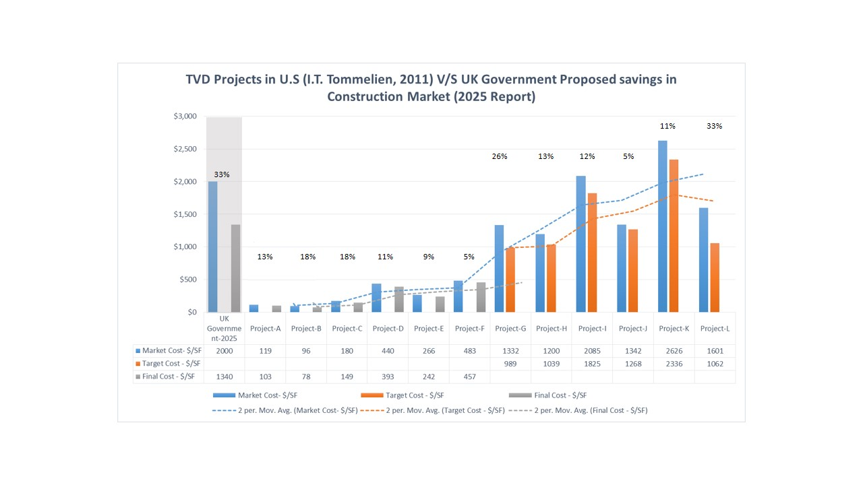
Figure 1 - TVD Projects performance V/S UK Government Targets
To address the UK industry problems, University of Salford & Infra Projects Ltd collaborated to initiate a KTP to develop Target Value Design framework for the UK Construction Industry.

Methodology
Knowledge Transfer Partnership (KTP) is a collaborative research programme initiated by Technology Strategy Board (TSB) across the UK. It aims to transfer the knowledge and expertise from the academia world to the UK Industry to allow them to increase their productivity, technology and services. On the other hand, the knowledge base partner also gains insights about the knowledge needs of the industry and business relevance of their input. A KTP Associate, university employee but working at the industry partner office is at the centre of the project.
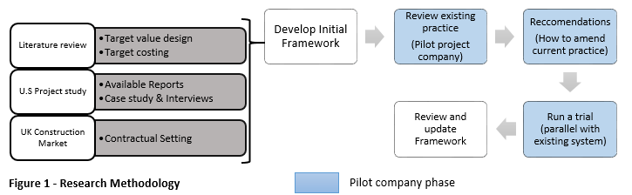
This KTP Project is a two year collaboration between Infra Projects Ltd and University of Salford. It has been aimed to transfer the expertise and knowledge of Target Value Design to Infra Projects Ltd to allow them to deliver better Project Delivery solutions in the Built Environment Industry.
The Aim of the of the project is
Figure 2 – Research Methodology
“To develop and Implement Target Value Design processes, procedures and supporting ICT for use in heavy infrastructure construction”
There are four objectives of the KTP;
- Detailed analyses of the market and the use of TVD.
- Analyse UK Construction Industry and alignment of TVD Approach.
- Produce Prototype Target value Design Framework.
- Pilot Implementation of the developed Target Value Design framework.
- Project review and evaluation, including cost benefit analysis.

The research methodology adapted to achieve various objectives of the KTP Project can be seen below.

Target Value Design
Target Value Design (TVD) is a management practice/ process which aims to achieve the maximum value in a set target cost lower than the Market Benchmark Price (Ballard, 2012).
Target Value Design aims to generate client’s value within the client’s conditions of satisfaction (Time, cost, features etc.). It is an adaptation of Target Costing from manufacturing industry and focuses on establishing values for the client and delivering them in a set Target Cost using various cost and design management tools. The target value/cost acts as an integral input to the design process (Zimina, et al., 2012) (Figure -2).
The first project using TVD approach was Tostrud Fieldhouse at St. Olaf College, USA by Boldt Company in 2002. The term Target Value Design was first used years later by Hal Macomber, Greg Howell and Jack Barberio in 2007 for the adoption of target costing to construction field (Macomber, et al., 2007).
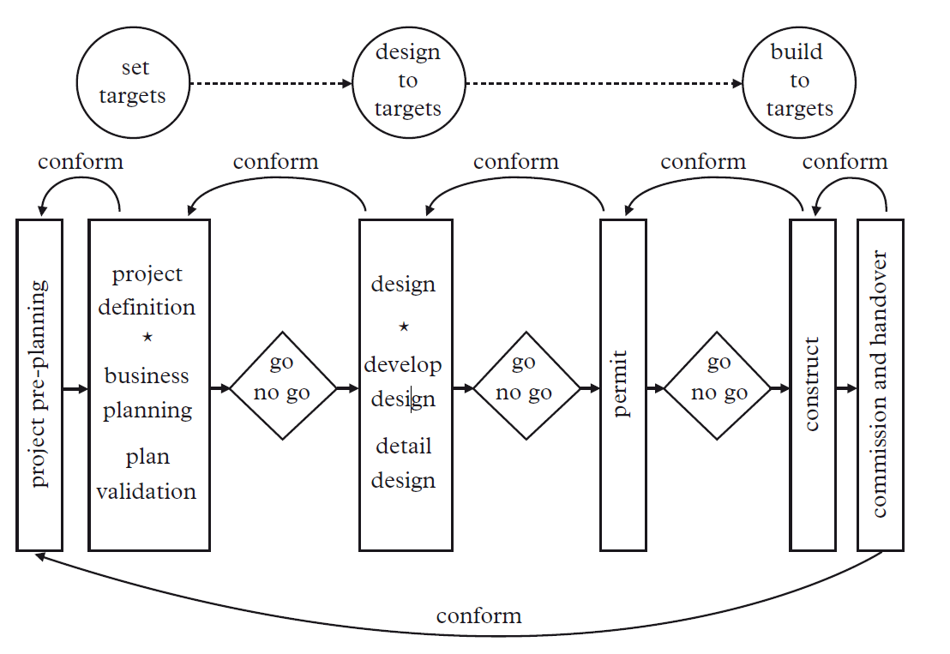
“Main idea of TVD is to make a client’s value (design criteria, cost, schedule & constructability) a driver of design, thereby reducing waste & satisfying or even exceeding the client’s expectation” (Zimina, et al., 2012)

Figure 3 - TVD Process (Zimina, et al., 2012)
Target value design (TVD) inherits its process elements from Target Costing. However, In TVD, project is not only defined on the basis of the target estimate/profit but also keeping Client's business and operation model as a core element of the Project’s Value. Design brief, cost, schedule and constructability are also integral elements in defining the client’s value definition. The process initiates with project planning, which includes market analysis of risks and opportunities to validate the project definition and plan (figure 3).

In TVD, detailed scope of project and set Target Cost drives the Design. It follows various principles of Target Costing (Manufacturing Industry), such as anticipating design decision’s implications and eliminating design alternatives with low build-ability. However, these techniques are still in development phase and the industry is still in learning phase. Therefore, it is recommended that cross-functional teams work together and share expertise in order to identify the range of required characteristics of the project likes schedule and constructability (Ballard & Reiser, 2004).

Value in TVD
“TVD Targets the value profile of the project. It is composed of broadly two types of components in a product or process. Ones that directly deliver value, and those characteristics that are conditions for realization of value. The former include the functionalities and capacities that enable the customer to best accomplish their purposes. The latter typically include cost, schedule, and location” (Ballard, 2013).

TVD Principles
According to (Macomber, et al., 2007), TVD turns current design practice upside-down:
It broadly has five fundamental components (Figure – 4)
- Setting the Target Cost for design: “Rather than estimate based on a detailed design, design based on a detailed estimate”.
- Work Structuring: “Rather than evaluate the constructability of a design, design for what is constructible”.
- Collaboration: “Rather than design alone and then come together for group reviews and decisions, work together to define the issues and produce decisions then design to those decisions”.
- Set-Based Design: “Rather than narrow choices to proceed with design, carry solution sets far into the design process”.
- Collocation: “Rather than work alone in separate rooms, work in pairs or larger groups, face to face”.
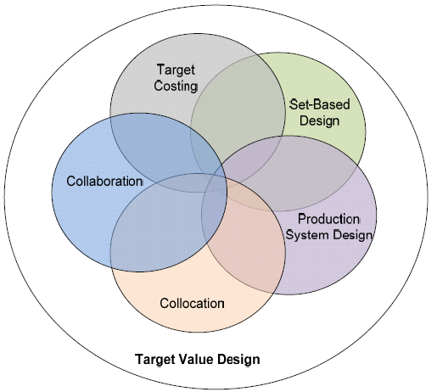
Figure 4 - Target Value Design (Macomber, et al., 2007)

TVD Case studies
Project | Contract | Detail | Result (Expected)
University of California, SF - Medical Center at Mission Bay, SF | Two Stage GMP  (Guaranteed Maximum Price) | - 289 patient bed  - 869,000 square ft  $1.5 Billion Project | - $765 million for design and construction – Feb 2015  - Roughly 10-15% Savings Expected
Alta Bates Summit Medical, Oakland | IPD, IFOA (Integrated Form Of Agreement) | - 240 patient beds  - 230,050 square feet | - $245 Million project –Jan 2014  - 10-15% savings expected
UHS, Temecula | IPD, IFOA | - 5 Story Building  - 178,000 square ft | - $159 Million Project – September 2013  - 30 % – US Standard  - 40% - California State

Current TVD Practices
Table 1 - TVD Case Studies
All TVD projects have been documented in California region’s healthcare projects. A detailed analyses of available literature and case study suggests that TVD approach has been applied with a set of lean tools to enable the effective TVD implementation and achieve the set Target Cost. Industry professionals were interviewed in a research to identify various Lean practices which help increase value and decrease waste in the project delivery (Novak, 2012). (Figure – 5
Figure 5 - Current TVD Practices

TVD Enablers
A set of 17 benchmarks practices have been set by P2SL Labs, University of Berkeley, California to ensure the successful implementation of TVD. These Benchmarks have been updated twice. However, these benchmarks are focused towards US Construction Industry equipped with IPD (Integrated project delivery) and Multi party collaborative contract IFOA (Integrated Form of Agreement).
KTP research project team has extracted four conditions/practice from the 17 Benchmarks which could provide the minimum required setting for TVD Implementation in any Non-IPD Environment. These are
- Early Collaboration of stakeholders – Early Collaboration of major stakeholders in the project is essential to ensure that all necessary expertise is available from the beginning of the project. This not only enables team to set the right targets and goals as per client’s requirements but also use structure a collaborative design process to achieve cost targets and required design features.
- A shared risk & rewards mechanism – It is necessary to motivate various project stakeholders to work hard towards project’s interest, hence, it is required to align team members’ interest with the project/client’s interest. In the UK, Contracts like NEC-3, PPC -2000 with little amendments allow to provide such mechanism.
- Cluster Organisation - A cluster organisation is a project hierarchy system inspired from the manufacturing industry. Clusters are groups divided amongst the project team based on the trades (MEP, Structure etc.). Each cluster has a cluster leader who is a part of the core team governing the project delivery decisions. (Figure – 6).

(Nicolini, et al., 2000) Explains, "A cluster is, in many respects, a 'design & construct' mini-project that takes place within the larger framework of the project. It is a place where a limited number of designers, suppliers of materials or components engage in intensive collaboration to design & deliver a significant, recognizable element of the overall building working to reduce costs, improve value & minimize waste".

- Iterative design cycles with continuous cost engineering in a collocated setting – It is necessary to design various elements, systems of the overall design in an iterative design cycle carrying maximum number of options to last responsible moment of decision. The centre of iterative process is client needs. The major difference is from traditional design management practice is parallel process of aligning the expected cost of various design options to the target cost. These collaborative efforts are attempted in a structured collocated setting, allowing team to interact and share expertise to reach the required design and cost.
Figure 6 - TVD Design Clusters (TVD - Dr Glenn Ballard)

The Way forward
The KTP Project is half way through, initial research and analyses objectives have been achieved. An initial draft of TVD Implementation has been completed. As part of the project objectives, team is discussing the possibilities of pilot implementation of Target Value Design with various organisations. It is aimed to gather learning from the pilot project and update the framework for the UK Industry. Post KTP Project, Infra Projects Ltd will use the framework and TVD expertise to deliver better project delivery services enabling various project delivery teams to deliver the client’s requirements in a cost controlled environment and adding value to various projects and to the UK Construction Industry.

Acknowledgement
Thanks are due to TSB (Technology Strategy Board, UK) for funding the research project and the CIB conference anonymous reviewers for their valuable comments on this paper.

References
Ballard, G., 2012. Should Project budgets be based on worth or cost ?. San Diego, CA, IGLC.
Ballard, G., 2013. Target Value Design [Interview] (13 May 2013).
Ballard, G. & Reiser, P., 2004. The St. Olaf college fieldhouse project:A case study in designing to target cost.
Banwell, H., 1964. The Placing and Management of Contracts for Building and civil Engineering work. London: HMSO.
BIS, July, 2013. UK Contruction: An Economic analysis of the sector, London: Department of Business, Innovation & skills.
Egan, S. J., 2004. Rethinking Construction, London: Construction Task force.
Folwell, K. et al., 2012. UK Industry Performance Report, London: Construction Excellence.
Latham, M., 1994. Constructing the Team: The Final Report of the government/Inustry review of procurement & contractual arrangements in the UK Construction Industry, London: HMSO.
Macomber, H., Howell, G. & Barberio, J., 2007. Target value Design: Nine foundational and six advanced practices for delivering surprising client value.. Lean project consulting.
Nicolini, D. et al., 2000. Can Target Costing and whole life costing be applied in the Construction Industry?: Evidence from two case studies. British journal of management, Volume 11, pp. 303-324.
Novak, V., 2012. Target Value Design:Sustainabilites values in construction. Hong Kong, ICVEM.
Office, C., 2011. Government construction strategy, s.l.: Cabinet office.
Tommelien, I., Ballard, G. & Lee, H., 2011. Develop target value design and delivery process to incoporate energy efficiency metrics, s.l.: United states department of energy.
Zimina, D., Ballard, G. & Pasquire, C., 2012. TVD: Using collaboration and lean approach to reduce construction cost. Construction Management Economics, 30(5), pp. 383-398.

KTP Associate, PhD Student, University of Salford. a.k.kaushik@salford.ac.uk
BSc (QS) Programme Director, Room 432a, Maxwell Building, The University of Salford, Salford, United Kingdom, M5 4WT, k.p.keraminiyage@salford.ac.uk
Professor, School of the Built Environment. University of Salford, Maxwell Building, room 507, The Crescent, Salford, M5 4WT, UK, l.j.koskela@salford.ac.uk
Director of Design and Property Management Directorate, School of the Built Environment. University of Salford, Maxwell Building, The Crescent, Salford, M5 4WT, UK, p.tzortzopoulos@salford.ac.uk
Managing Director, Infra Project Ltd., gary.hope@infra-projects.com
Integrated Project Delivery (IPD) is a project delivery approach that integrates people, systems, business structures and practices into a process that collaboratively harnesses the talents and insights of all participants to optimize project results, increase value to the owner, reduce waste, and maximize efficiency through all phases of design, fabrication, and construction

