D2 Graphs showing datasets with misclassification costs reduced into groups

D2.1 Multi-class datasets in 3 misclassification cost groups

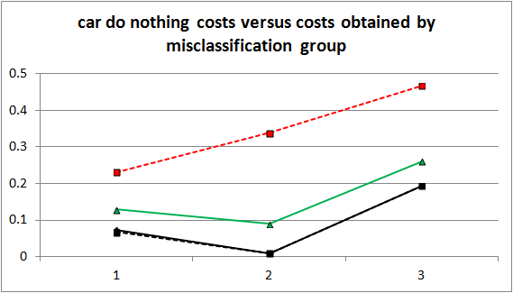 | 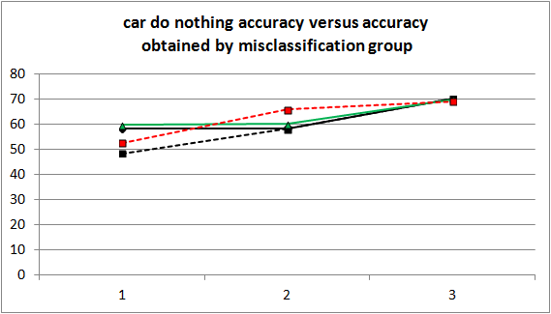
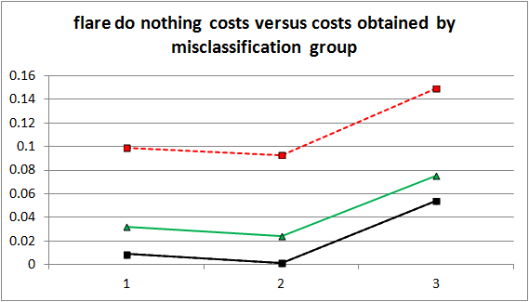 | 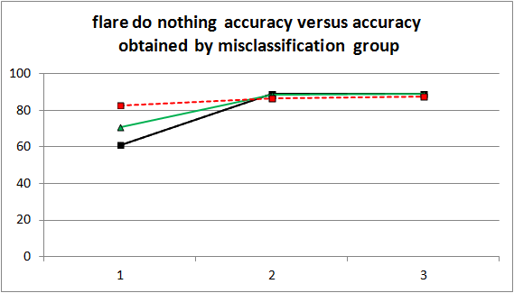
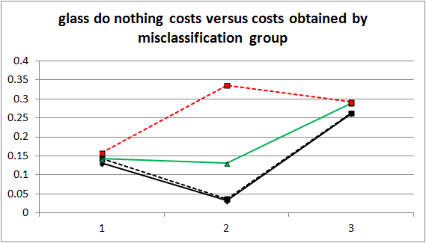 | 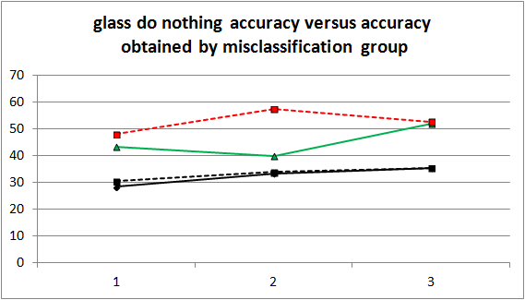
dn_cost(examples) dn_cost(trees) cost(examples) cost(trees)
dn_accuracy(examples) dn_accuracy(trees) accuracy(examples) accuracy(trees)

Graphs showing multi-class datasets in their 3 groups of misclassification costs: mixed, low, high

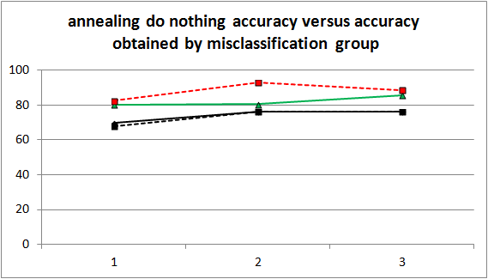 | 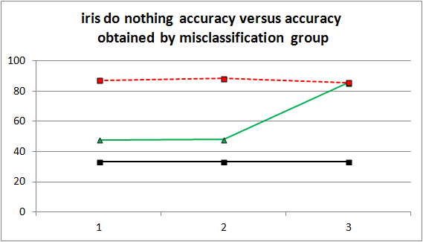
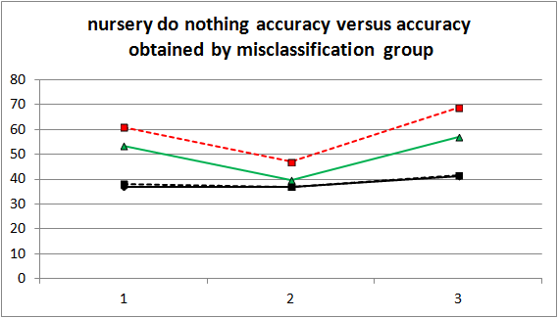 | 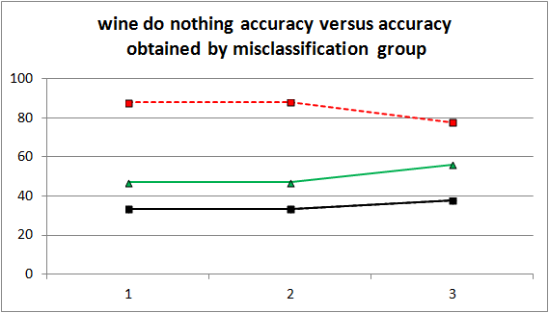
dn_accuracy(examples) dn_accuracy(trees) accuracy(examples) accuracy(trees)

Graphs showing multi-class datasets in their 3 groups of misclassification costs: mixed, low, high

D2.2 Binary class datasets reduced to 1 misclassification group
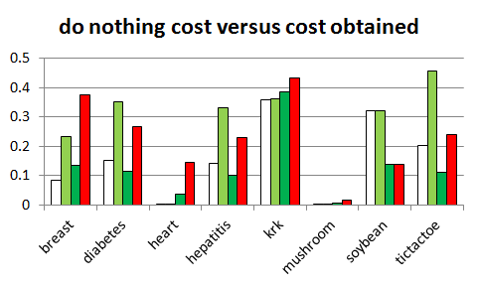 | 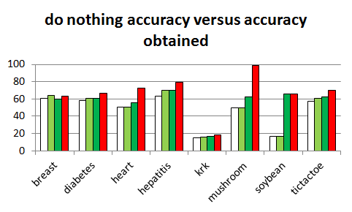
dn_cost(examples) dn_cost(trees) cost(examples) cost(trees)
dn_accuracy(examples) dn_accuracy(trees) accuracy(examples) accuracy(trees)

Graphs showing datasets, which can have only one group of misclassification costs: mixed

