Urban Picnic

An interactive public video installation

For Picnic in Arcadia between the Museum of Folk Art Shanghai and Bluecoat Gallery Liverpool

By Paul Sermon & Charlotte Gould, October 2010

Software Development by Alasdair Swenson

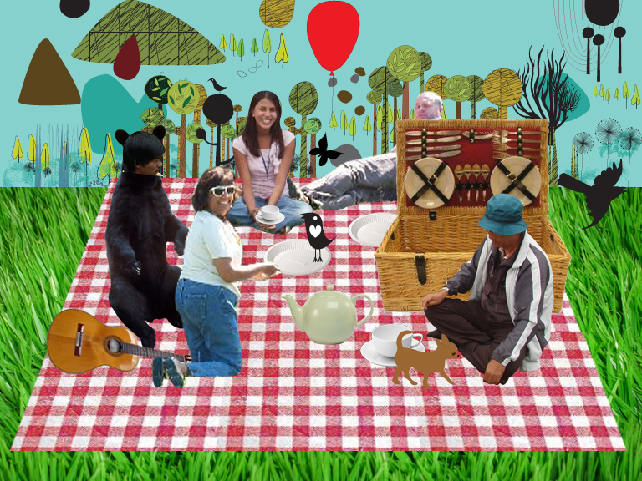

Paul Sermon & Charlotte Gould
School of Art & Design
The University of Salford
Centenary Building, Peru Street, Salford
Greater Manchester
M3 6EQ
United Kingdom

Paul Sermon <p.sermon@salford.ac.uk>
Mobile Tel.: 07753 167726
http://www.paulsermon.org

Charlotte Gould <c.e.gould@salford.ac.uk>
Mobile Tel.: 07525 011167
http://creativetechnology.salford.ac.uk/gould/
The work and the artists

Following the success of ‘Picnic on the Screen’ presented at the Glastonbury Festival 2009 (http://creativetechnology.salford.ac.uk/paulsermon/picnic/) Charlotte Gould and Paul Sermon have been invited to develop a new version of this interactive public video installation for Picnic in Arcadia (http://www.movementonscreen.org.uk/) used to link public audiences between the Bluecoat Gallery Liverpool and the Museum of Folk Art Shanghai, for the first time via a telematic videoconference connection.

Utilising the latest blue screen and HD videoconferencing technology the installation will bring public participants together within a shared telepresent urban picnic scene. Merging live camera views of remote audiences together and placing them within a computer illustrated environment, together with computer animated elements that are triggered and controlled by the audience through a unique motion tracking interface integrated within the installation. When a member of the audience discovers their image on screen they immediately enter the telepresent space, watching a live image of them selves sitting at a picnic scene next to another person. They soon start to explore the space and understand they are now in complete physical control of a telepresent body that can interact with another person in an illustrated enchanted ludic scene, complete with animated characters that respond to the their movement and actions.

This artistic proposal, for Picnic in Arcadia has been developed by Manchester based artists Charlotte Gould and Paul Sermon, and brings together twenty years of experience in interactive media arts practice. Paul Sermon is a leading pioneer of telematic art and performance, bringing remote participants together in shared and immersive telepresent environments. His numerous awards include the prestigious Prix Ars Electronica “Golden Nica” for interactive art (for Think about the People now, 1991) and the Los Angeles Interactive Media Festival “Sparkey” Award (for Telematic Dreaming, 1994). He has been an Artist in Residence at ZKM in Karlsruhe, Germany, a Guest Professor in Performance and Environment at the University of Art and Industrial Design in Linz, Austria, and is currently leading research in immersive and expanded telematic environments at the University of Salford, UK.

Charlotte Gould has developed a series of projects including Urban Intersections, at the Waterfront Hall, Belfast for ISEA 2009, Picnic on the Screen for the BBC Village Screen at the Glastonbury Festival 2009, Ludic Second life Narrative for the BBC Big Screen in Liverpool for the MOVES09 Festival and Ludic Narrative, an installation using Bluetooth technology and mobile phones shown at the Futuresonic Festival in May 2008 - on which she delivered a paper at ISEA 2008 Singapore.

Further collaborators on this project include Alastair Swenson who is developing the motion tracking and Flash programming in this installation and have also worked on the Ludic Projects above. This project will represent a fusing together of previous projects and will allow for the further development of the artists practice.

The artists will further utilise the technical developments already used in previous projects, and explore the concepts and techniques of telepresent interaction and ludic narratives in this wider context. Our engagement with all aspects of the project will include continuous project documentation through on-site video shoots and post-production, website archives, Blogs, Wikis and media streaming.

How the public will engage with the work

This is site-specific work, to be shown in Shanghai and simultaneously in the Bluecoat Gallery, will allow the public to engage and interact while simply passing through or relaxing having lunch. This playful environment merges two public spaces together, creating a third otherworldly space on screen where people can interact with others across the city at a virtual picnic table, allowing the audience to explore alternative networked spaces.

The key impact of this project can be measured through its focus on public arts engagement. The primary users in this project will involve public audiences in Shanghai and Liverpool. The Impact of this project aims to identify alternative creative and cultural use of videoconferencing as sustainable public media platforms and also looks to explore the potential for site-specific works in order to contribute to specific urban environments and communities.

The piece explores the potential for interactive works to engage the public and in this way the audience make a creative contribution to the installation through the development of unique narrative events. The works encourage visitors to be playful, interacting with others and the environment in a way that they would not otherwise do. We will also offer workshop activities to the public as part of the exhibition.

Hardware and installation equipment

Video and computer at the Bluecoat Gallery Liverpool:

1 x LifeSize Express 220 Videoconference System
1 x HD video camera and video camera mounting
2 x Edirol-V4 video mixer
1 x MacBook Pro laptop computer
1 x HDMI to Composite scaler/convertor
1 x Composite to HDMI scaler/convertor
1 x 52” LCD screen and stand
1 x 14” preview monitor
Power cables/supplies/outlets, HDMI cables, video cables and adaptors

Installation Materials:

1 x Chroma-key blue picnic blanket 5 x 5 metres
Selection of chroma-key blue cushions and blankets
Augmentation cards and picnic basket
Florescent lighting (house lighting for chroma-keying)

Video and computer at the Museum of Folk Art Shanghai:

1 x LifeSize Express 220 Videoconference System
1 x HD video camera and video camera mounting
2 x Edirol-V4 video mixer
1 x MacBook Pro laptop computer
1 x HDMI to Composite scaler/convertor
1 x Composite to HDMI scaler/convertor
1 x 52” LCD screen and stand (provided by museum)
1 x 14” preview monitor (provided by museum)
Power cables/supplies/outlets, HDMI cables, video cables and adaptors

Installation Materials:

1 x Picnic blanket/background 5 x 5 metres
Selection of cushions and blankets
Augmentation cards and picnic basket

Video flow diagram:

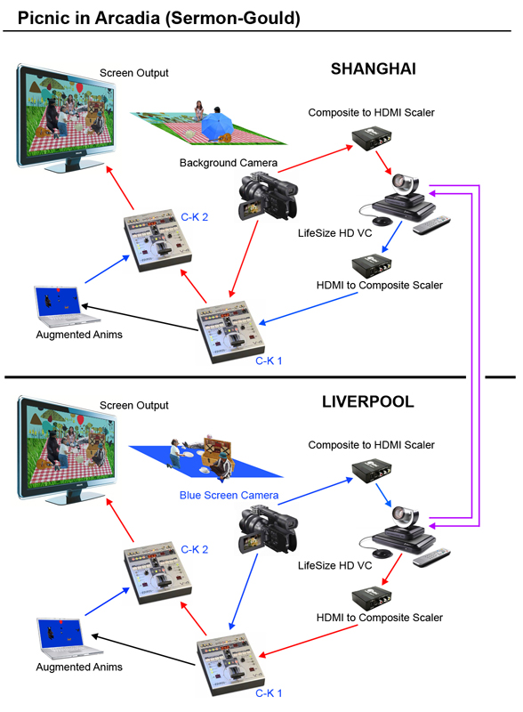
Video chroma keying sequence:

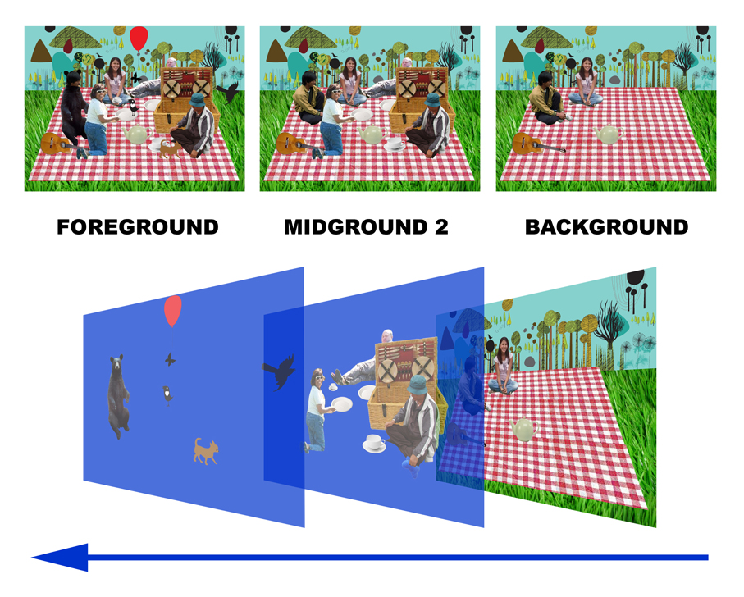
Charlotte Gould - Lecture in Digital Media

Creative Technology & Communications Research centre,
The University of Salford, Greater Manchester, UK
Email: c.e.gould@salford.ac.uk URL: http://creativetechnology.salford.ac.uk/gould/

Biography

Charlotte Gould has developed a number of web-based interactive environments that explore user identity and the notion of a floating narrative. She is currently developing location specific work in which the user becomes an active participant in the narrative and explores methods of user driven content. The work seeks to identify a counter culture, and provide an alternative aesthetic that questions the predominance of digital realism and explores the conventions and politics of embodiment in multi-user virtual environments. Through her work she encourages creative play and looks at the way the audience can experience the urban space through telepresent technology. She has undertaken illustration and animation commissions from a range of companies including the BBC and Manchester Art Gallery. She graduated with a BA Honours Degree in Graphic Design from Chelsea School of Art in 1990 and was awarded an MA in Creative Technology from the University of Salford (2003). Charlotte Gould is Programme leader of BA Honours Graphic Design at the University of Salford.



Paul Sermon - Professor of Creative Technology

Creative Technology & Communications Research centre,
The University of Salford, Greater Manchester, UK
Email: p.sermon@salford.ac.uk URL: http://www.paulsermon.org

Biography

Born in Oxford, England, 1966. Studied BA Hon's Fine Art degree under Professor Roy Ascott at The University of Wales, from September 1985 to June 1988. Studied a Post-graduate MFA degree at The University of Reading, England, from October 1989 to June 1991. Awarded the Prix Ars Electronica “Golden Nica”, in the category of interactive art, for the hyper media installation “Think about the People now”, in Linz, Austria, September 1991. Produced the ISDN videoconference installation “Telematic Vision” as an Artist in Residence at the Center for Art and Media Technology (ZKM) in Karlsruhe, Germany, from February to November 1993. Received the “Sparkey Award” from the Interactive Media Festival in Los Angeles, for the telepresent video installation “Telematic Dreaming”, June 1994. From 1993 to 1999 employed as Dozent for Media Art at the HGB Academy of Visual Arts in Leipzig, Germany. During this time continued to produced further interactive telematic installations including “Telamatic Encounter” in 1996 and “The Tables Turned” in 1997 for the Ars Electronica Centre in Linz, and the ZKM Media Museum in Karlsruhe. From 1997 to 2001 employed as Guest Professor for Performance and Environment at the University of Art and Industrial Design in Linz, Austria. Since June 2000 based at The University of Salford working primarily within the research field of immersive and expanded telematic environments.



