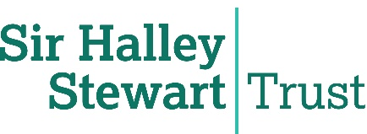


Preventing home accidents caused by children’s ignorance of GHS hazard warning signs: an interactive intervention

FINAL REPORT

Professor Tony Long
Professor Andrew Rowland
Keeley Guest
Stephen Brown

November 2022


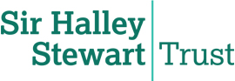

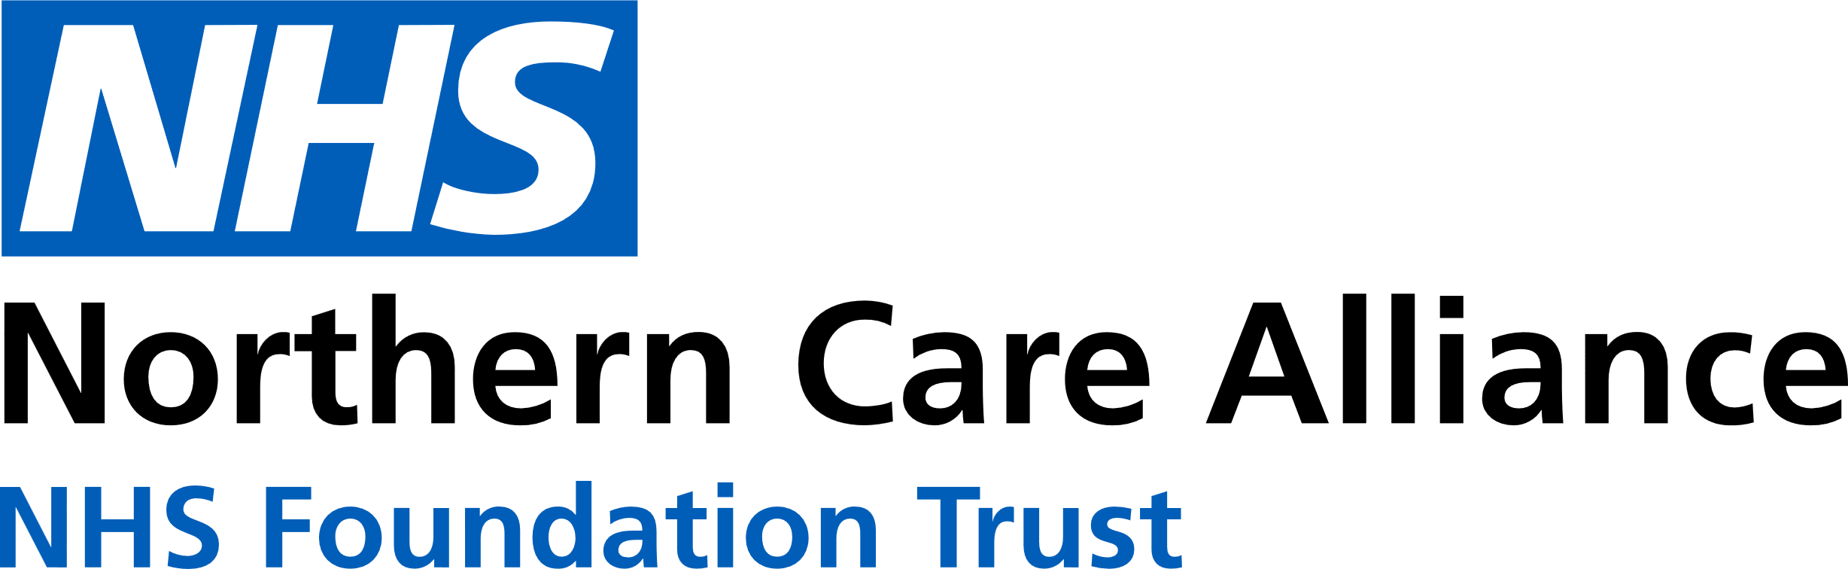

RESEARCH TEAM
Professor Tony Long ^{1,5}
Professor Andrew Rowland ^{1,2,3}
Keeley Guest ⁴
Stephen Brown ⁵

¹ University of Salford
² Community Paediatrics, Manchester Local Care Organisation
³ Manchester University NHS Foundation Trust
⁴ Staffordshire University
⁵ Northern Care Alliance NHS Foundation Trust
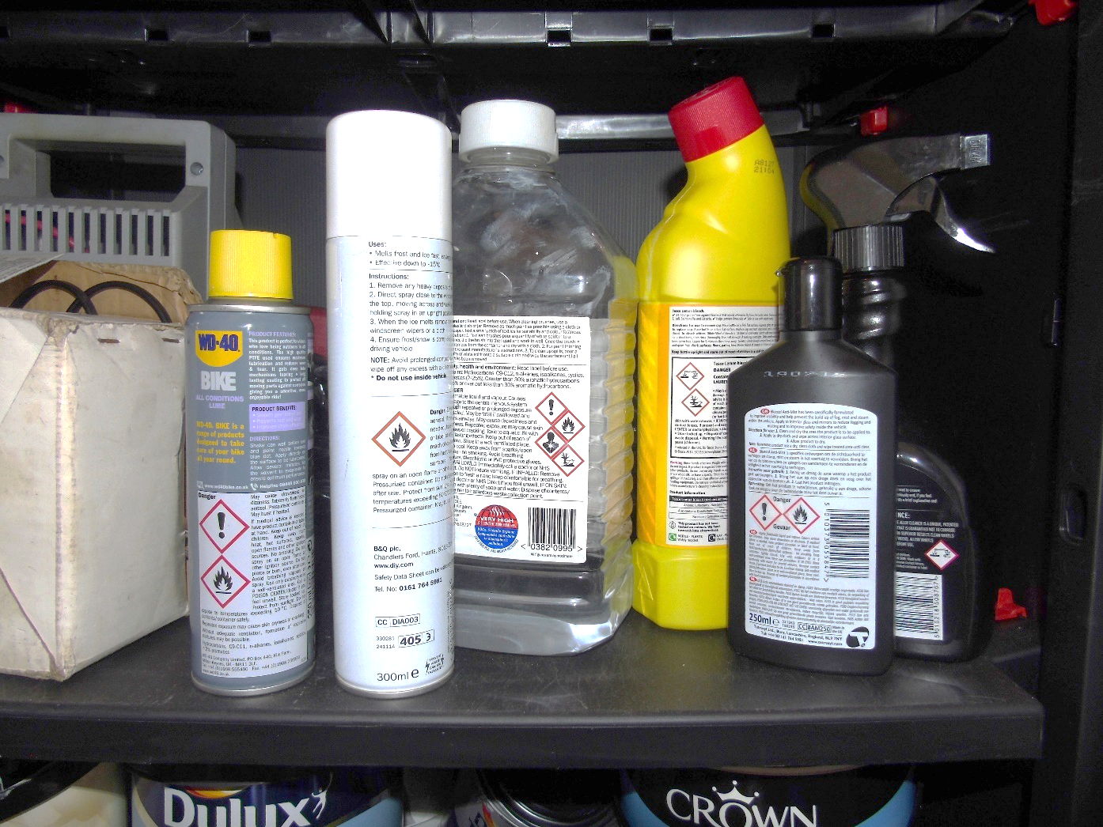
CONTENTS
 |  |  | Page
Section 1 |  | Objectives | 4
Section 2 |  | Context of the Work | 4
Section 3 |  | Preparation for This Study | 7
Section 4 |  | Recruitment and Problem-Solving | 8
Section 5 |  | Findings from the Survey | 9
5.1 |  | Demographics | 9
5.2 |  | Identifying Existing Misunderstanding | 9
5.3 |  | Results of the Final Quiz | 17
5.4 |  | Informal Feedback | 23
Section 6 |  | Objectives, Conclusions and Learning for the Next Study | 25
Appendix 1 |  | The Hard Copy Version of the Programme | 27
Table 1 |  | Age of participants | 9
Table 2 |  | Number of Incorrect Responses in the Final Quiz | 22
Figure 1 |  | Interactive Quiz on GHS Hazard Warning Signs with Children | 4
Figure 2 |  | The Mobile Research Laboratory | 5
Figure 3 |  | The Nine GHS Hazard Warning Pictograms | 6
Figure 4 |  | Scouting badges supported by involvement in the programme | 8

1. Objectives
The objectives were:
(1) To elicit understanding of hazard signs currently and as this evolves with societal changes.
(2) To promote understanding and awareness of the meaning and impact of the signs in order to keep children safe.
(3) To prepare for a larger, professionally-produced online programme across the UK and internationally through identified colleagues.

2. CONTEXT OF THE WORK

2.1 ORIGINS OF THE PROGRAMME AND PREVIOUS WORK
This workstream started with a PhD student investigating the best way to teach primary school children about hazard warning signs on household products. We continued to work on the issue, but from a public health perspective: trying to establish the misunderstandings held by children, and informing them of the actual meaning of the signs. The focus at that point was the best means to achieve this, and we found the greatest effect by taking our mobile research laboratory to primary schools to engage with children directly. We included the use of a click-voting system (Figure 1) to facilitate the participation of children in a fun way.

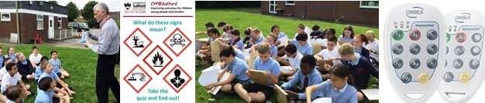
Figure 1: Interactive quiz on GHS hazard warning signs with children

2.2 LIMITATIONS OF THE PREVIOUS APPROACH
While effective, this approach was limited in scale since it was possible to include only a small number of schools with this mode of presentation (at the most two schools in one day), and these locations would need to be within easy reach of the university. A different approach was needed that retained (1) the focus on establishing current understanding first, before (2) correcting this, and then (3) encouraging safe interaction with products. For large numbers of children to be included, the route through schools was agreed to be the most efficient.
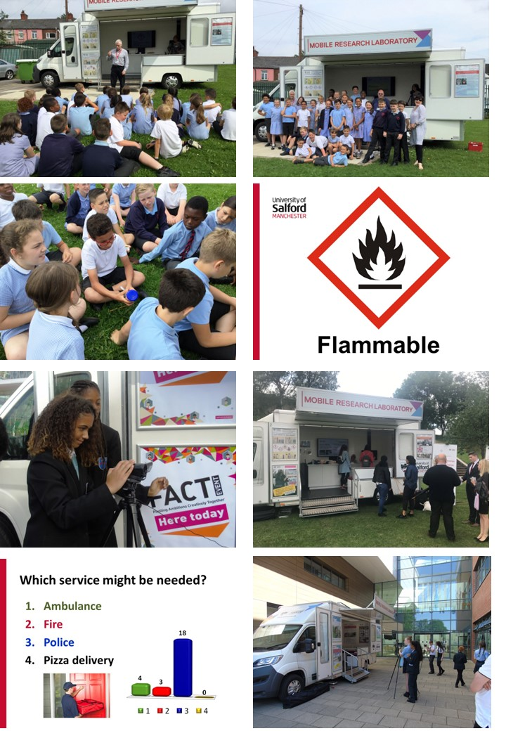

Figure 2: The University of Salford’s mobile research laboratory
The work to that point had sought only to understand and then inform. However, we also developed the desire to elicit indications of learning: to see if the intervention prompted a change in understanding. This might then lead to a change in behaviour, reducing risk and promoting safety.

A third factor was the notion that adults might be equally lacking in understanding of many of the signs. The primary prevention approach that we adopted could be made to address a whole family through the medium of parents or their carers helping their child to complete a purpose-designed programme.

2.3 PURPOSE AND FOCUS OF THIS work
We applied to the Sir Halley Stewart Trust (“the Trust”) for funding to support the development and testing of an upgraded programme to address the three factors highlighted in section 2.2. This would be more interactive in a digital sense, available to a population potentially across the UK (though starting in a single city – Salford) to test for wider reach, and it would facilitate testing for feasibility and acceptability of methods and materials. In this, it would prepare the ground for the next study, to be funded through an application to the National Institute for Health Research (NIHR). The next study would include other countries through our contact with colleagues in Cambodia, Finland, Ireland, Norway, Jordan and Saudi Arabia. Evidence of such preparatory research is essential for consideration by the NIHR.

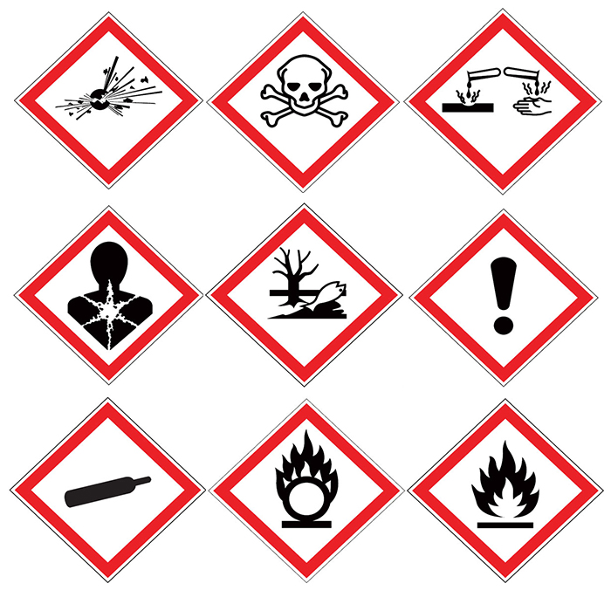

Figure 3: The nine GHS hazard warning pictograms

3 PREPARATION for THIS STUDY

3.1 DIGITALISING THE PROGRAMME

The previous analogue, in-person programme was transformed into an online format as a remote rolling programme. This online programme was hosted by one of the study partners – the Northern Care Alliance NHS Foundation Trust.

The new version had four parts: an initial quiz; a follow-up explanation; then an easy multiple choice “test”; finishing with an activity to find examples of the signs and electronically stick them in the room where they were found (“The Hazard House”). The whole programme was advised to be done by the child with an adult assisting (but not helping with the initial identification of the meaning of the signs). The Hazard House activity was explicitly for the family. A hard-copy version was also produced for families without access to the internet. These were for teachers to distribute discreetly as needed. Obviously, the video content could not be viewed, but otherwise it was the same content.

At this point we were not able to afford translation into languages other than English, but this will be addressed in the next study. In other research, particularly in the Middle East, we have made extensive use of “Back-Translation” to ensure that the intended meaning of translated documents and instruments is not corrupted. The warning signs are not accessible in real life to those without sight, or with reduced sight, (though some products carry a tactile warning triangle to advise that the product may be harmful). We invited thoughts from participants about how to make the programme accessible to more children. Other than that, some aspects were a little difficult for the youngest children to understand or follow, however no suggestions were made for improvements.

3.2 PRELIMINARY TESTING
We tested the programme online over several months with academics, researchers (nationally and internationally), parents, and others. We presented it as an item in the Economic and Social Research Council Festival of Research in November 2021. Despite some problems with slow access to the university platform that served as a portal, the feedback was entirely positive. (The portal is no longer part of the process of accessing the programme). Adults reported being surprised at how little they knew about the signs. Some of the international partners with whom we expect to conduct the next study tested the programme at this point: Maggie Eno (Co-Director & Founder of M'Lop Tapang, Cambodia); Professor Ekhlas Al-Gamal (University of Jordan, & King Saud bin Abdulaziz University for Health Sciences, Saudi Arabia); and Professor Veronica Lambert (Dublin City University). All were eager to use the programme immediately, but there is considerable work to do in preparation for this.

3.3 RESEARCH ETHICS APPROVAL
We secured research ethics approval from the university, including two amendments to allow recruitment from specific populations (Jewish schools whose families could not access the Internet and for whom the explanation of how to complete one section would not make sense; and Scout organisations). University and NHS governance processes were negotiated and compliance maintained. No unexpected ethical issues arose, and there were no incidents to report.

4. Recruitment and PROBLEM-SOLVING
The main plan to recruit from all 75 primary school in Salford via the local Council proved problematic, as there was delay beyond the Easter holiday period when we hoped families would enjoy the distraction of the programme and then it became apparent after some weeks that the initial call had been made only through a newsletter rather than a specific request to support the programme. The project team then posted copies of the materials, together with the letter to Head Teachers, directly to all of the schools. Yet there was still only one response (from an independent school), though two fully completed programmes were recorded separately from children in Salford.

Personal consultation with teachers confirmed that the “ask” was minimal – sending letters home to parents and carers – and that this ought to have been received positively. However, in the aftermath of COVID-19, the emphasis had been on remedial improvement in literacy and maths. Personal, social and emotional development (PSED) activities were focussed more on mental health, well-being and social skills – all badly affected by interrupted schooling. Together, these may have led to lack of prioritisation of the programme for parent engagement. The outcome was that parents were not offered the opportunity to take part.

Direct approaches (in person) to four more schools in other towns resulted in an enthusiastic response from a head teacher in Nottinghamshire, offering to contact three more schools in a consortium, too. A further three schools were contacted separately by the business manager of this school, but by then it was close to the summer holiday, and there were no responses.

In the earlier stages of developing the work, a version of the intervention was presented to a Beaver group (children running to a picture of an ambulance, police car, fire engine or the coastguard in response to a brief scenario). This had worked well. Accordingly, following approval of a research ethics application amendment, we took the opportunity to extend the means of recruitment from the same population of primary school children to Cub [8-10½ years] and Beaver [6-8 years] groups – rather than solely through primary schools [4½ to 11 years]. Cub and Beaver groups in Cheshire, Staffordshire, Warrington and Greater Manchester expressed a desire to be involved. This led to a further 13 responses in a short time period. More importantly, this alternative means of engaging nationally with the desired population was important learning. There are more than 7,500 Scout groups in the UK. Although somewhat fewer in number, girls in Rainbows (4-7 years), Brownies (7-10 years) and the youngest members in Guides (10-14 years) could also be targeted.

Figure 4: Scouting badges supported by involvement in the programme


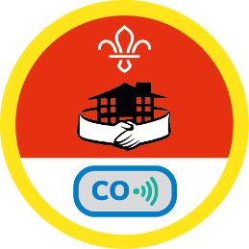
Cubs Home Safety Activity Badge
Identify the common causes of
accidents in the home.
Beavers Safety Activity Badge
Point out dangers around the home or at your meeting place.

5. FINDINGS
5.1 DEMOGRAPHICS
In total there were 47 complete responses. The following postcode areas were represented.
M7 Salford x28
OL1/2/8/9 Oldham x8
WA5 Warrington x5
FY3, FY5 Thornton-Cleveleys x2
M38 Little Hulton x2
M25 Prestwich x1
JO Jordan x1

The age range of participating children was from 4 years to 11 years (Table 1).
Table 1: Age of participants
Age | Number | %
4 | 1 | 2.1
5 | 3 | 6.4
6 | 5 | 10.6
7 | 8 | 17.0
8 | 5 | 10.6
9 | 11 | 23.4
10 | 7 | 14.9
11 | 6 | 12.8
Unknown | 1 | 2.1

5.2 IDENTIFYING EXISTING MISUNDERSTANDING
The sign indicating “Flammable” was recognised the most readily, and “Explosive” was often partially recognised. Two symbols caused dangerous misunderstanding: “Corrosive” and “Gas under pressure”. This has remained unchanged since the beginning of this programme of work a decade ago. The children generally had little idea of the meaning of a further five symbols: “Health Hazard”, “Hazardous to the Aquatic Environment”, “Toxic”, “Harmful Irritant”, and “Oxidising agent”. In these cases, many adults commented that they, too, had no previous understanding of four of these five signs.

There was commonly a default response to “Caution” for several signs; children acknowledging that there was risk or danger of some undefined nature. In itself, this may be encouraging. Remembering the exact meaning of the signs is less important than children associating them with danger and acting accordingly.
Some responses suggest that further iteration of the programme needs to link the signs more directly and obviously with containers. In face-to-face versions of the programme, examples of such containers have been incorporated, and children have had the opportunity to handle and examine a wide variety of product containers (empty or inert), but this was lost in the online version. Presenting the signs initially in a wide view of a product and then zooming in to the sign should achieve this. Video clips linking the sign to a product in use in the home could also be included.

5.2.1 Flammable
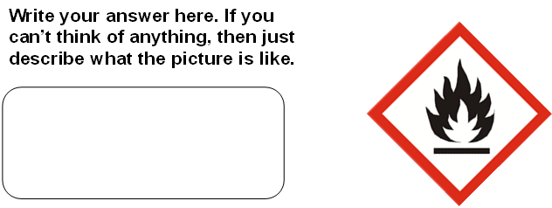
This most obvious pictogram is attached to chemicals which, when exposed to air or water, may either emit flammable gas or even self-ignite. The water-reactive hazard is generally less well-recognised.

Twenty-eight respondents recognised this as a sign of a flammable substance, often as an indicator that it was “Easy to catch fire”. A further 19 identified the symbol as warning of something associated with fire. “Inflammable” means the same as “flammable”, but the former may be mistaken as meaning “non-flammable” and so is not used in the GHS system.

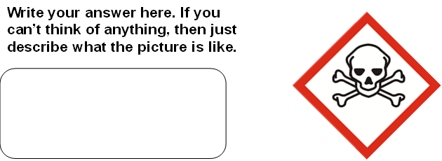
5.2.2 Toxic

The skull and crossbones pictogram is used to identify chemicals that are acutely toxic, with immediate, severe (possible lethal) impact on humans. Ingestion, inhalation or skin contact are potential routes of exposure.

Twenty respondents correctly identified this as a warning of “poison”. These were all older children. Another nine children believed it to indicate “Danger”, “Danger of death” or a “Life-threatening” substance. While the notion of danger is important, these responses all showed failure to understand the intended toxic nature of the threat (for example, that coming into contact or ingesting a small amount could result in poisoning).
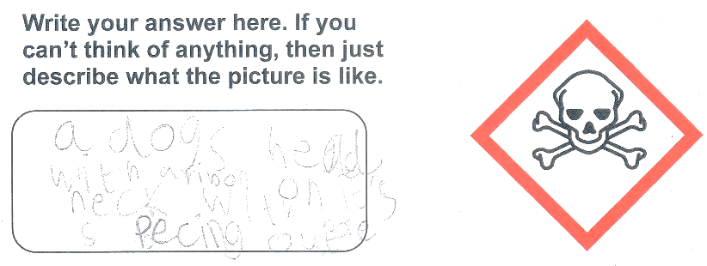
Eight children, resorting to describing what they saw in the picture focussed on “Dead people”, a “Burial place”, “Skeleton/Skull/Bones”, or a very precise Dog. [“A dog’s head with a ribbon on his neck, with its bones peeking out”]

“Pirates” has been a common answer in previous work (particularly when found on a bottle, and therefore as a “pirate drink”), but this time only six reported this. Other responses were “Drugs” (n=1), “Monster” (n=1), and “Don’t know” (n=1).

5.2.3 Explosive
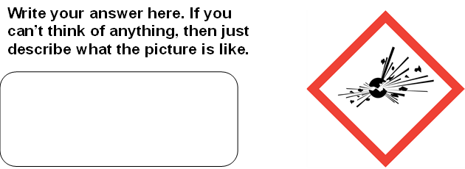

This symbol is used to label chemicals that are unstable and which may cause fire or an explosion, perhaps as a result of friction, mechanical shock or jostling. Most responses to this item were basically correct, with 19 reports of “Explosive” and eight of “Bomb” - sufficiently close for understanding in primary school children. Although not capturing the risk of an explosion, a further six children believed the sign to represent “Smash”, “Fragile” or “Glass”.

Other responses (12 in all) related to eggs cracking or pieces coming out of something (n=4); fireworks or sparklers (n=2); a volcano (n=2); and single answers of “Something boiling”, “Danger”, “Bang”, and “Pokemon Pikachu” (somewhat concerning if the contents were included in a game with other Pokemon characters). The remaining two children had no answer.

5.2.4 Health Hazard
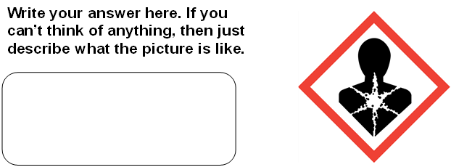
This symbol was perhaps the most confusing of all for the children (and adults). The intended meaning is that the labelled product could cause widespread, serious illness in a variety of ways, attacking multiple organs and systems over time. The material could be carcinogenic (cancer-causing), mutagenic (resulting in genetic defect), toxic to the developing fetus, or associated with chemical damage to organs.

Two responses were fairly close: “Do not swallow” and “Someone drank something not edible/safe”, though the product could be inhaled or enter the body in a variety of ways. Four children assumed that it represented a poison or toxin (one of these visualising the substances “burning your insides”).
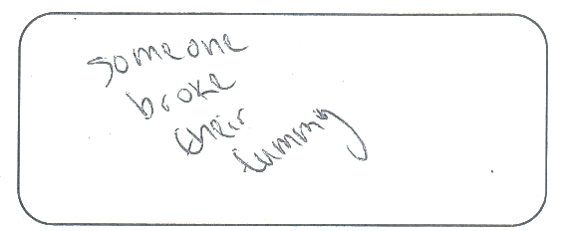
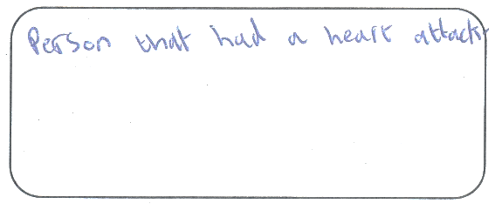
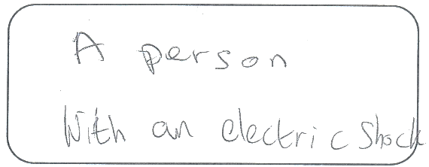
A further nine children focussed on trauma: “Heartless”, “Skin peels”, “Hole in body”, “A void”, “Crumbling”, “Injury”, “Someone broke their tummy”, “Person blowing up”, “A human being cracked”.

Two respondents considered that the sign indicated an individual experiencing an electric shock, while three more considered it to be a representation of someone suffering a heart attack. A warning of impending death was proposed by three children. Eleven responses related to general illness or harm to the body, making a person sick or unwell without any specific cause or focus. The apparent star shape in the symbol was dominant in the interpretation by five children, with some imaginative responses: “A person with a star on them”, “Skeleton with a star inside”, “Starfish holding on to a human”, “A star in the middle of a chest”, “A diamond”.

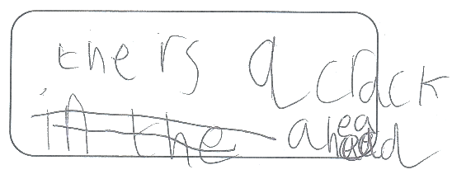
Other imaginative responses included “Person who ate too much”, “Crumbling person”, “There’s a crack ahead”, “Careful washing body”, “Wrong things can go in the wrong pipes”.

Three children had no answer.

5.2.5 Corrosive
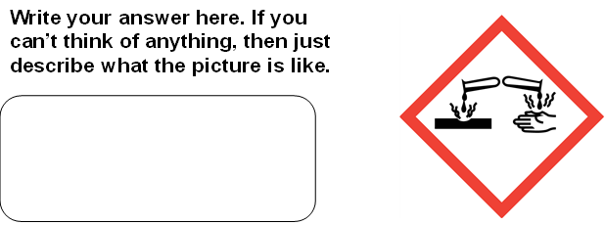
This was the symbol that caused the greatest concern for the researchers. The picture shows a corrosive substance dripping onto a metal bar and a hand, each showing erosion and fumes.
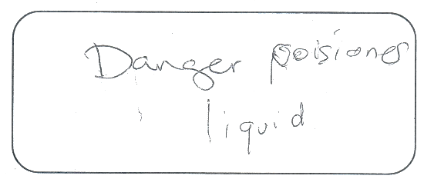
Twelve children correctly identified this as a warning relating to chemical burning: “Corrosive”, “Dangerous liquid/acid”, “Chemicals like acid”, “Do not touch. This is a chemical that can burn you.” Four others recognised a warning of a “Dangorus liukiud”, “Chemical warning”, “Danger poisonous liquid”, or “Wrong chemicals can go on your hands and infect them”.

Seven respondents mistook this for a warning of burns from fire.

Ten children failed to recognise the danger or misunderstood it completely - with potentially horrendous consequences. These perceived only water dripping or running from a tap onto a hand. They interpreted this as a sign instructing a person to wash their hands here with this substance, that there was hot and cold water, or that the taps were out of order. “Wash your hand frequently because its germs!” wrote one child, perhaps remembering COVID-19 guidance.
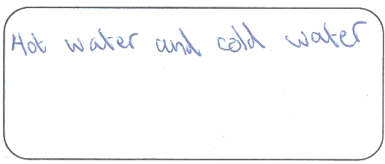
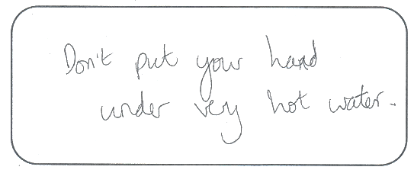
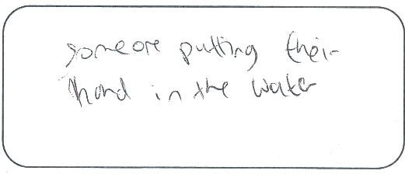

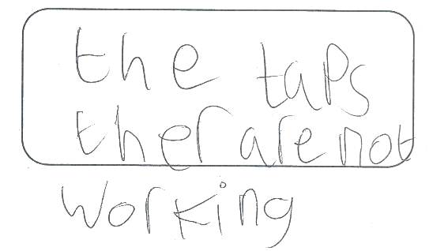
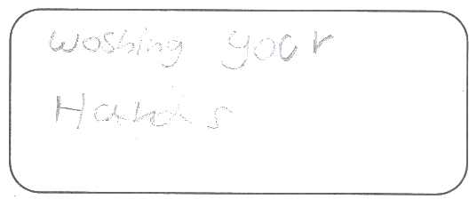
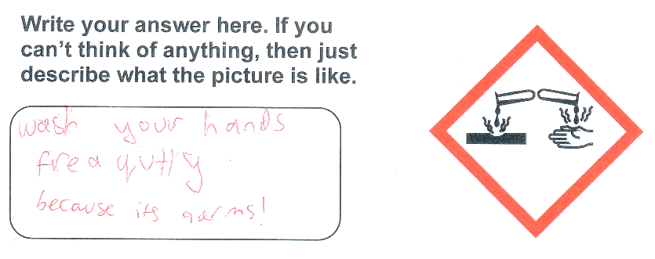

There were ten other responses describing varied or general hazards.
Science Something coming onto person hand Don't touch
Making holes A tissue playing with a hand Sensitive
Electric shocks Rubs away the skin Dangerous Skin irratant

Three children were unable to provide an answer.

5.2.6 Hazardous to the Aquatic Environment
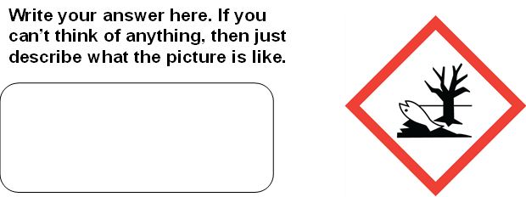
This is sole pictogram to warn of an environmental hazard. The associated chemical is toxic to aquatic wildlife and requires careful disposal to ensure that it is not released into such environments. The picture shows a dead tree and a dead fish (out of the water).

Five responses were correct or fairly well connected to danger to the environment: “Harmful to the environment”, “Pollution”, “Environmentally hazardous substance”, “Danger to environment”, and “If gets in water can kill certain animals”. A further eleven showed associated ideas.
No harmful waste products to be put in the water Poison water
Water can be full of rubbish from citizens and kill the fish Poisonous water
Something dangerous for animals Don’t dispose in water
Make animals sick or dead Danger to animals
If animals touch it, it will kill them Danger for living things
Can kill animals in water
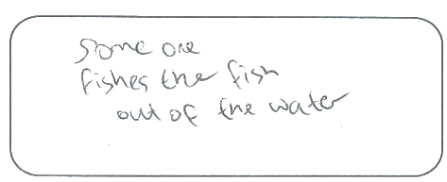
Thoughts about the fish predominated in other responses: that fish would die (n=15), that someone had caught the fish, or that the fish do not like the water.
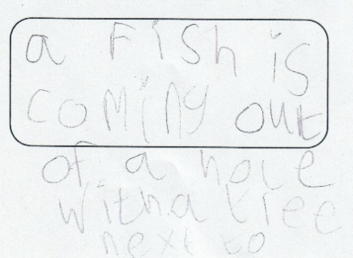

Seven children did not realise that the fish was dead, describing a number of imagined scenarios: “Fish by a bean tree”, “Fish jumping”, “A healthy fish in the water”, “A fish and a tree” (x2), “A fish is coming out of a hole with a tree next to it”.

Six other answers were incorrect, warning of deep water or drowning hazard, “Bleed in the sea”, an earthquake, or that “you can die”. Two children had no answer.

5.2.7 Gas Under Pressure
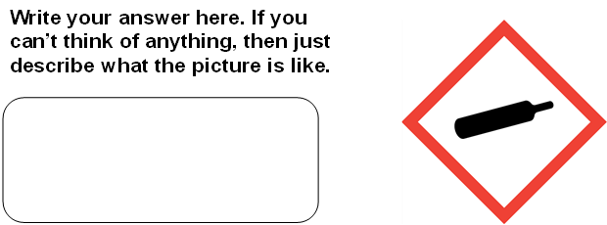

The picture of a compressed gas cylinder is a warning of the potential for an explosion if subjected to excessive heat or physical damage. The gas may be compressed, liquified, refrigerated or dissolved.

There was some understanding (n=7) of the representation of a gas cylinder (including “Vape or gas”), and of the danger of explosion (“If it cracks it could explode”, “Danger bottle can burst”).

Eight children identified this as “Alcohol” or “Wine bottle”. This has been a persistent response over the time of the overall programme. Further questioning in the face-to-face activity with the mobile research laboratory revealed that the meaning intended by children who reported “Alcohol” was that of nitrous oxide cannisters found discarded in the street or in car parks. It was not possible to clarify if this was case in the online package.
Predictably, some children recognised the shape of a cricket bat in the pictogram (n=7), making no more sense of the meaning than that “You can’t play cricket here”. Seven others associated the picture with a gun, bomb or other explosive weapon: “Dynamite”, “Bombs”, “War”, “Be careful not to touch fire button”.

Four responses were blank or “Don’t know”. A variety of other responses indicated equal lack of understanding but considerable imagination (such as the swab from a COVID-19 lateral flow test).
Batteries and it has a lot of electricity in Whistle
Smoke that can come on fire Cigarette
Rolling pin missing one handle Litter
No baking in the area Chemical
Medicine - it's dangerous to have it if you don't need it. Covid test

5.2.8 Harmful Irritant
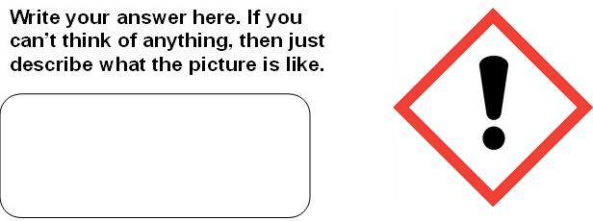

This exclamation mark pictogram is used in road signs as a general warning of “other danger”. However, in the GHS system it refers specifically to substances that act quickly to cause physical harm or irritation (particularly to the eyes, skin or respiratory tract). Such substances are less dangerous than those marked as “Toxic”.

The responses from 37 children were that this meant “Caution”, “Warning”, “Danger” or “Attention”, presumably derived from the meaning in similar road signs. A further three children simply described “an exclamation mark”.

The remaining responses were non-specific, too: Stop; Shock; Be careful; Read the label; Be aware and alert; Someone might be alarming. There were no correct responses. Comments from adults were that they, too, had not understood the meaning of the sign.

5.2.9 Oxidising Agent
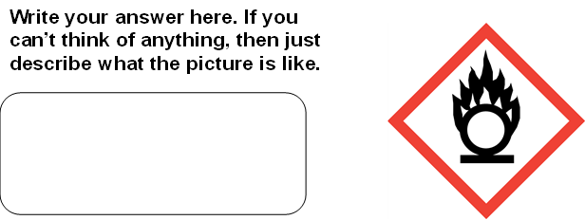

Once exposed to oxygen, oxidising agents both prompt otherwise stable substances to ignite and may make existing fires burn for longer and with increased heat. The flames in the pictogram suggest a connection with fire, but the circle and the line underneath often cause confusion.

“Flammable” was the most common response (n=29), including “They are not allowed to have a fire”, “No bonfires”, “Fire is going bigger (which can be an effect of an oxidising agent)”, and “Makes the fire extremely dangerous”.

Four children had no answer.

The remaining responses related mostly to fire or explosions, including some further imaginative perspectives.
Explosive barrles Explosion? Bomb Very hot Oxygen
The area could burn you. Head on fire Head burning A human with firey head
Put sun cream on I think it’s a sign for the trolls village

5.2.10 Conclusion from this Part of the Programme
Overall, the results of the first part of the programme confirmed that understanding was especially poor for some signs, sometimes dangerously so, though some (usually older) children were able to make sense of other pictograms. The greater imagination in children to attribute a meaning to an unfamiliar sign, and therefore to increase the risk of harm, was confirmed. While the risk indicated by some items was not recognised, there was some awareness of the general need for caution. This is important since the overall intention of the programme is to increase children’s awareness of danger when any of the signs are encountered, even if the precise meaning is not remembered.

5.3 RESULTS OF THE FINAL QUIZ
The final quiz was a test to gauge whether or not children had learned more about the meaning of the signs and the danger posed by the substance. The children were asked first to give the meaning of the sign and then to complete a simple multiple-choice question to link the sign to a statement and to reinforce the learning.

EXAMPLE
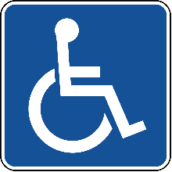
Which of these is used for writing?
What does this sign mean?

Disabled
_______________

- Umbrella
- Toothbrush
- Pencil
- Banana

1
What does this sign mean?

Flammable
_________________________________

If an accident happened where this sign was displayed, which emergency service would be needed first?

- Ambulance
- Fire and Rescue
- Police
- Coastguard

All respondents identified the pictogram correctly.

There were no wrong responses to this item.

2
What does this sign mean?

Toxic
_________________________________

If you saw this sign on a bottle, what would you do?

- Wash your face with it
- Run away
- Play pirates with it
- Don’t touch it

Two children identified this pictogram wrongly as “Death”, and one each as “Corrosive” or “Danger”. Those who entered “Death” here had originally identified the pictogram as ”Danger” and “Danger of death” indicating that they had at least retained the notion of a potentially fatal risk, though not the nature of the risk. The original suggestion for the other two responses were “Burial place” and “Pirate”. One child was clearly still confused, while the other returned the common default explanation of “something dangerous”.

One selected “Run away” (but this was still considered to be a safe option).

3
What does this sign mean?

Explosive
_________________________________

Which of these products should have this sign?

- Box of fireworks
- Lollipops
- Perfume
- Party balloons
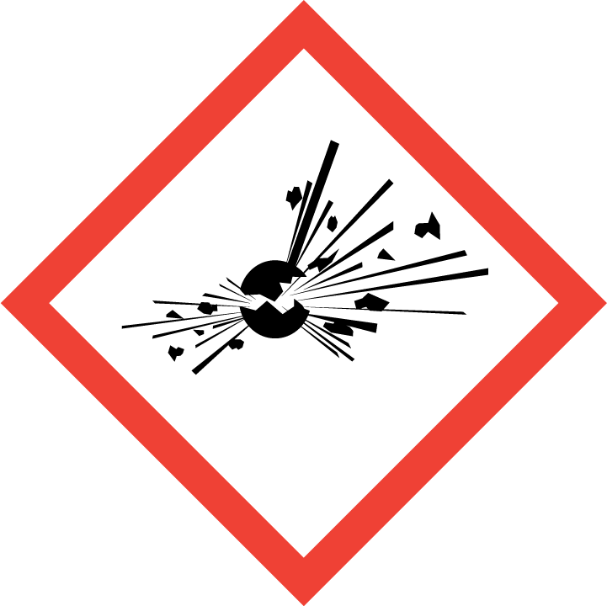

One response identified this pictogram as “Bomb”, but this was considered to be the right effect.

There were no wrong responses to this item.
4
What does this sign mean?

Health Hazard
_________________________________

Which of these is wrong?

- It means “Exploding man”
- It can make you very ill
- It could affect your breathing
- It may cause cancer
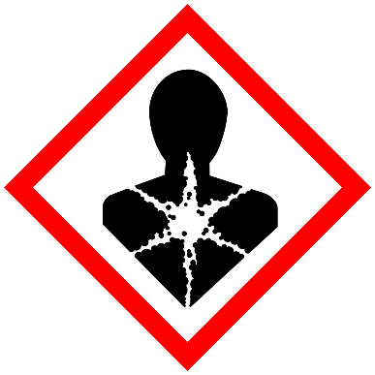

Four children identified this pictogram wrongly as “Irritant”, “Harms skin”, “Exploding”, or ”Very dangerous”.

There were four incorrect responses (not all the same children). This may have been misunderstood by the question being negatively phrased. If so, then those four intended responses would have been correct. We will avoid such questions in the next version.

5
What does this sign mean?

Corrosive
_________________________________

Which of these is corrosive?

- Pure orange juice
b) Cotton wool balls
c) Hand gel
d) Acid

Only three children identified this pictogram wrongly as “Dangerous”, “Hot”, or ”Glass will come out”.

There were three incorrect responses - all “Hand gel”. This would bear the Flammable pictogram.
6
What does this sign mean?

Hazardous to the Aquatic Environment
_________________________________

Which of these places might show this sign?

- A children’s playground
- A swimming pool
- A polluted industrial area
- A nature reserve

Two responses identified this pictogram wrongly as “Don’t litter” and a third as “A deadly thing”.

This quiz question was flawed, causing confusion. It should be replaced. (The sign would not be shown at the site but on the container holding the products.)

7
What does this sign mean?

Gas Under Pressure
_________________________________

What would something be used for if it had this sign?

- Playing cricket
- Paddling a canoe
- Holding oxygen in hospital
- Keeping tea hot

Three children identified this pictogram wrongly as “Can”, “Bat”, or ”Dangerous spray”.

“Playing cricket (x1)” (the same child as “bat”). “Keeping tea hot (x1)” with no response to the meaning of the sign. Other responses from this child were reasonable, so it was probably simply wrong rather than a mischievous response.
8
What does this sign mean?

Harmful Irritant
_________________________________

How might this substance affect you?

  - Irritate your skin with a rash
  - Make your ears fall off
  - Give you super powers
  - Give you a sun tan

Twenty-two children identified this pictogram wrongly as “Danger (x10)”, “Caution (x8)”, “Careful - allergy”, “Warning”, “Not good for the body” or “Explosive”.

“Give you super powers” (x1)”, “Give you a sun tan (x1)”. Other responses from both children were reasonable (according to our professional judgement), so these were assumed to be incorrect or a guess.

9
What does this sign mean?

Oxidising Agent
_________________________________

What can happen if this substance is mixed with other chemicals?

- It bleaches your hair
- It puts fires out
- It turns into gold
- It can start a fire
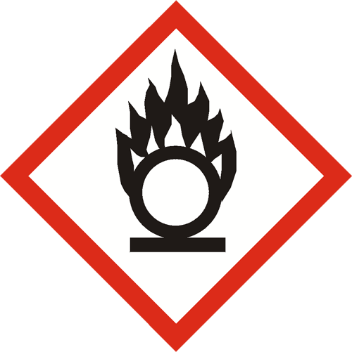

Twenty-three children identified this pictogram wrongly as “Fire / flammable”. However, four of these also expressed “Can make a fire worse” which is part of the explanation for the meaning of the sign. “Chemical fire” was not the right meaning but shows learning. The notion of a fire hazard was important for keeping children safe even if not strictly understood. “It puts fires out” was the sole wrong answer in the second part.
5.3.1 Conclusions from the Final Quiz

The final quiz showed significant learning in almost all areas. Children remained clear about the “Flammable” pictogram. Almost all responses were correct for “Explosive”, Health Hazard”, “Corrosive”, “Harmful to the Aquatic Environment”, and “Gas Under Pressure”. Although 23 were wrong about the exact meaning of “Oxidising Agent”, they all showed awareness of a fire hazard and some understanding of being more complex and dangerous than simply “Flammable”. The “Harmful Irritant” pictogram remains puzzling for the children, perhaps because of a firmly embedded understanding or “danger” or “caution” in more everyday scenarios. The multiple choice question regarding the “Hazardous to the Aquatic Environment” pictogram was flawed, so responses to this, while showing insight into the nature of the problem should be considered void. In face-to-face versions this was not a problem, but future iterations of the online programme need to use a revised question. The negatively worded multiple choice question for “Health Hazard” should also be revised for the same reason.

Table 2: Number of incorrect responses in the final quiz

SIGN | Number of incorrect meaning of pictogram | Number of incorrect responses to multiple choice
Flammable | 0 | 0
Toxic | 4 | 1
Explosive | 1 | 0
Corrosive | 3 | 3
Health Hazard | 4 | 4
Hazardous to the Aquatic Environment | 3 | Void
Gas Under Pressure | 3 | 2
Harmful Irritant | 22 | 2
Oxidising agent | 23 | 1

5.4 INFORMAL FEEDBACK

Comments were invited from parents, children and teachers to help the researchers to improve the programme. While meant to be enjoyable, the programme was designed to identify mistaken perceptions of the signs and to improve understanding of hazards - with the ultimate aim that children would react more safely to relevant substances.

“This quiz was very informative for myself and children! Many thanks.” (Parent)

“Thank you so much. It was so much fun!” (Child)

“My older son (11 years old) was so interested and just submitted his response. His feedback is that he enjoyed it and learned more about hazards.” (Parent)

“A couple of people did mention they thought it was quite difficult for the younger children. But otherwise the feedback was that they enjoyed doing it, and was nice to be part of your research.” (Teacher)

“That was brilliant. Neither of us knew what some of them meant at all. We enjoyed doing the Hazard House hunt. I’ve moved some bottles now!” (Parent)

“From the students who completed it, we had some lovely feedback – they enjoyed doing the quiz and many found it very helpful.” (Teacher)

“They are very common hazard warning signs that are on loads of stuff in the kitchen cupboard – but I didn’t know all that ‘til we did the Hazard House.” (Parent)

“My daughter completed it, she and even I did not even know them all. She thought the gas cylinder was a bottle of wine or cricket bat! What a great idea to make this into a quiz. Thank you!” (Parent)

There were no suggestions about how to make the programme accessible to more sub-populations (such as those with special educational needs or disability) but one of the researchers is a trustee at a charity for children with special educational needs and disability, and this avenue can be pursued before the next iteration of the project.

Informal feedback from colleagues in other countries is that the programme will transpose well, mostly without changes or translation. However, Arabic and Khmer versions could be prepared by these partners.

6. OBJECTIVES, CONCLUSIONS AND LEARNING FOR THE NEXT STUDY

(1) To elicit understanding of hazard signs currently and as this evolves with societal changes.
Current understanding and misunderstanding was established, with confirmation of some previously identified confusion but with continued influence of societal problems, from discarded nitrous oxide canisters to COVID-19 swab tests.
(2) To promote understanding and awareness of the meaning and impact of the signs in order to keep children safe.
There was remarkable learning (at least in the immediate term) on all but one of the pictograms. Overall, there was increased appreciation of the message that all of the signs indicated danger, usually with insight into the nature of the risk. Parents (or carers), too, expressed surprise at their gap in knowledge, prompting action to reduce exposure to harmful substances.
(3) To prepare for a larger, professionally-produced online programme across the UK and internationally through identified colleagues.
The learning from this study has been significant and varied, and this learning will be invaluable in preparing the application for an NIHR research grant.

The risk of recruiting through local authorities
With the impacts of the loss of schooling during the pandemic expected to be felt for years rather than for months, the strategy of recruitment primarily through schools via Local Authorities is a major risk. Establishing partnerships with a number of academy groups (particularly with a national portfolio) or other consortia should be a precursor to the next study. Similarly, formal collaboration with independent schools and faith school affiliations may prove fruitful.

Finding the right officer in schools (rather than the head teacher) – with a role in parent engagement or school management – may also prompt a more positive response, together with a snowball sampling effect through networks with others in similar posts. Including such an individual as a co-applicant in the next grant would be beneficial.

Partnership-building with other organisations serving this age group such as Scouts (Cubs and Beavers) could offer greater reach in sampling with longer-term potential for follow-up studies. Corresponding organisations for girls (Guides, Brownies, and Rainbows) should be explored to avoid gender bias. Formal arrangements with the central authorities for these should be established.

The use of social media to advertise widely should be reconsidered. This would require collaboration with existing parent-focused groups. Appearance on regional TV to talk about the programme with taster activities should also prompt interest to engage without third party brokering.
The unexpected failure of the primary recruitment mode was a major setback, but even this allowed for contingency planning for the next study as well as contact with bodies that could provide alternative access to the target population. Those who completed the programme found it valuable, fun and informative, so the key issue is to ensure that parents have access to the programme and are persuaded to investigate it. This message needs to be conveyed at the point of decision by potential participants to promote commencement of engagement – which is then usually maintained.

Addressing new problems associated with remote versions of the programme
The disconnection between the containers bearing the signs and the danger posed had not been anticipated. The impact of viewing and handling such containers in previous face-to-face versions had not been obvious. Similar learning about hard copy versions for those without internet access was valuable. Strategies to recreate this link will be incorporated.

The Hazard House
Additional help may be needed to prompt the location of more examples of hazardous substances throughout the place where children live. Those who completed this part and provided feedback indicated that it was both enjoyable and educational, but there was clearly a failure to find many common items that were expected to be there. Some items which had seemed obvious to the research team were often overlooked. This misses the opportunity for immediate safety action by parents. We should provide more clues about where to look and what to look for in order to maximise the impact. Digital searching by virtual opening of cupboard doors to reveal items may be incorporated.

Age-Appropriate and Developmentally-Appropriate Differentiation in Presentation
Two versions may be needed for younger and older primary school children, reducing the amount of text and increasing interactive aspects of the programme with sorting true/false statements, drawing lines to connect the correct object with the corresponding pictogram, and so on. Some of this will be more feasible in a professionally-produced package. This strategy should also facilitate inclusion of differently-abled children and those with special educational needs.

Research Ethics Committee Approval
Negotiation with the research ethics committee to provide even shorter, simpler Participant Information Sheets (including sample images) could influence uptake by parents and carers once organisations have introduced the programme. We may need to review the amount of text to be read and entered by parents and carers, too, replacing some aspects with more visual digital activities.
Partnerships for the Next Iteration
International partners have been identified and recruited in Cambodia, Ireland, Saudi Arabia, Jordan, Finland and Norway. Additional university and public health partners have been sounded out successfully in other countries in the UK. Most of these have tested the programme personally and with children, and they are keen to be involved.

6.1 THE CONTRIBUTION OF THE GRANT FROM THE TRUST

The grant from the Sir Halley Stewart Trust has facilitated exploration of the means to take the programme to a far wider target population, identifying problems and solutions to the necessary new means of presentation for large scale impact. It has prompted robust alternative planning for the unforeseen (such as the lingering effect of loss of formal schooling during the pandemic on recruitment).

- We have developed alternative recruitment strategies to secure access to the target population should recruitment directly through schools continue to be problematic.

- We have identified the need for an easier version for younger children and those with special educational needs, together with suggested means to operationalise this.

- We have (re-)discovered the importance of tangible association of the signs with relevant containers and the need for alternative means to achieve this remotely.

- We know that more help is needed to identify likely locations and types of products in the Hazard House activity in order to reinforce learning in the family and to maximise immediate parental action.

- We appreciate the need to negotiate with the Research Ethics Committee for even shorter, simpler information sheets, though this will be challenging. However, we will have the support of additional teaching professionals in this.

- We understand the challenges of making hard-copy versions comparable to the online programme in terms of experience, and have new partners who are willing to support us in this.

- We have identified organisations from which to recruit new co-applicants for the next grant to ensure even wider expertise in the team and access to networks for recruitment. Key individuals nationally and internationally have also made an enthusiastic commitment to support the next programme.

Although feedback from other funders of large grants was minimal, it was hinted that additional preliminary work was considered necessary first. The formal preparatory work supported by the Trust is essential for application to the NIHR for a series of grants of between £150,000 and £350,000 to establish the effectiveness of the method and then the longer-term outcomes in terms of children’s safety.

APPENDIX 1: THE HARD COPY VERSION OF THE PROGRAMME

A hazard warning signs interactive
quiz for primary school children

A hazard warning signs interactive quiz for primary school children
TOP
SECRET
Workbook V1

Welcome and Consent

Thank you for reading the information about this programme and allowing your child to complete the quiz and associated activities. Accidental poisoning in young children is a major problem, and we hope to make a difference through this work.

Please remember that you can help your child to understand the instructions (and read any text to them), but try not to give them clues or hints about the meaning of the signs.

The activity has four parts.

(1) First we will show you nine hazard warning signs that are found on common household goods and ask your child to write what the signs mean. Through this we learn how young children can misunderstand the signs and be prone to injury.

(2) Then we show the signs again with the real meaning and an explanation of what the danger is. It is helpful for you to discuss this part with your child.

(3) A fun (easy) test to see how much your child remembers and to reinforce the learning.
(4) Finally, you can complete the hazard house hunt to find some of the symbols on products where you live. If you like you can send us your picture of what you found.

Completing this paper copy of the programme, ticking in the space below, and returning the booklet to the researchers will confirm that you agree to take part in this research study by the university of Salford.

I consent to my child to completing this programme [ ] (tick)

The next page is the start of the programme. There are 9 signs in total.

What do these signs mean? For each one, write what you think in the space. If you don’t know, just describe the sign.
Write your answer here. If you can’t think of anything, then just describe what the picture is like.

Write your answer here. If you can’t think of anything, then just describe what the picture is like.

Write your answer here. If you can’t think of anything, then just describe what the picture is like.

What do these signs mean? For each one, write what you think in the space. If you don’t know, just describe the sign.
Write your answer here. If you can’t think of anything, then just describe what the picture is like.
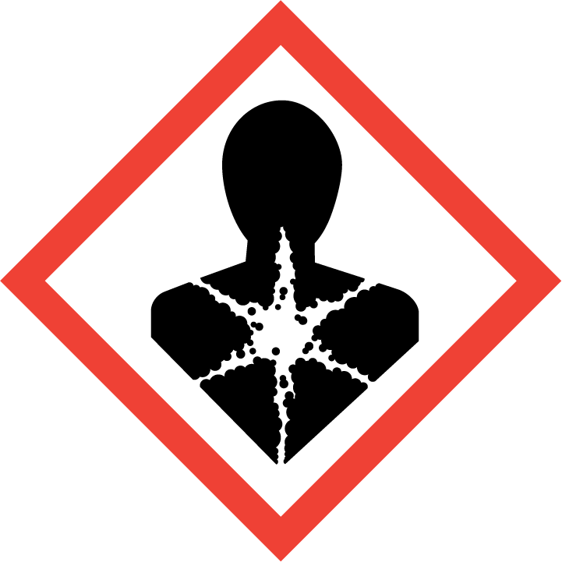

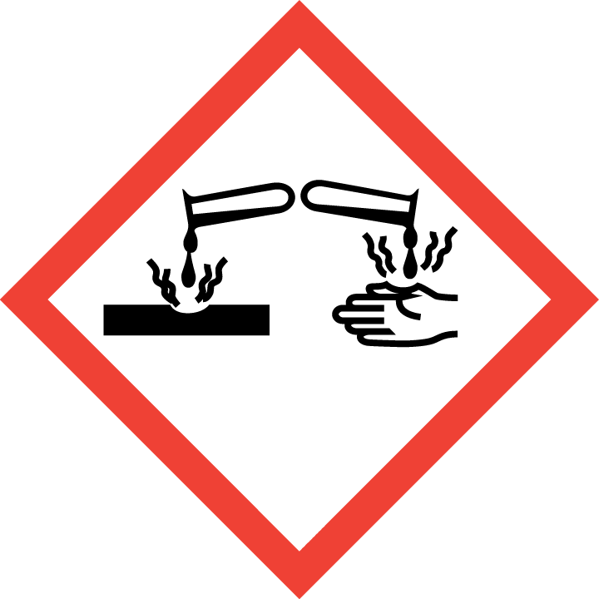
Write your answer here. If you can’t think of anything, then just describe what the picture is like.

Write your answer here. If you can’t think of anything, then just describe what the picture is like.
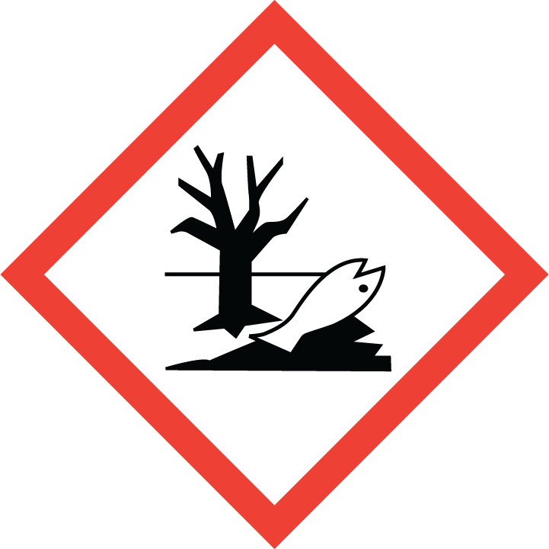
What do these signs mean? For each one, write what you think in the space. If you don’t know, just describe the sign.
Write your answer here. If you can’t think of anything, then just describe what the picture is like.
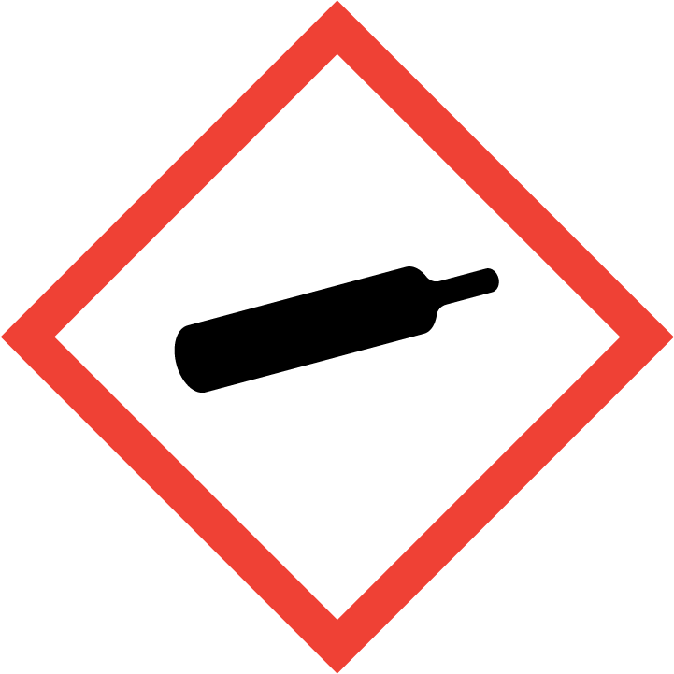

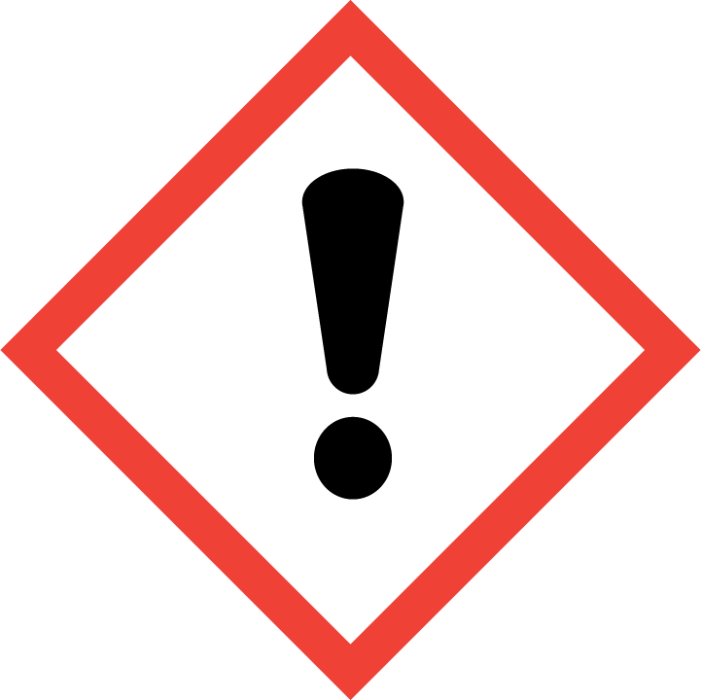
Write your answer here. If you can’t think of anything, then just describe what the picture is like.

Write your answer here. If you can’t think of anything, then just describe what the picture is like.
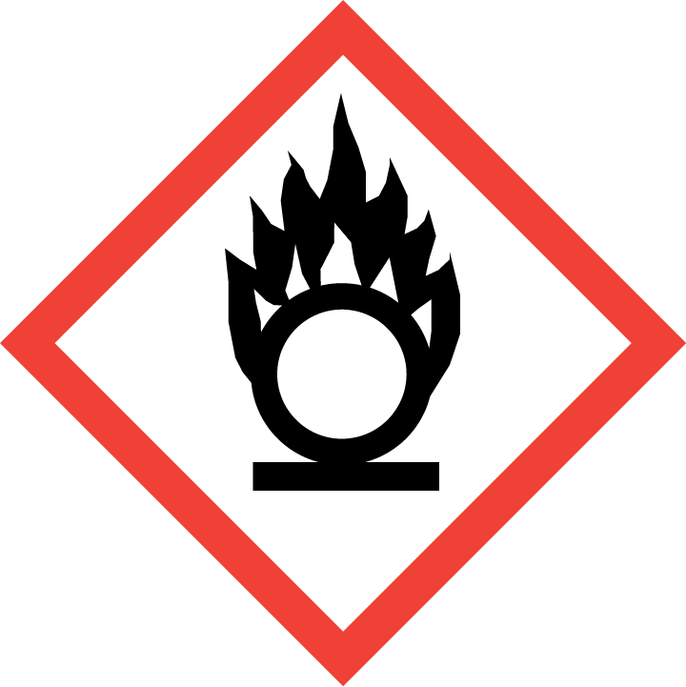
We hope that you enjoyed the quiz. These were the signs that you saw. The last two here look quite the same, but they are a bit different, really.

The real meaning of the mystery signs!
Now we will show you the signs again and explain what they mean.

We will tell you what danger they warn about!

Parents: please feel free to talk about these explanations with your child. It is OK to move backwards and forwards through this section.

Children: you can look at the pictures as many times as you like.

Flammable

You probably got this one right.
This can set on fire easily.
A match or a spark could do this.
Then this could burn you.
It could be petrol, or nail polish, or hand sanitizer.

Oxidizing Agent

This can make a fire much worse.
It can start a fire without heat or a flame.
Mixing this with another chemical can cause a fire to start.

Explosive

This could explode!
BOOM!!
It might explode if…
…it gets too hot, or
…if it is bumped hard, or
…if it is squashed.

It could be a chemical.
It might be in an aerosol.
It could be a firework.

Health Hazard
This sign is often shown with 3 others.

It’s not an exploding person!
It means that this could make you very ill in lots of ways.
It might cause cancer.
It could damage your lungs so you
can’t breathe.
It could cause damage inside your body.

Toxic

“Toxic” means poisonous!
Poison could get into your body by…
…drinking it,
…eating it,
…breathing it in, or
…just spilling it on your skin.

Corrosive
Something that is corrosive burns into skin and even into metal. It can make you blind. It is in lots of chemicals:
…bleach
…car cleaner foam
…drain cleaner
…oven cleaner.
It may even be acid! Button batteries can be corrosive if swallowed.

Button batteries are all over the house! The Child Accident Prevention Trust has more resources like this: https://www.capt.org.uk/

Hazardous to the Aquatic Environment

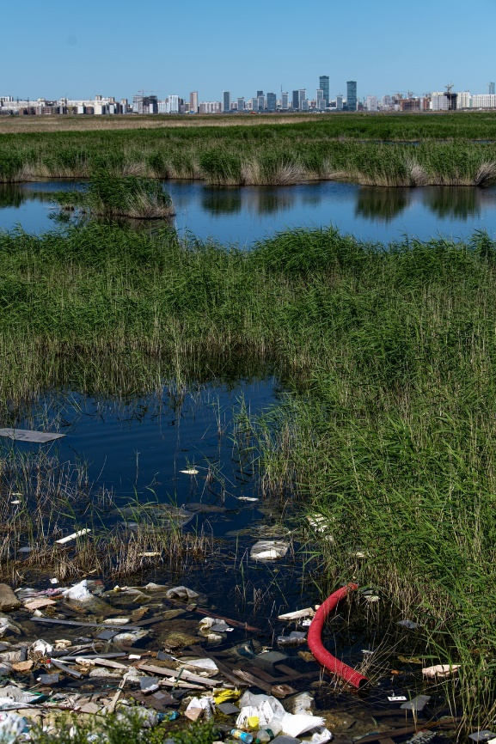
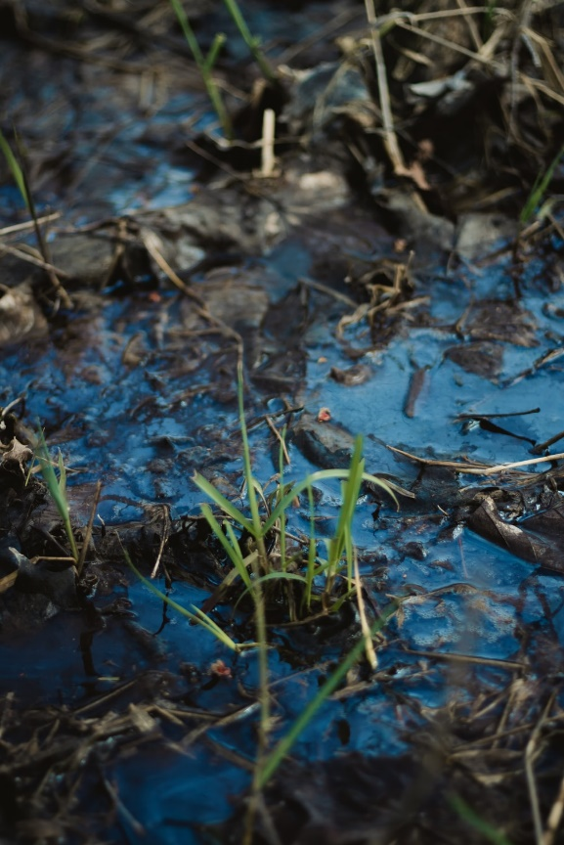
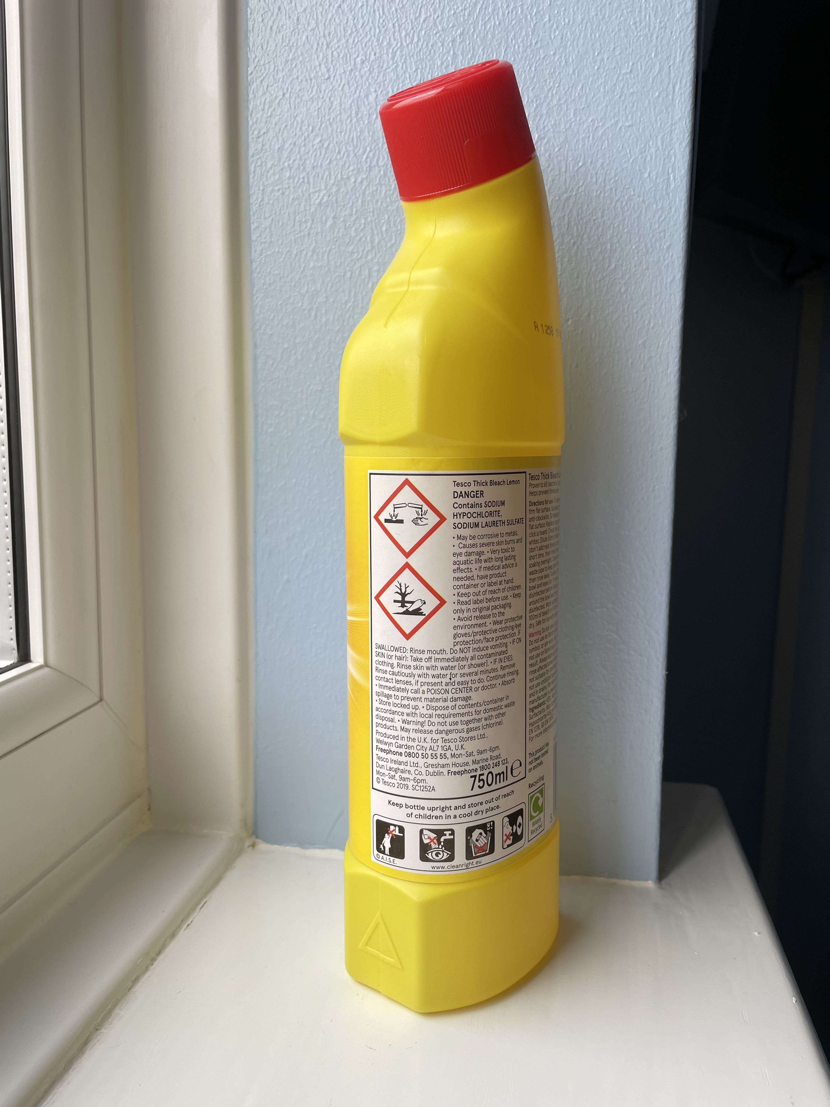
If this gets into the water
it kills animals, fish and plants.

These can all cause this damage…
…paint thinner,
…bleach,
…pesticide (insect killer),
…pollution from rubbish, or
…chemicals from factories.
Gas under Pressure
No. It’s not a cricket bat!
It’s not a wine bottle.

This is a picture of a gas container. The gas inside has been forced in.

Cracking, squashing, or heating the container can cause it to explode. It could also set on fire.

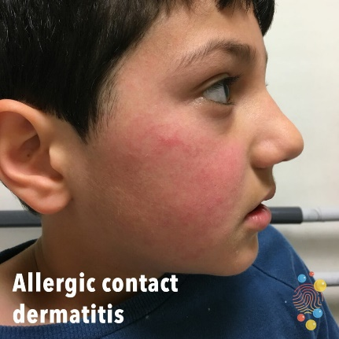
Harmful Irritant

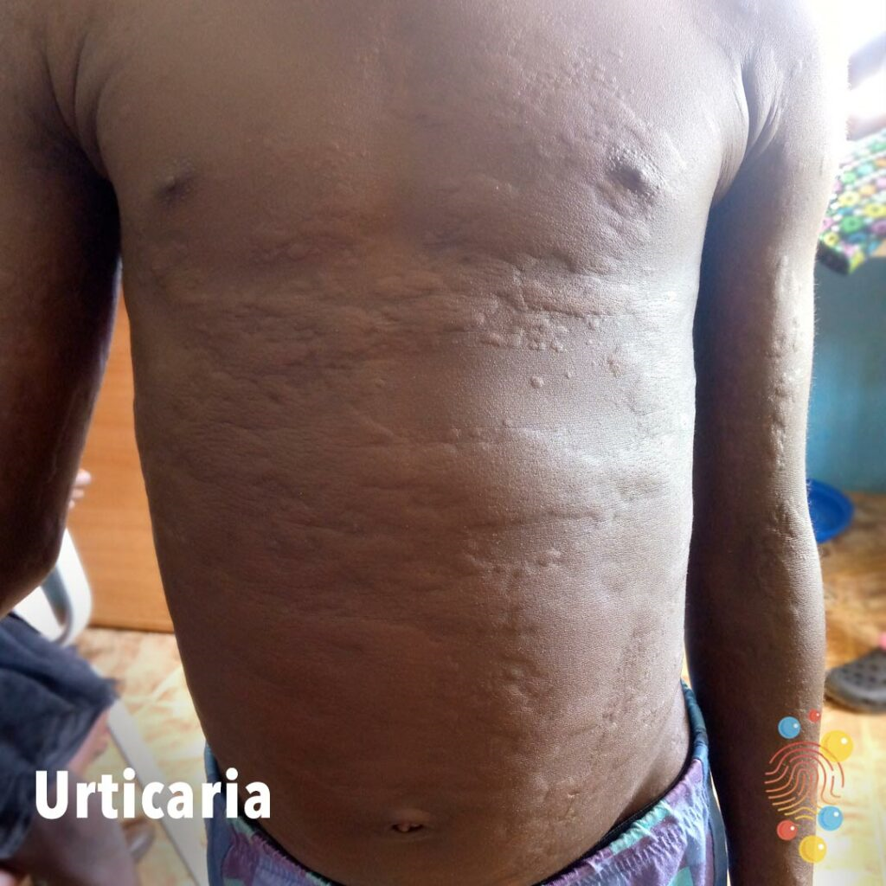
Pictures from
Skin Deep
https://dftbskindeep.com/
Getting this onto your skin, or into your eyes, or breathing it in would cause a rash, or stinging, or trouble breathing.
This sign is on lots of containers: hand gel, bicycle chain oil, deodorant, and washing up liquid.
These boys have been in contact with an irritant.
Great. Now it's time to test yourself on what you have learnt!
This should be fun. No cheating, now.
Write what the sign means (in your own words) and circle the right answer. If you don’t know, it does not matter. Have a go.

Parents: Please don’t help until your child has selected a response. We want to find how much is remembered. You can discuss the right answer once they have chosen.

Children: This should be fun, so don’t worry if you pick some wrong answers.

EXAMPLE
Which of these is used for writing?
What does this sign mean?

Disabled
_______________

- Umbrella
- Toothbrush
- Pencil
- Banana

1
What does this sign mean?

_________________________________

If an accident happened where this sign was displayed, which emergency service would be needed first?

- Ambulance
- Fire and Rescue
- Police
- Coastguard

2
What does this sign mean?

_________________________________

If you saw this sign on a bottle, what would you do?

- Wash your face with it
- Run away
- Play pirates with it
- Don’t touch it

3
What does this sign mean?

_________________________________

Which of these products should have this sign?

- Box of fireworks
- Lollipops
- Perfume
- Party balloons

4
What does this sign mean?

_________________________________

Which of these is wrong?

- It means “Exploding man”
- It can make you very ill
- It could affect your breathing
- It may cause cancer

5
What does this sign mean?

_________________________________

Which of these is corrosive?

- Pure orange juice
b) Cotton wool balls
c) Hand gel
d) Acid

6
What does this sign mean?

_________________________________

Which of these places might show this sign?

- A children’s playground
- A swimming pool
- A polluted industrial area
- A nature reserve

7
What does this sign mean?

_________________________________

What would something be used for if it had this sign?

- Playing cricket
- Paddling a canoe
- Holding oxygen in hospital
- Keeping tea hot

8
What does this sign mean?

_________________________________

How might this substance affect you?

- Irritate your skin with a rash
- Make your ears fall off
- Give you super powers
- Give you a sun tan

What does this sign mean?

_________________________________

What can happen if this substance is mixed with other chemicals?

- It bleaches your hair
- It puts fires out
- It turns into gold
- It can start a fire
9

Well done! You have finished. Was the test fun?
It doesn’t matter if you can’t always remember all of the signs. You know that if there is one of them on something, then there is DANGER!
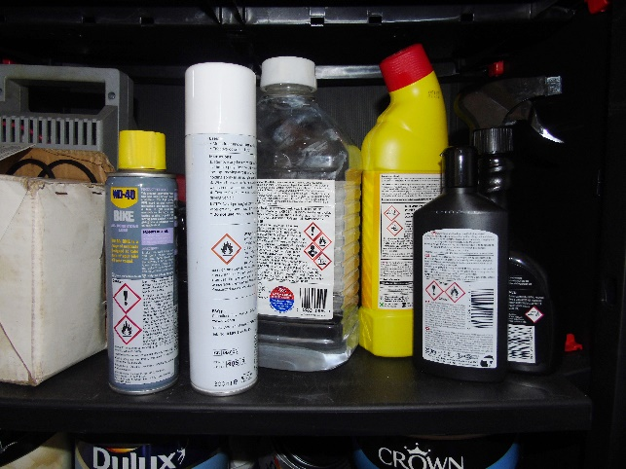

There’s just one thing left.
You must proceed to The Hazard House!

Homework Time!
(Don’t worry – you will enjoy this homework.)

It’s time to explore round where you live to see how many of these signs you can find.

With the adult who is helping you, and with anyone else in the house, too, look in the bathroom, the kitchen and any other rooms. Remember that is it dangerous to touch some of these products. Take this booklet with you and complete the Hazard House map by drawing or writing in the signs that you found in each place. You can change the name of the room if you like.
Shed/Garage
Bathroom
Kitchen

Living room
Bedroom

The Hazard House: Find and Record

That’s all. The programme is finished. We hope that you enjoyed it.
Please remember to return the completed booklet to the teacher at the school. It is important that we learn from all of the children who take part.

Thank you for taking part. Your responses will help us to guide future messages for young children (and adults) about staying safe.
Contact details for the research team:

Dr Tony Long Dr Andrew Rowland
Professor of Child & Family Health Hon Professor (Children’s Rights, Law and Advocacy)
University of Salford University of Salford
SALFORD SALFORD
M5 4WT M5 4WT

t.long@salford.ac.uk a.rowland@salford.ac.uk

This work was supported by a grant from the Sir Halley Stewart Trust, and also by:
The Royal College of Emergency Medicine
The Royal College of Paediatrics and Child Health
Kidscan
With material from The Child Accident Prevention Trust

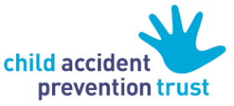
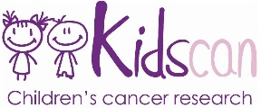
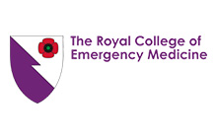
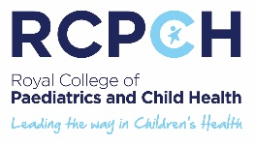

© University of Salford 2022

Long T, Rowland AG, Guest K, Brown S (2022) Final Report: Preventing home accidents caused by children’s ignorance of GHS hazard warning signs: an interactive intervention. Salford (UK): University of Salford. ISBN: 978-1-912337-89-7

This report includes independent research funded by Sir Halley Stewart Trust. The views expressed in this publication are those of the authors and not necessarily those of the Trust.

© University of Salford and Sir Halley Stewart Trust 2022

