Investigation into the Antimicrobial Properties of Metal-coated Surfaces Against the Transmission of Infection.
By Kelsey Broadbent

Table of Contents
Table of Contents 2
List of Tables 5
1 Introduction 7
1.1. Introduction to Antibiotics 7
1.2. Antibiotic Resistance 8
1.3. Mechanisms of AMR (Table 1.1) 9
1.4. ESKAPE Pathogens 10
1.4.1. Enterococcus faecalis 10
1.4.2. S. aureus 11
1.4.3. K. pneumoniae 11
1.4.4. A. baumannii 11
1.4.5. P. aeruginosa 12
1.4.6. Enterobacter spp. 12
1.5. The Role of Biofilms in AMR 13
1.6. Antimicrobial Properties of metals 14
1.7. Metal Surface Coatings to Reduce Environmental Survival of ESKAPE pathogens. 14
1.8. Chemical Vapour Deposition (CVD) 15
2. Aims and Objectives 15
3. Materials and Methods 18
3.1 Initial Cultivation of Bacterial Strains 18
3.1.1. Preparation of Bacterial Suspension and Inoculation of Inert Agar 18
3.1.2. Bacterial Transfer 19
3.2. Clinical Sample Collection – University of Salford Podiatry Clinic 21
4. Results 23
4.1. Survivability and Transmission rates of Lab Strains on CVD Sample squares after Bacterial Transfer 23
4.1.1. E. coli (ATCC 25922) 23
4.1.2. S. aureus (ATCC 29213) 30
4.1.3. K. pneumoniae (ATCC 700603) 36
4.1.4. A. baumannii (ATCC 19606) 42
4.1.5. P. aeruginosa (ATCC 27853) 48
4.1.6. E. cloacae (ATCC 13047) 54
4.1.7. E. faecalis (ATCC 29212) 60
4.1.8. Graphs Containing Collated Data from Each Bacterial Species 65
4.2. Real-World Swab Data 70
4.2.1. Set 1 – Clinical Isolate data (Patient Booth) 70
4.2.2. Set 2 – Clinical Isolate Data (Clinic Reception) 71
4.2.3. Overall Distribution of Clinical Isolate Cell Characteristics 75
5. Considerations and Conclusions 77
Bibliography 85
3.2 Lawn Plate and CFU Transmission Yield Calculations 105
^{3.2.1} 1.71*10⁵/ 6361.725 = 26.88CFU/mm² 105
^{3.2.2} 1.2*10⁶/ 6361.725 = 188.63 CFU/mm² 106
^{3.2.3} 1.35*10⁶/ 6361.725 = 212.21CFU/mm² 106
^{3.2.4} 1.62*10⁵/ 6361.725 = 25.46CFU/mm² 107
^{3.2.5} 5.7*10⁵/ 6361.725 = 89.6CFU/mm² 107
^{3.2.6} 1.03*10⁶/ 6361.725 = 161.91CFU/mm² 108
^{3.2.7} 1.47*10⁶/ 6361.725 = 231.1CFU/mm² 108

List of Tables

Table 1.1 Summary Table for Antibiotic Classification, Mechanism of Action, Target Bacteria, and Antibiotic Resistance Mechanisms 6
Table 4.1 Results Matrix of p-values from One-Tailed Mann-Whitney analysis of each Coated Surface on Brushed Steel against E. coli 24
Table 4.2 Results Matrix of p-values from One-Tailed Mann-Whitney analysis of each Coated Surface on Borosilicate Glass against E. coli. 27
Table 4.3 Results Matrix of p-values from One-Tailed Mann-Whitney analysis of each Coated Surface on Brushed Steel against S. aureus 30
Table 4.4 Results Matrix of p-values from One-Tailed Mann-Whitney analysis of each Coated Surface on Borosilicate Glass against S. aureus. 33
Table 4.5 Results matrix of p-values from One-Tailed Mann-Whitney analysis of each Coated Surface on Brushed Steel against K. pneumoniae 36
Table 4.6 Results matrix of p-values from One-Tailed Mann-Whitney analysis of each Coated Surface on Borosilicate Glass against K. pneumoniae 39
Table 4.7 Results matrix of p-values from One-Tailed Mann-Whitney analysis of each Coated Surface on Brushed Steel against A. baumannii 42
Table 4.8 Results matrix of p-values from One-Tailed Mann-Whitney analysis of each Coated Surface on Borosilicate Glass against A. baumannii 45
Table 4.9 Results matrix of p-values from One-Tailed Mann-Whitney analysis of each Coated Surface on Brushed Steel against P. aeruginosa 48
Table 4.10 Results matrix of p-values from One-Tailed Mann-Whitney analysis of each Coated Surface on Borosilicate Glass against P. aeruginosa 51
Table 4.11 Matrix of p-values from One-Tailed Mann-Whitney analysis of each Coated Surface on Brushed Steel against E. cloacae 54
Table 4.12 Results matrix of p-values from One-Tailed Mann-Whitney analysis of each Coated Surface on Borosilicate Glass against E. cloacae 57
Table 4.13 Matrix of p-values from One-Tailed Mann-Whitney analysis of each Coated Surface on Brushed Steel against E. faecalis 60
Table 4.14 Matrix of p-values from One-Tailed Mann-Whitney analysis of each Coated Surface on Borosilicate Glass against E. faecalis. 62
Table 4.15 Table to show the Clinical Isolate data record for Coated Sample board located in a patient booth within the Salford Podiatry Clinic. 68
Table 4.16 Table to show the Clinical Isolate data record for Coated Sample board located in the reception area located within the Salford Podiatry Clinic. 69
Table 3.1 E. coli (ATCC 25922) survival rates on CVD coated borosilicate glass surfaces using modified x ISO protocol 93
Table 3.2 S. aureus (ATCC 29213) survival rates on CVD coated brushed steel surfaces using modified x ISO protocol 94
Table 3.3 S. aureus (ATCC 29213) survival rates on CVD coated borosilicate glass surfaces using modified x ISO protocol 95
Table 3.4 K. pneumoniae (ATCC 700603) survival rates on CVD coated brushed steel surfaces using modified x ISO protocol 96
Table 3.5 K. pneumoniae (ATCC 700603) survival rates on CVD coated borosilicate glass surfaces using modified x ISO protocol 97
Table 3.6 A. baumannii (ATCC 19606) survival rates on CVD coated brushed steel surfaces using modified x ISO protocol. 98
Table 3.7 A. baumannii (ATCC 19606) survival rates on CVD coated borosilicate glass surfaces using modified x ISO protocol 99
Table 3.8 P. aeruginosa (ATCC 27853) survival rates on CVD coated brushed steel surfaces using modified x ISO protocol 100
Table 3.9 P. aeruginosa (ATCC 27853) survival rates on CVD coated borosilicate glass surfaces using modified x ISO protocol 101
Table 3.10 E. cloacae (ATCC 13047) survival rates on CVD coated brushed steel surfaces using modified x ISO protocol 102
Table 3.11 E. cloacae (ATCC 13047) survival rates on CVD coated borosilicate glass surfaces using modified x ISO protocol 103
Table 3.12 E. faecalis (ATCC 29212) survival rates on CVD coated brushed steel surfaces using modified x ISO protocol 104
Table 3.13 E. faecalis (ATCC 29212) survival rates on CVD coated borosilicate glass surfaces using modified x ISO protocol 105

Introduction

Introduction to Antibiotics

Antibiotics are renowned as one of the greatest achievements of the past century. From the first discovery of Salvarsan and deployment to the public in 1910, antibiotics have been at the forefront of modern medicine for combating infectious disease (Hutchings et al., 2019). Despite these advances infection remains one of the biggest threats to human health in the modern era of medicine, specifically by pathogens that have developed their own defence mechanisms against these antibiotics. The World Health Organization (WHO) recognise that the exploitation and dependency on antibiotics has given rise to a global health crisis as increasingly more pathogens have established and are continuing to develop resistance mechanisms to the antibiotics that we have become reliant on (Bengtsson-Palme et al., 2018; Davies & Davies, 2010; Ghosh et al., 2020). Today, there are numerous of types of antibiotics in clinical use, most of which can be arranged into distinct groups based on their structure and mechanism of action (Table 1) (Antibiotics - NHS, n.d.).

Table 1.1 Summary Table for Antibiotic Classification, Mechanism of Action, Target Bacteria, and Antibiotic Resistance Mechanisms
Antibiotic Class | Mechanism of Action | Example Target Bacteria | Examples of Resistance Mechanisms
Aminoglycosides | Cessation of Protein Synthesis via 30s Ribosomal Binding | Enterobacteriaceae spp. | - Ribosomal methyltransferases
Beta-Lactams | Disruption of Cell Wall Synthesis | Enterobacteriaceae spp. | - Drug Inactivation via Beta Lactamase enzymes
Glycopeptides | Cell Wall Synthesis | Enterococcus spp. | - Target alterations leading to reduced affinity (e.g., D-ala D-lac)
Macrolides | Cessation of Protein Synthesis via 50s Ribosomal Binding | S. aureus | - Binding site modifications leading to reduced affinity to target  - Drug inactivation  - Efflux Pumps
Fluoroquinolones | DNA Synthesis Interference | Pseudomonas spp. | - Enzyme target site modifications  - Efflux Pumps
Tetracyclines | Cessation of Protein Synthesis by blocking tRNA binding sites | Rickettsia spp. | - Ribosomal Binding-site mutations  - Efflux Pumps

Antibiotic Resistance

The definition of antimicrobial resistance (AMR) is the development of tolerance and reduced susceptibility of a microorganism to a substance which has previously displayed antimicrobial properties against it, i.e. the ability to effectively inhibit microbial growth (NHS England » Antimicrobial Resistance (AMR), n.d.). It is widely known that AMR genes (ARGs) are naturally present in the environment, and due to the profligate use and overwhelming presence of antibiotics in society it is evident that ARGs are being selected for, creating the emergence of AMR with the development of Multi-drug Resistant (MDR), Extensively drug resistant (XDR), and Pan-drug resistant (PDR) species (De Oliveira et al., 2020; Magiorakos et al., 2012; Mulani et al., 2019). Magiorakos et al., 2012 proposed to the European Committee on Antimicrobial Susceptibility Testing (EUCAST) and the Clinical Laboratory Standards Institute (CLSI) that the definitions of MDR, XDR, and PDR be updated and standardised as follows:
MDR: “The isolate is non-susceptible to ≥1 agent in ≥3 antimicrobial categories”
XDR: “The isolate is non-susceptible to ≥1 agent in all but 2 or fewer antimicrobial categories”
PDR: “Non-susceptibility to all agents in all antimicrobial categories “.

It is entirely natural for pathogens to develop ARGs, typically this occurs through genetic mutation or the procurement of Mobile Genetic Elements (MGEs). Most MGEs are known for their ability to transpose around the bacterial host genome and be intercellularly transferred via Horizontal Gene Transfer (HGT), plasmids, however are an exception to this as they do not transpose, rather they are transferred between cellular organisms via transduction and conjugation (Partridge et al., 2018). There are 3 mechanisms for HGT; Conjugation, Transduction, and Transformation. Arguably the most important HGT mechanism for the spread of ARGs is conjugation facilitated by plasmids that are transferred from one cell to another via a conjugation tube, these plasmids typically carry genes that code directly for AMR mechanisms or virulence factors that may contribute to the overall fitness of the cells in vivo (Gibert et al., 2022; Marraffini & Sontheimer, 2008). Transduction occurs through bacteriophages mobilising genetic material from one cell by packaging within a viral capsid then injecting into another cell upon interaction with specific receptors (Lerminiaux & Cameron, 2019). Transformation occurs when extracellular naked DNA is taken up by the cells and recombined into the recipient host chromosome (Hasegawa et al., 2018).

Mechanisms of AMR (Table 1.1)

There are several mechanisms that pathogens may routinely implement to directly counteract, bind, block or otherwise negate the effect(s) of antimicrobial agents. These range from: i) the production of a protective exopolysaccharide matrix recognised as a major component of protective biofilms (see section 1.2) enzymes that bind to and modify or hydrolyse to inactivate the antimicrobial compound, iii) mutations which modify specific enzymes or cellular structures that the antimicrobial agent is targeting to reduce the compounds affinity to the target (e.g., DNA replicases), or produce bypass or alternative targets, iv) alteration of membrane permeability, either via efflux pumps, which forcibly remove the antimicrobial before it can take effect and upregulation of genes coding for efflux pumps, in turn increasing the rate of efflux, or by reduction of influx by altering expression of porins (Mancuso et al., 2021).

ESKAPE Pathogens

The leading AMR pathogen threats that medical experts are contending with have been identified as; Enterococcus faecium, Staphylococcus aureus, Klebsiella pneumoniae, Acinetobacter baumannii, Pseudomonas aeruginosa, Enterobacter spp. together these bacteria have been coined as ESKAPE pathogens

Enterococcus faecalis

Naturally occurring in the gut microbiome Enterococcus faecalis is an opportunistic pathogen causing potentially fatal infections (Makarov et al., 2022). Quickly becoming an increasing threat in hospitals, E. faecalis is a prominent causative agent for infective endocarditis and bacteraemia, which are associated with mortality rates of up to 40% (Beganovic et al., 2018; Miro et al., 2013). Beta-lactam antibiotics (e.g. penicillins and cephalosporins) have shown very little antimicrobial activity versus E. faecalis, this in combination with the strong ability the create biofilms at alarming rates, means that this microbe has rapidly gained the attention of many global health organisations (Baddour et al., 2005; Di Rosa et al., 2006; Duprè et al., 2003). Matle et al., 2023 developed a comprehensive analysis of the genetic factors affecting the virulence of E. faecalis, they noted the presence of several MGEs (including plasmids and prophages), adherence-encoding genes, exoenzyme-encoding genes, and AMR genes encoding resistance to several groups of antibiotics such as aminoglycosides, trimethoprim, and dalfopristin.

S. aureus

Causing a variety of infections from minor soft-tissue infections to lethal endocarditis, S. aureus is a highly adaptable and persistent human pathogen. This Gram-positive, facultative anaerobe can generate severe chronic infections, especially in device-related infections (Tong et al., 2015). Beta Lactam antibiotic treatments of S. aureus (e.g., Methicillin) work by attaching to membrane-associated Penicillin-binding Proteins (PBP’s) (Kulanthaivel et al., 2018). Upon successful binding of Penicillin to the PBP’s the cross-link structure of the cell wall lyses, causing the cell to leak cytoplasm and rupture under its own internal pressure (Foster, 2019; Soares et al., 2012). Methicillin-resistance in S. aureus commonly manifests by production of alternative PBP’s which display a very low affinity to almost all β-lactam antibiotics such as; penicillin, flucloxacillin, and oxacillin (Mancuso et al., 2021). These are typically spread via the HGT of plasmids containing the PBP2 encoding genes mecA and mecC.

K. pneumoniae

K. pneumoniae is a Gram-negative, opportunistic pathogen, renowned for its contribution to the morbidity and mortality of patients suffering from community-acquired and hospital-acquired pneumoniae, urinary tract infections, and bacteraemia (G. Wang et al., 2020). Becoming an increasingly more common sight in hospitals is multidrug resistant (MDR_{kp}) and extensively drug resistant (XDR_{kp}) K. pneumoniae (Martin & Bachman, 2018; Navon-Venezia et al., 2017). The AMR activity of K. pneumoniae is heavily dependent on the presence of its large accessory genome consisting of plasmids and other MGEs, these elements are easily distributed amongst K. pneumoniae and are responsible for the emergence of Hypervirulent K. pneumoniae (Lery et al., 2014; Liu et al., 2017).

A. baumannii

A. baumannii is an opportunistic, Gram-negative, obligate aerobe responsible for many nosocomial infections, namely Ventilator-associated Pneumonia (VAP), skin and soft tissue infections, and haematological infections. These infections have been reported to be reaching mortality rates of up to 54% in intensive care unit (ICU) patients (Fournier & Richet, 2006; Sun et al., 2024). A. baumannii employs many different mechanisms by which it may develop AMR, including but not limited to; β-lactamase production, overexpression of efflux pumps, aminoglycoside modification enzymes, decreased outer membrane permeability (via Porins), and a range of antibiotic-target modifications (Abdi et al., 2020; Almasaudi, 2018; Asif et al., 2018; Harding et al., 2018; Kyriakidis et al., 2021; Lee et al., 2017; Ramirez et al., 2013). These resistance mechanisms are major conducive factors to the transmission of infection by this pathogen as they contribute to its ability not only to survive, but persist on surfaces for prolonged stretches of time (Bianco et al., 2016).

P. aeruginosa

As the third most common opportunistic pathogen accountable for bloodstream infections, P. aeruginosa is a major contributor to patient morbidity and mortality rates (Recio et al., 2020). P. aeruginosa is responsible for a wide range of acute and chronic infections, both community-acquired and hospital-acquired, and is a highly dominant microbe, with a particular prevalence in immunocompromised patients and patients suffering from Cystic Fibrosis (CF) (Jurado-Martín et al., 2021). Some of the superior resistance mechanisms displayed by P. aeruginosa include; over-expression of efflux pumps, and the procurement or mutation of protein-encoding genes, specifically those that control the passive diffusion of antibiotics across the cell membrane, resulting in decreased outer membrane permeability, and the production of all 4 classes of β-lactamases (A, B, C, and D) (Dehbashi et al., 2020; Henrichfreise et al., 2007; Langendonk et al., 2021).

Enterobacter spp.

Known for causing a wide range of infections, E. cloacae is regarded a major pathogen for causing bloodstream infections (Mezzatesta et al., 2012). E. cloacae is a Gram-negative bacillus which among many other Enterobacter species is naturally resistant to ampicillin, tetracycline, and kanamycin, with increasing levels of resistance to aminoglycosides, penicillin, and erythromycin (X. Wang et al., 2022; Yan et al., 2012). A growing concern for the healthcare community is the growing incidence of MDR Enterobacter infections in ICU patients, particularly those reliant on mechanical ventilation as there are few remaining treatments available to patients that are still effective (Davin-Regli & Pagès, 2015)(Meini et al., 2019).

The Role of Biofilms in AMR

Considered to be one of the biggest challenges when combatting bacterial infection is a complex and highly organised superstructure produced by bacterial cells known as Biofilm. Biofilms are a water-based (up to 97%) complex of long-chain exopolysaccharides secreted by bacteria that develop into micro-colonies with natural protection from challenging environments, host immune cells, and other antibacterial threats (Rather et al., 2021). Antibiotics are unable to effectively penetrate and diffuse through the biofilm matrix and bacterial cells grown more slowly. As such, the biofilm is considered to increase the antibiotic resistance of any inhabiting cells by 1000 times, allowing persistence. At concentrations high enough to reach the biofilm-occupying cells there is high risk of in vivo toxicity contributing to the morbidity and mortality of these infections (Potera, 2010; Roy et al., 2018).

Biofilm is freely produced by both Gram-Positive and Gram-Negative bacteria, some of the most common causative agents for biofilm production on medical equipment are E. coli, Staphylococcus aureus, Klebsiella pneumoniae, Pseudomonas aeruginosa and Enterococcus faecalis, all of which occupy the ESKAPE pathogen list (see section 1.4)(Chen et al., 2013; Khatoon et al., 2018).

Antimicrobial Properties of metals

A 2004 study by Harrison et al., investigating and evaluating the antimicrobial effects of 17 cations and oxyanions against reference strains of planktonic and biofilm embedded cells (E. coli, P. aeruginosa, S. aureus) found susceptibility to metal toxicity. They identified Ag⁺, Hg²⁺, and TeO³₂₋ as the 3 most toxic metal compounds against all target species. Further investigation into the role that biofilm plays in metal resistance for these 3 species determined that biofilm does not intrinsically provide protection from the biocidal effects of these metals, rather that it provides a time-dependent protective barrier, as the biocidal effects of the metal ions were observed at the same concentrations as the planktonic cells, however over a larger timeframe (24 hours). Das et al., (2013) discusses the oxidant effects of CuO and how these properties can be implemented in a real-world scenario to reduce bacterial burden.

Metal Surface Coatings to Reduce Environmental Survival of ESKAPE pathogens.

In 1999, Nies produced a comprehensive study observing the toxicity of heavy metal compounds against E. coli, this was one of the first major modern investigations into the antimicrobial properties of biologically relevant heavy metals showing low MICs of Hg²⁺, Ag⁺ and Au³⁺.

Titanium Oxide known also as Titania (TiO₂) has been widely investigated for its antimicrobial properties as it is an abundant and easily available substance with high chemical stability. When subjected to Ultraviolet light (UV) TiO₂ exhibits photocatalytic qualities by producing Reactive Oxygen Species (ROS) – a subset of free radicals containing Oxygen (Nakai & Tsuruta, 2021; Xue et al., 2010). ROS are highly unstable molecules of Oxygen with at least one unpaired electron which cause disruption in the integrity of lipids and proteins found in the surface structures of microbes causing degradation and eventual lysis of the cells (Formation of Reactive Oxygen Species and Cellular Damage – The Alcohol Pharmacology Education Partnership, n.d.).

Chemical Vapour Deposition (CVD)

Flame-assisted chemical vapour deposition allows for the creation of solid, thin films of metal oxides on surfaces like brushed steel and borosilicate glass. CVD is a useful mechanism which can be utilised to deposit antimicrobial metals (see previous section) onto both borosilicate glass and brushed steel surfaces. The use of aqueous salt solutions and a high temperature flame at atmospheric pressure provides a low cost and more environmentally friendly alternative to other chemical vapour deposition techniques. Polycrystalline copper on borosilicate glass resulted in the deposition of nanoparticles varying in size (120nm to 323nm), the size of which are dependent on the growth conditions, particularly the temperature (Yates et al., 2008). Titania is a photocatalytic metal compound that can be utilised as an antimicrobial when exposed to UV radiation. When deposited onto the surfaces in combination with copper oxide, the titania has been suggested to add to the antimicrobial activity of the resulting surface whilst improving the rigidity of the surface, increasing its longevity (Vernardou et al., 2009).

Aims and Objectives

A range of thin-film metallic surface-coatings have been developed by Dr Heather Yates using a chemical vapour deposition method at The University of Salford (Yates et al., 2008). The overall goal of this research project was to evaluate survival and transfer of clinically relevant bacteria on the coated surfaces with 2 main approaches:

- An empirical study to quantify the antimicrobial activity of Copper Oxide and Copper Oxide + Titania coated Brushed steel and Borosilicate Glass surfaces using a novel method to simulate bacterial transfer by touch.

- An in situ study to evaluate the performance of coated surfaces in a real clinical setting by monitoring the diversity of bacteria that colonise and persist on them over time.

Specific Objectives
1a. To develop a method which imitates the real-world action of touch-contact for quantifying bacterial transfer and survival on surfaces.
ISO Protocol 22196 is the industry standard for antimicrobial surface testing (ISO 22196:2011 - Measurement of Antibacterial Activity on Plastics and Other Non-Porous Surfaces, n.d.). However, several limitations have been identified, including the use of a coverslip following inoculation to promote even contact and maintain moisture at the surface. This does not mimic a life-like touch-contact scenario. In attempt to create more real-world conditions, it was decided that inoculating agar with a suspension of known bacterial density then touching the inoculated agar with the antimicrobial coated surface would imitate touch-contact in a more life-like manner. Sample squares (20*20mm) of coated and uncoated test surfaces were exposed by touching them onto agar inoculated with known densities of bacteria. Transfer efficiency and bacterial survival on test samples were compared by quantifying viable colony forming units that grew following direct touch transfer back from sample squares onto fresh agar surfaces at time intervals. Incorporating uncoated surfaces and Titania-only coated surfaces into the bacterial transfer experiments created a baseline of bacterial transfer and survival in the absence of copper components.

1b. To compare antimicrobial activity of coated and uncoated surfaces against representatives of the ESKAPE pathogens. Once the parameters for simulated touch transfer had been defined the next objective was to compare antimicrobial activity of each surface type against representative reference strains of the 6 ESKAPE pathogens. Reduced survival would indicate potential of the surface coatings to reduce transmission in targeted settings. A large database was created to compare transfer and survival rates of each reference ESKAPE strain on each surface type to determine whether any of the coated surfaces displayed significantly more antimicrobial activity than the others and whether this effect was consistent against all members of the ESKAPE group or limited to specific species.

2a. To install and evaluate the performance of test surfaces in a clinical setting.
The increasing reports of MDR ESKAPE pathogens causing HCAIs (Idris & Nadzir, 2023) prompts targeted action. One approach to tackle this issue would be to coat high-touch surfaces with antimicrobial metal combinations to reduce survival and transmission of these bacteria in healthcare settings. There is well reported empirical evidence of antimicrobial activity of various metals and metal-coated surfaces in control conditions using ISO protocols, but there is little data on their performance in a real-world setting. Original permissions and ethical approvals were acquired to place several sets of test samples at multiple locations within a local foundation trust hospital. However, numerous administrative and logistical complications caused major delays and prevented successful placement. Instead, two panels, each holding 4 sheets of antimicrobial coated or uncoated brushed steel (40*80mm), were installed by wall-mounting at the Salford University Podiatry Clinic: one in the reception, and the other in a treatment booth for monthly sampling of microbial presence on the surfaces.

2b. To monitor the temporal diversity of bacteria that colonised and persisted on coated and uncoated surfaces in situ.
Logistics of accessing clinics during the study dictated an irregular and uncontrolled sampling regimen and absolute quantification of bacterial load could not be reliably monitored. Once per month the test and control surfaces on each mounted board were sampled, when possible, by dry swabbing and stored in transport media before inoculation onto Chocolate agar and then a range of selective agar. Qualitative visual assessment of microbial diversity was performed. Select colonies were isolated and archived at – 80 °C. Each selected isolate was characterised by Gram-staining and observation of colony morphology to create a snap-shot database of diversity over time. This enabled comparison of relative diversity of bacterial persistence to determine the long-term effects of antimicrobial coatings on bacterial survival on surfaces.

Materials and Methods

Initial Cultivation of Bacterial Strains

Initial cultivation of bacterial test strains was carried out by reconstituting and incubating each reference strain in Luria Bertani Broth (LB) (Neogen) overnight (approximately 15 h) statically at 37 ºC. The dense bacterial suspensions were then spread (100µL) onto Muller Hinton Agar (MHA) (Neogen) plates and further incubated overnight (approx. 15 h) at 37 ºC. Freezer stocks were made by preparing thick suspensions of fresh culture from overnight plate cultures in LB supplemented with 50 % Glycerol (VWR Chemicals) and stored at – 80 ºC.

Table 3.1 Bacterial test strains and their respective cell lines
Bacterial Species | Cell Line
E. coli | ATCC 25922
S. aureus | ATCC 29213
K. pneumoniae | ATCC 700603
A. baumannii | ATCC 19606
P. aeruginosa | ATCC 27853
E. cloacae | ATCC 13047
E. faecalis | ATCC 29212

Preparation of Bacterial Suspension and Inoculation of Inert Agar

Bacterial suspensions were prepared from fresh colonies in 10 mL phosphate buffered saline (PBS) (VWR Chemicals) to an optical density (OD) within the range of 0.08 and 0.1 at 625 nm (as outlined by the European Committee for Antimicrobial Susceptibility Testing (Eucast: AST of Bacteria, n.d.). Thorough mixing by vortex for 20 s was used to fully disperse the cells, which were diluted 1:10 in PBS and spread (100 µL) over 5% w/v bacteriological agar (Neogen), the agar was prepared to specifications higher than standard (1.5% w/v) as this provides more strength and stability when inoculating surface squares with sharp edges. Stronger agar prevents the test surfaces from disturbing the integrity of the agar surface which could allow bacteria from the inoculation suspension to avoid contact with the test surfaces.

Bacterial Transfer

NB. All work during this section was completed in a Biomat2 Class II Microbiological Safety Cabinet (Medical Air Technology)

Thin film Copper Oxide, Titania, and Copper + Titania-coated squares (20mm*20mm) of brushed steel and borosilicate glass were used as test surfaces. Each coated sample surface was produced by Dr Heather Yates at The University of Salford (personal communication, 2023), using chemical vapour deposition. Uncoated brushed steel and borosilicate glass were used as controls. All test and control surface squares were sterilised using 70% ethanol (EtOH) and left to air dry, once dry the surface squares were placed face down using sterilised tweezers on the inoculated bacteriological agar for 60 s (this part of the experiment was redesigned to simulate the touch of a hand to a surface more realistically than that of the original ISO 22196 protocol). Each surface was then transferred with sterile tweezers to fresh sterile MHA plates, again placed face down for 60 s before removing, and the MHA plates were incubated for approx. 24 h at 37 ºC. Efficiency of bacterial transfer from agarose surface to test square and on to the agar surface was quantified by counting resultant colonies that grew from assays performed in triplicate (Figure 1.1).

This process was repeated for each lab strain, with increasing “Periods of Exposure” between inoculation of the surface square and transfer onto agar in 15 min increments up to 120 min. During the periods of exposure, the inoculated squares were left uncovered and undisturbed, face up in the hooded cabinet until the appropriate length of time had lapsed, then the squares were transferred to MHA plates and incubated for 24 h at 37 ºC.

Test and control surfaces were re-sterilised with 70 % ethanol and re-used to save on cost and resources. Due to the nature of the coatings being tested, once they had either been used 3 times or visibly oxidised (Figure 2), they were discarded and fresh, new squares were implemented in the testing phases. Non-parametric statistical analyses (Kruskal-Wallis with Dunn post hoc and Mann-Whitney) were applied to the data collected from this testing phase, as not enough data was collected to determine whether the results were normally distributed. Both parameters were tested as Kruskal-Wallis is an extension of Mann-Whitney and both parameters are best implemented when experiments involve multiple independent variables (e.g, surface coating and length of exposure)

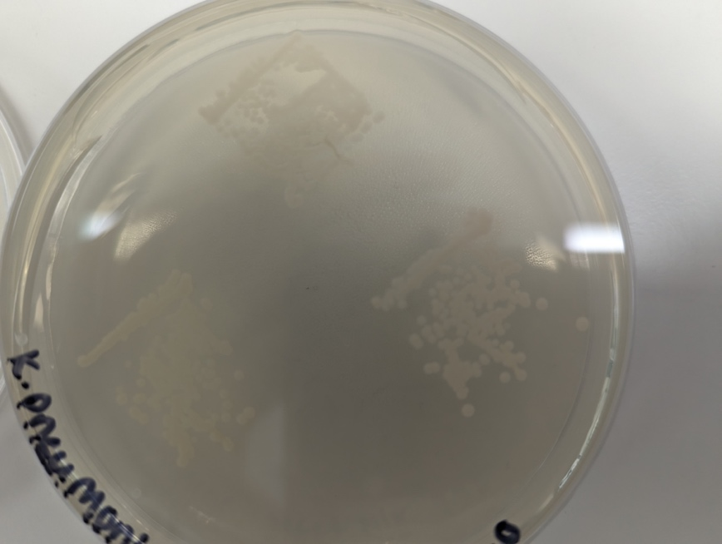
Figure 1.1 Photograph of colony clusters of K. pneumoniae strain 700603 following Bacterial Transfer t= 45min after initial touch exposure. Outlined are the positions the surface squares were placed during the Bacterial Transfer

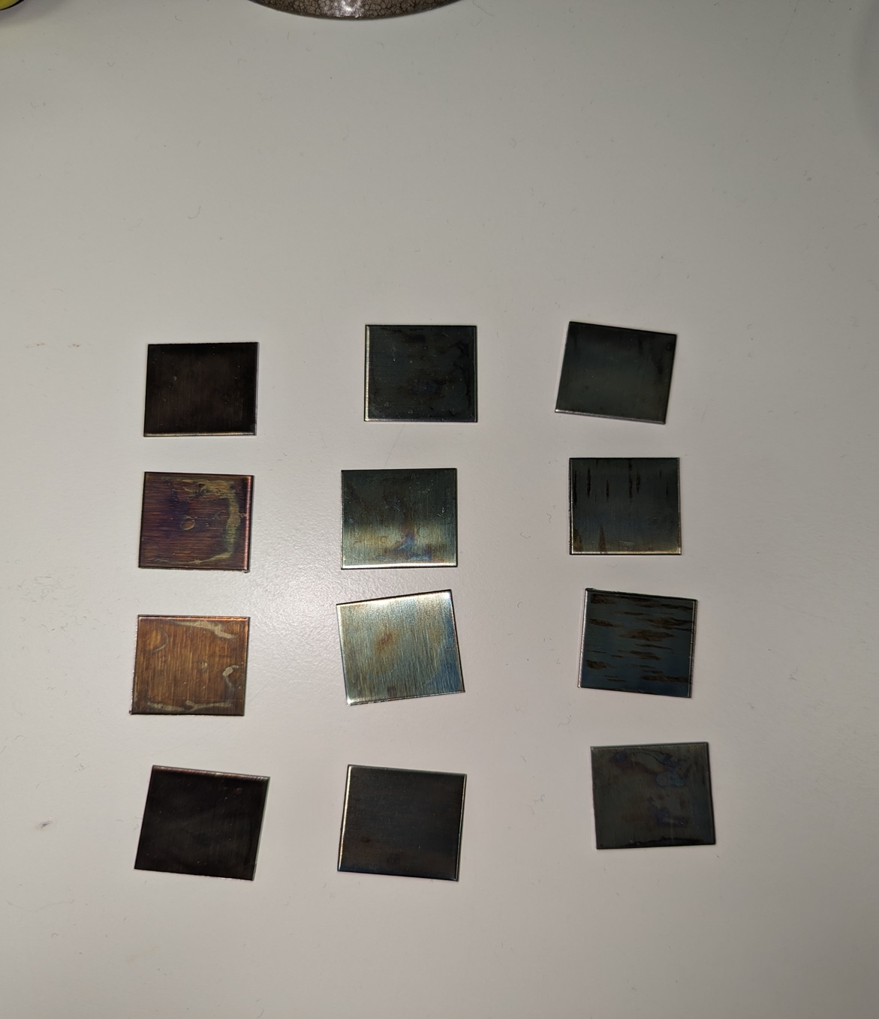

C
B
A

Figure 2 Photograph of visibly tarnished/oxidised coated steel squares ready to be discarded. marks on the surface may indicate rust, damage to the coatings, or collections of debris impeding the surface coatings antimicrobial properties. A) CuO coated brushed steel, B) TiO coated brushed steel, C) CuO+TiO coated brushed steel surfaces.

Clinical Sample Collection – University of Salford Podiatry Clinic

Identical pieces of plywood boards were mounted in the Podiatry Clinic at the University of Salford. Two identical boards were designed, each holding a set of 4 different test samples of coated brushed steel (40x80mm) as follows: i) control uncoated brushed steel, ii) CuO coated, iii) TiO coated, iv) CuO and TiO coated. Set 1 was mounted on the wall inside a patient treatment room in the clinic. Set 2 was mounted in the reception area of the clinic, adjacent to the reception desk (Figure 3). These 2 locations were chosen as the reception area offers high foot-traffic of people, and the patient booth offers an area that represents a clinical setting like a hospital ward.

Once per month both sets were dry swabbed, this involved the use of sealed microbiological sample collection swabs being opened upon use and the swabbing of the entire test surface avoiding the plywood panel, these swabs were placed and transported inside individual transport tubes containing amies buffer supplied within the sealed package with the swabs (Sterilin) to preserve any bacteria present. On each sampling visit, all swabs were obtained on the same day and transported to the microbiology lab where they were vortexed for 20 s and each swab was streaked onto Chocolate agar (supplemented with 5% lysed defibrinated Horse Blood), and 100 µL of the transport buffer was spread onto 2 further Chocolate agar plates (3 total per swab). The supplemented Chocolate agar was chosen for its ability to support and grow fastidious microorganisms that tend not to thrive on typical growth media such as Muller Hinton. All inoculated plates were incubated for 2-3 d at 37 ºC. Colonies were picked and isolated by patching into grids on fresh Chocolate agar (Figure 4), with a sample of each archived in the -80ºC freezer.

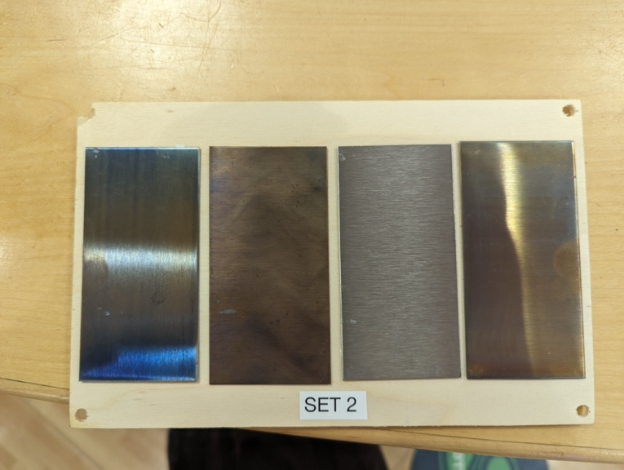

D
A
D
C
B
A

Figure 3 Example of the boards mounted in the Podiatry Clinic. Test surfaces had a surface area of 40*80mm. A)TiO, B) CuO, C )Uncoated, D) CuO + TiO

Results

Survivability and Transmission rates of Lab Strains on CVD Sample squares after Bacterial Transfer

The standard ISO protocol (22196) for investigating the antimicrobial properties of surface coatings typically uses a liquid inoculum with a cover slip. However, to better simulate the act of touching a surface this line of experimentation used suspensions of known bacterial densities inoculated onto the surface inert bacteriological agar (5%). This procedure was repeated to evaluate any inhibitory effects of Copper Oxide, and Copper-Titania coated brushed steel and borosilicate glass surfaces at 15 min intervals from 0 to 120 mins (T=0 -T=120). The implementation of Titania-only coated surfaces was used to identify any non-photocatalytic activity that may skew the results of the Copper-Titania combination coating. Transfer and survival of reference strains of each of the ESKAPE pathogens was monitored:

E. coli (ATCC 25922)

Figure 6 shows the recovery of E. coli from all brushed steel surface variants from T=0 to T=120 in 15-min increments. There was no significant difference observed in the number of viable E. coli cells recovered following an immediate transfer (T=0) across all coating types. Whilst a mean of 297 CFU per sample surface (0.74 CFU/mm²) was recovered from uncoated brushed steel (Figure 6a), means of 237.33 (0.59 CFU/mm²), 229.33 (0.57 CFU/mm²), and 175.67 (0.43 CFU/mm²) CFU were recovered from Copper Oxide (Figure 6b), Titania (Figure 6c), and Copper-Titania coated (Figure 6d) brushed steel surfaces respectively. The recovery rates reduced considerably within the 1st 15 min of exposure following the simulated touch inoculation. At T=15 the reduction in viable E. coli cells was 86% and 89.98% for uncoated and Copper Oxide coated steel, whereas only a 69.77% and 67.55% reduction in viable cells was observed by Titania and Copper-Titania (Figure 7). A general downward trend in recoverable bacterial cells was then observed across all surface types with the lowest recovery for both Uncoated (Figure 6a) and Titania coated (Figure 6c) brushed steel both occurring at T=105, those being 4.67 (0.01 CFU/mm²) and 11.67 (0.03 CFU/mm²) CFU respectively. For both Copper Oxide coated (Figure 6b) and Copper-Titania coated (Figure 6d) brushed steel the lowest recovery of viable E. coli cells occurred after T=120 with counts of 0.33 CFU (0.0008 CFU/mm²) and 0.67 CFU (0.0017 CFU/mm²) respectively. Mann-Whitney U analysis of the data identified significant differences between Copper Oxide-only and Titania-only coated brushed steel (p=0.02619) with Copper oxide showing more pronounced bacterial reduction, this was further identified by Kruskal-Wallis with Dunn post-hoc (p=0.02312). Also identified by Mann-Whitney as significantly different were Titania and Copper-Titania coated steel (p=0.03836), however this was not further identified by the Kruskal-Wallis with Dunn post-hoc (p=0.08285) (Table 2).

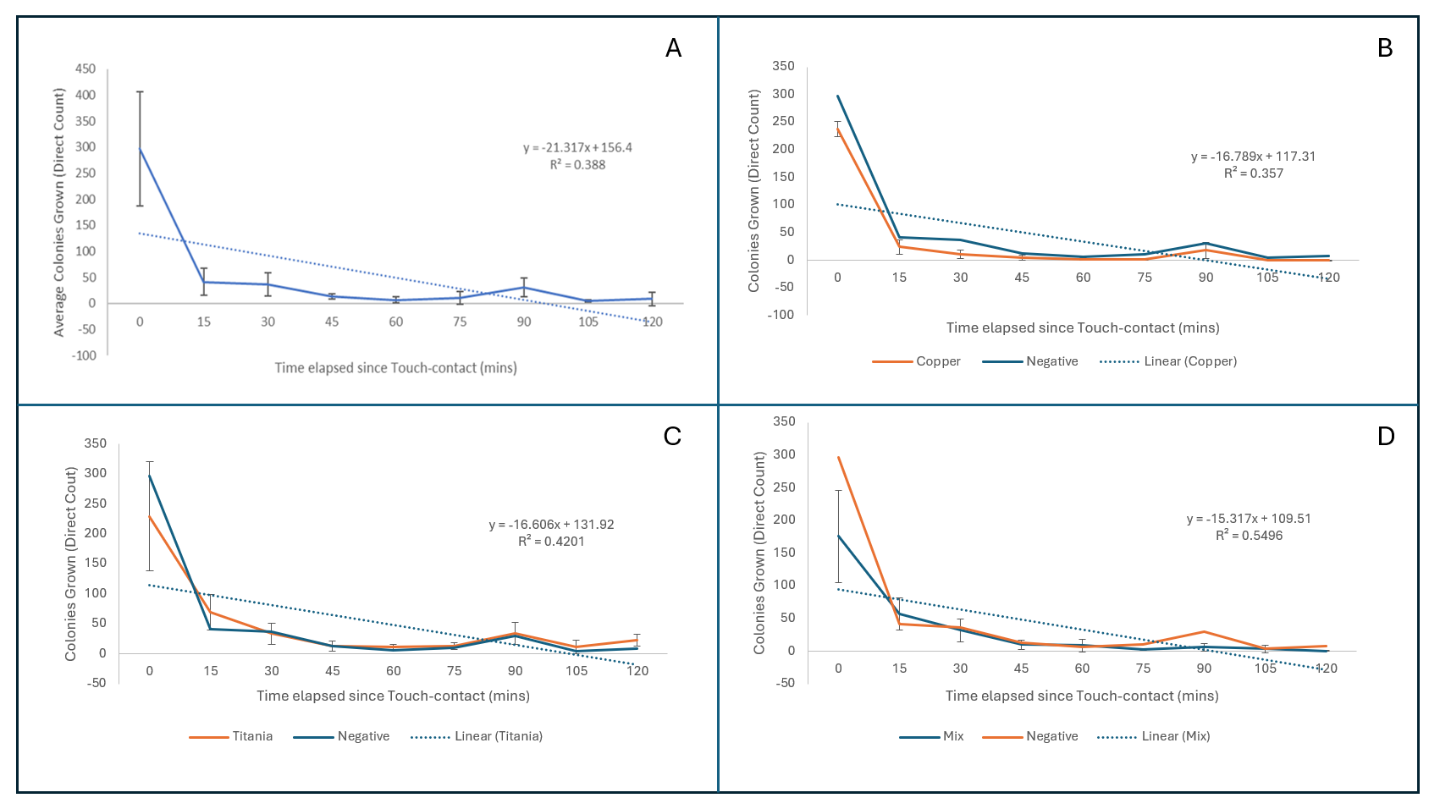
Figure 4 Results showing the average survival rates of E. coli on a) uncoated Brushed Steel, b) CuO coated Brushed Steel, c) TiO coated Brushed Steel, d) Cuo + TiO coated Brushed Steel. T=0 starts once the surface has been removed from the inoculated agar following touch contact. Error Bars represent Standard Deviation (SD calculated using 3 replicates of each data point).

Figure 5 Percentage change in E. coli recovered from coated steel variants after 15 and 30 minutes of exposure. Negative bars represent uncoated variant.

Table 4.1 Results Matrix of p-values from One-Tailed Mann-Whitney analysis of each Coated Surface on Brushed Steel against E. coli
 | Negative
Copper Oxide | 0.06057 | Copper Oxide
Titania | 0.18943 | 0.02619* | Titania
Copper Titania Mix | 0.17619 | 0.26763 | 0.03836
* p<.05 indicates significance.

Although slightly lower, like the brushed steel there was no significant difference in the average number of viable E. coli cells recovered from the Borosilicate Glass variants at T=0 with the mean recovered CFU for uncoated (Figure 8a), Copper Oxide (Figure 8b), Titania (Figure 8c), and Copper-Titania coated (Figure 8d) glass being 202.67 (0.51 CFU/mm²), 170 (0.425 CFU/mm²), 235 (0.59 CFU/mm²), and 114 (0.29 CFU/mm²) respectively. Similarly, after the 1st 15-minutes of exposure to the surfaces there was a remarkable decline in recovered cells with an 81.25% and an 86.27% drop in viable cells from the uncoated and Copper Oxide coated glass, and a less remarkable 70.78% and 72.22% drop on the Titania and Copper-Titania coated (Figure 9) glass. The lowest average counts of recovered E. coli for the uncoated (Figure 8a), Copper Oxide (Figure 8b), and Copper-Titania coated (Figure 8d) glass was observed at T=105, these being 6 (0.015 CFU/mm²), 0.67 (0.0017 CFU/mm²), and 1 (0.0025 CFU/mm²) CFU respectively. Whereas the lowest average number of viable cells recovered from the Titania coated (Figure 8c) glass was 2.67 (0.0067 CFU/mm²) CFU which occurred after T=120. Mann-Whitney analysis of E. coli on coated glass identified no significant difference between any 2 coatings including the uncoated reference surfaces (p>0.05) (Table 3), this was further analysed using Kruskal-Wallis with Dunn post-hoc which also noted no significance (p>0.05)

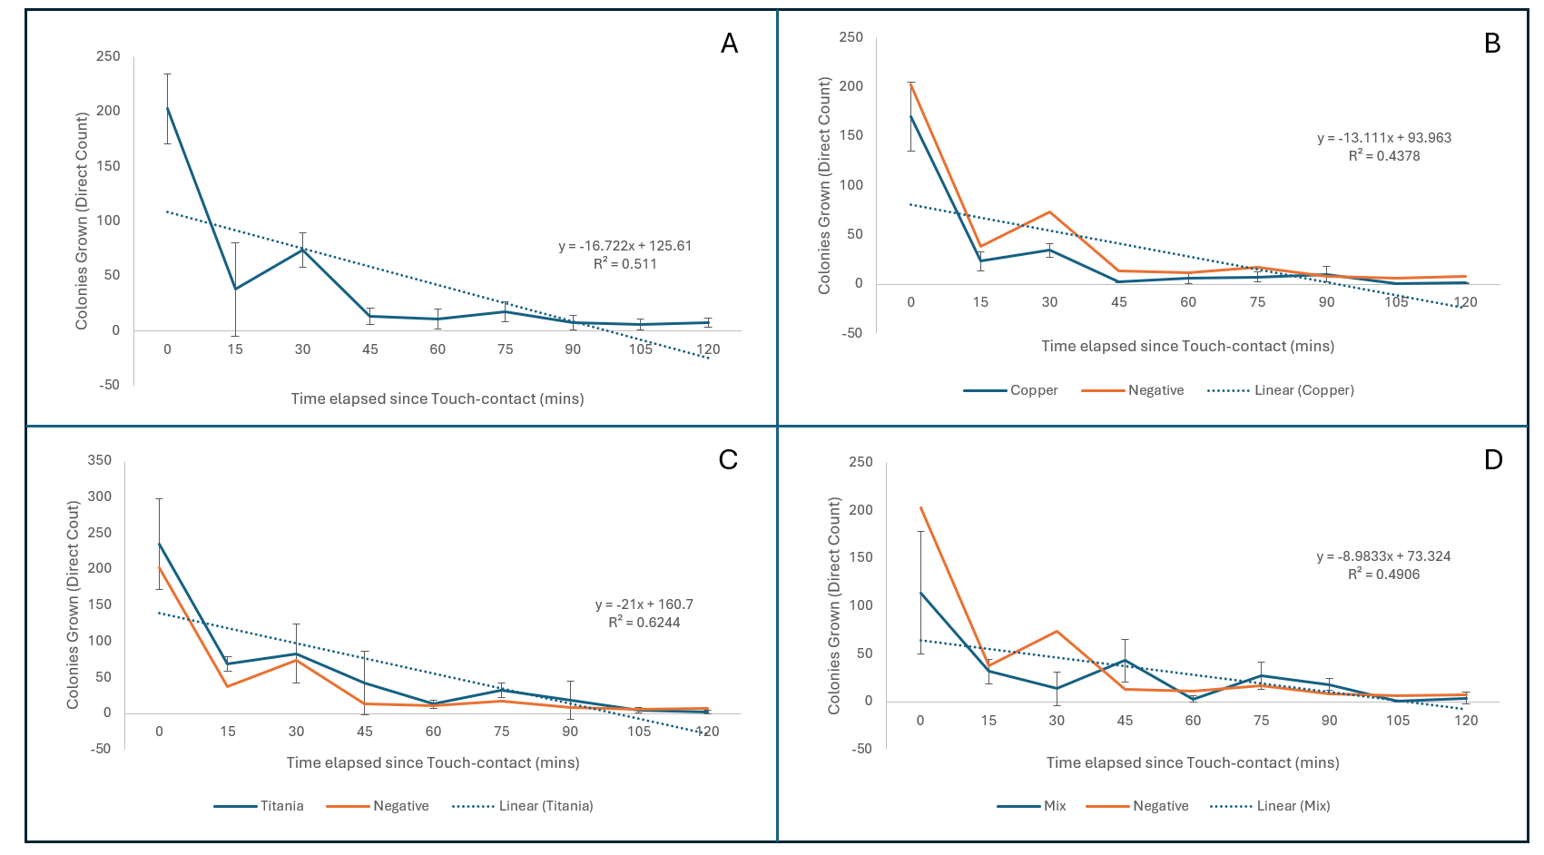
Figure 6 Results showing the average survival rates of E. coli on a) uncoated Borosilicate Glass, b) CuO coated Borosilicate Glass, c) TiO coated Borosilicate Glass, d) CuO + TiO coated Borosilicate Glass. T=0 starts once the surface has been removed from the inoculated agar following touch contact. Error Bars represent Standard Deviation (SD calculated using 3 replicates of each data point)

Figure 7 Percentage change in E. coli recovered from coated glass variants after 15 and 30 minutes of exposure. Negative bars represent uncoated variant.

Table 4.2 Results Matrix of p-values from One-Tailed Mann-Whitney analysis of each Coated Surface on Borosilicate Glass against E. coli.
 | Negative
Copper Oxide | 0.08534 | Copper Oxide
Titania | 0.29806 | 0.07215 | Titania
Copper Titania Mix | 0.42858 | 0.23885 | 0.18943

S. aureus (ATCC 29213)

The immediate (T=0) transfer results for S. aureus were 522.33 (1.31 CFU/mm²), 269.67 (0.67 CFU/mm²), 238 (0.6 CFU/mm²), and 341.33 (0.85 CFU/mm²) CFU for uncoated (Figure 10a), Copper Oxide (Figure 10b), Titania (Figure 10c), and Copper-Titania coated (Figure 10d) brushed steel. Following 15 minutes of exposure to the surfaces the average recovery of S. aureus from uncoated, Copper Oxide, and Copper-Titania Coated brushed steel dropped by 40.19%, 7.91%, and 35.73% respectively. In contrast, it was observed that the Titania-coated brushed steel had an increase in the average number of cells recovered (n=387), a 62.61% increase (Figure 11). For uncoated (Figure 10a), Copper Oxide (Figure 10b), and Titania coated brushed steel (Figure 10c), the lowest average recovery of viable S. aureus occurred after T=105, with 174.67 (0.44 CFU/mm²), 127.33 (0.32 CFU/mm²), and 231.67 (0.058 CFU/mm²)CFU recovered respectively. The Copper-Titania coated brushed steel however had its lowest recovery of viable cells occur at T=90, with an average recovery of 176.33 (0.44 CFU/mm²) CFU (Figure 10d). Mann-Whitney analysis of these results showed a significant difference between the Copper Oxide coated steel and Titania coated steel (p=0.04648) (Table 4), however further analysis with Kruskal-Wallis with Dunn post-hoc showed the results from these 2 coatings not to be significantly different (p=0.06174).

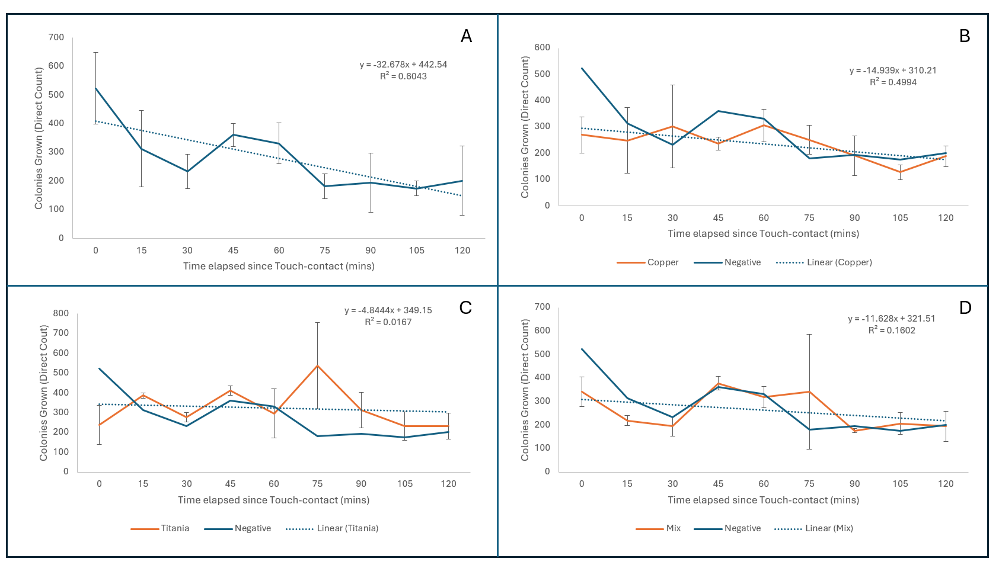
Figure 8 Results showing the average survival rates of S. aureus on a) uncoated Brushed Steel, b) CuO coated Brushed Steel, c) TiO coated Brushed Steel, d) Cuo + TiO coated Brushed Steel. T=0 starts once the surface has been removed from the inoculated agar following touch contact. Error Bars represent Standard Deviation (SD calculated using 3 replicates of each data point).

Figure 9 Percentage change in S. aureus recovered from coated steel variants after 15 and 30 minutes of exposure. Positive percentage represents the increase in recovered cells compared to that recovered at the previous timepoint. Negative bars represent uncoated variant.

Table 4.3 Results Matrix of p-values from One-Tailed Mann-Whitney analysis of each Coated Surface on Brushed Steel against S. aureus
 | Negative
Copper Oxide | 0.29806 | Copper Oxide
Titania | 0.13567 | 0.04648* | Titania
Copper Titania Mix | 0.46414 | 0.23885 | 0.07927
* p<.05 indicates significance.

Like the immediate transfer results on brushed steel there was no significant difference in the average recovered viable cells of S. aureus across all coatings. The average counts of S. aureus on uncoated (Figure 12a), Copper Oxide (Figure 12b), Titania (Figure 12c) and Copper-Titania coated (Figure 12d) borosilicate glass was 321 (0.8 CFU/mm²), 291.67 (0.73 CFU/mm²), 417 (1.04 CFU/mm²), and 358.33 (0.9 CFU/mm²) CFU respectively. After 15 minutes of exposure the average number of viable S. aureus recovered cells from all coatings decreased. The uncoated borosilicate glass had an average reduction of 17.65%, the smallest decrease of all the coatings from the same timeframe, the Copper Oxide however on average had the highest decrease in viable cells recovered of the coatings in the same timeframe with an average loss of 51.89%. Titania and Copper-Titania coated glass lost 42.05% and 43.53% respectively (Figure 13). A slight downward trend in the average number of viable cells recovered from T=0 – T=120 was observed on the uncoated (Figure 12a), Copper Oxide (Figure 12b), and Copper-Titania coated (Figure 12d) borosilicate glass, with the Titania-coated (Figure 12c) borosilicate glass having a slight upward trend. Mann-Whitney analysis of S. aureus on borosilicate glass identified significant differences between Uncoated and Copper Oxide (p=0.00676), Uncoated and Copper-Titania (p=0.04648), Copper and Titania (p=0.0024), and Titania and Copper-Titania (p=0.03216) coatings (
Table 5). Kruskal-Wallis analysis further identified a significant difference in Uncoated and Copper Oxide (p=0.00613), and Copper Oxide and Titania (p=0.004987) coatings against S. aureus (
Table 5).
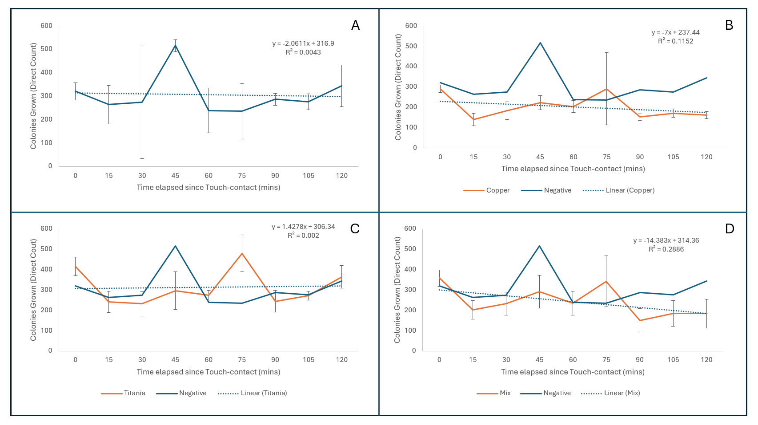
Figure 10 Results showing the average survival rates of S. aureus on a) uncoated Borosilicate Glass, b) CuO coated Borosilicate Glass, c) TiO coated Borosilicate Glass, d) CuO + TiO coated Borosilicate Glass. T=0 starts once the surface has been removed from the inoculated agar following touch contact. Error Bars represent Standard Deviation(SD calculated using 3 replicates of each data point)
Figure 11 Percentage change in S. aureus recovered from borosilicate glass variants after 15 and 30 minutes of exposure. Positive percentage represents the increase in recovered cells compared to that recovered at the previous timepoint. Negative bars represent uncoated variant.

Table 4.4 Results Matrix of p-values from One-Tailed Mann-Whitney analysis of each Coated Surface on Borosilicate Glass against S. aureus.
 | Negative
Copper Oxide | 0.00676* | Copper Oxide
Titania | 0.5 | 0.0024* | Titania
Copper Titania Mix | 0.04648* | 0.06057 | 0.03216*
* p<.05 indicates significance.

K. pneumoniae (ATCC 700603)

At T=0 for K. pneumoniae on brushed steel there was little variation between uncoated (Figure 14a), Titania (Figure 14c), and Copper-Titania coated (Figure 14d) as the average recovered viable bacterial cell count of these were 154.67 (0.39 CFU/mm²), 141.33 (0.35 CFU/mm²), and 135.33 CFU (0.34 CFU/mm²). For K. pneumoniae against Copper Oxide coated (Figure 14b) brushed steel however, the viable count at T=0 was 82.33 (0.21 CFU/mm²) CFU. After the 1st 15 minutes of exposure there was a remarkable drop in recovered viable cells. The respective decrease in recovered cells for uncoated, Copper Oxide, Titania, and Copper-Titania coated (Figure 15) brushed steel were 94.61%, 96.76%, 71.93%, 96.31%. The Copper-Titania coated steel surface 1st reported an average of 0 CFU as early as 45 minutes after initial touch inoculation (T=45), with uncoated and Copper Oxide coated returning the same results after 60 minutes (T=60), and finally Titania coated brushed steel recovering 0 CFU after 75 minutes of exposure (T=75). Mann-Whitney and Kruskal-Wallis with Dunn post-hoc calculations found no significant difference between any of the coatings against K. pneumoniae (Table 6).

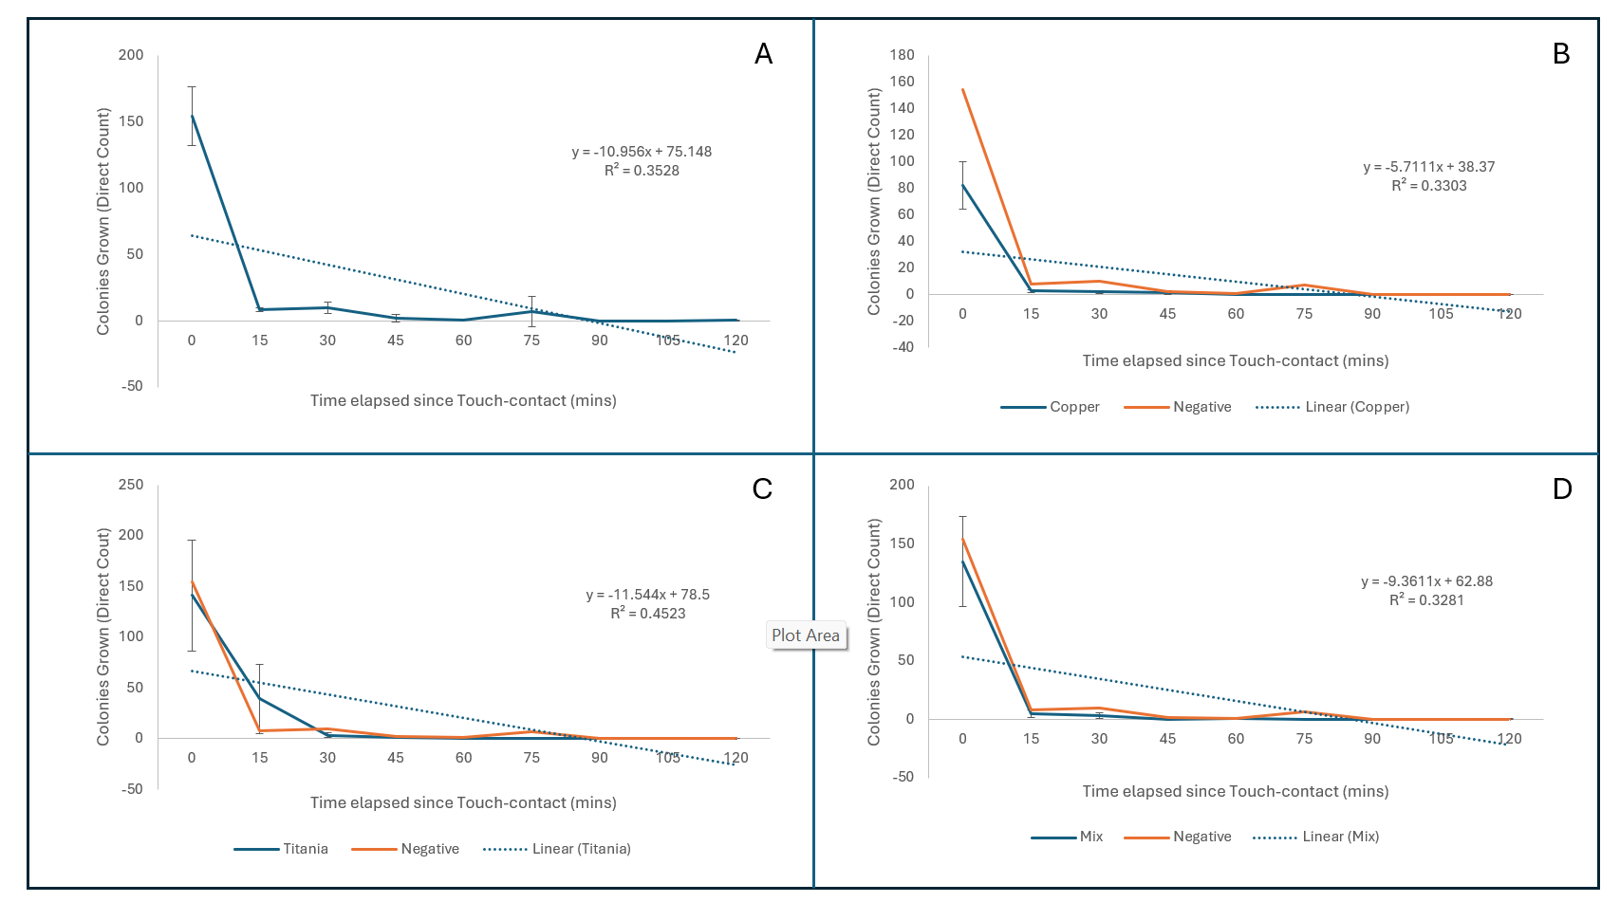
Figure 12 Results showing the average survival rates of K. pneumoniae on a) uncoated Brushed Steel, b) CuO coated Brushed Steel, c) TiO coated Brushed Steel, d) Cuo + TiO coated Brushed Steel. T=0 starts once the surface has been removed from the inoculated agar following touch contact. Error Bars represent Standard Deviation (SD calculated using 3 replicates of each data point).

Figure 13 Percentage change in K. pneumoniae recovered from coated steel variants after 15 and 30 minutes of exposure. Positive percentage represents the increase in recovered cells compared to that recovered at the previous timepoint. Negative bars represent uncoated variant.

Table 4.5 Results matrix of p-values from One-Tailed Mann-Whitney analysis of each Coated Surface on Brushed Steel against K. pneumoniae
 | Negative
Copper Oxide | 0.11702 | Copper Oxide
Titania | 0.26763 | 0.25463 | Titania
Copper Titania Mix | 0.13567 | 0.36317 | 0.36317

Immediate (T=0) of K. pneumoniae on uncoated (Figure 16a) borosilicate glass showed a slightly higher recovery of viable K. pneumoniae cells than the various coated samples with an average recovery of 182.67(0.46 CFU/mm²). At T=0 Copper Oxide (Figure 16b), Titania (Figure 16c) and Copper-Titania coated (Figure 16d) borosilicate glass however showed returns of 104.67(0.26 CFU/mm²), 131(0.33 CFU/mm²), and 96.33 (0.24 CFU/mm²) CFU respectively. After 15 minutes of exposure there was a notable decline in recovered viable cells from all surface coating types, there were declines of 96.72% from uncoated, 97.45% from Copper Oxide, 95.42% from Titania, and 98.96% from Copper-Titania coated (Figure 17) borosilicate glass. It was observed that the uncoated (Figure 16a), Copper Oxide (Figure 16b), and Copper-Titania coated (Figure 16d) borosilicate glass successfully recovered averages of 0 viable CFU at T=90, T=60, and T=45 respectively, whereas the Titania coated (Figure 16c) borosilicate glass had a lowest average recovery of viable K. pneumoniae of 0.33 CFU at T=90. Mann-Whitney analysis of the data identified significant differences between Copper Oxide and Titania (p=0.0233), and Titania and Copper-Titania (p=0.00964) coated surfaces (Table 7). Both were also identified in further analysis using Kruskal-Wallis with Dunn post-hoc; p=0.03388 and p=0.1654 respectively.
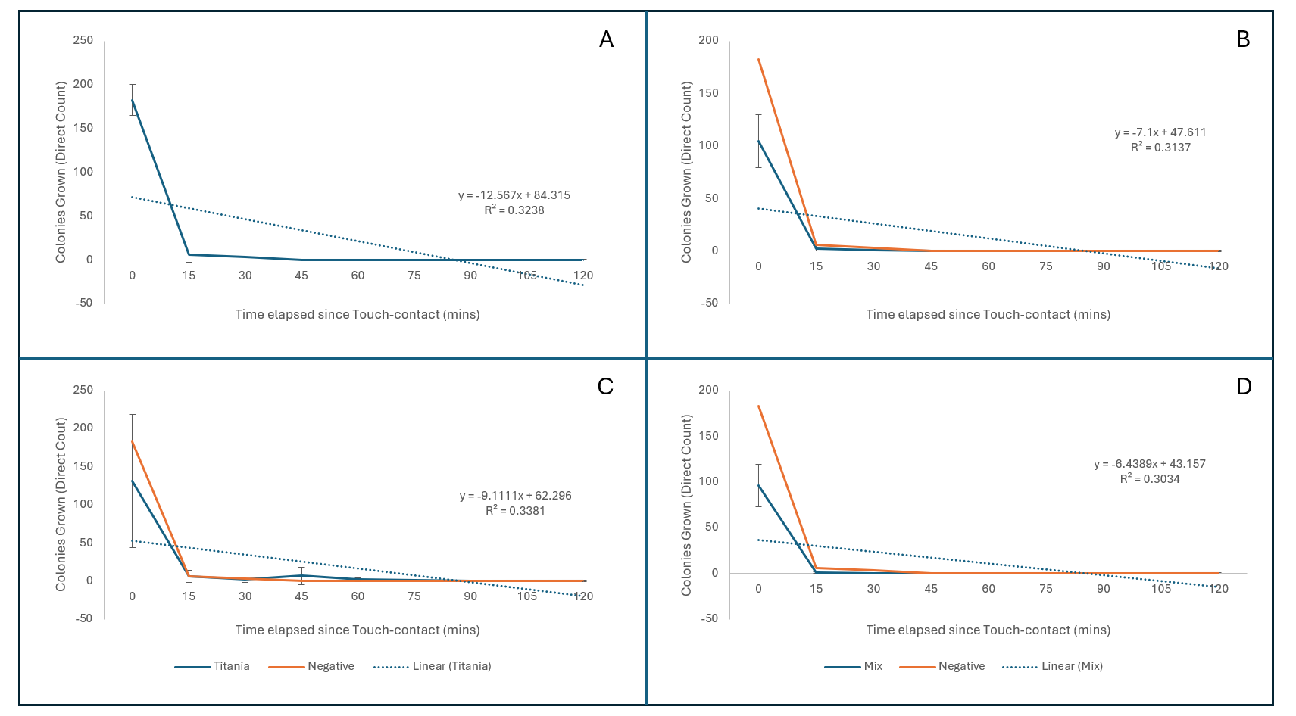
Figure 14 Results showing the average survival rates of K. pneumoniae on a) uncoated Borosilicate Glass, b) CuO coated Borosilicate Glass, c) TiO coated Borosilicate Glass, d) CuO + TiO coated Borosilicate Glass. T=0 starts once the surface has been removed from the inoculated agar following touch contact. Error Bars represent Standard Deviation (SD calculated using 3 replicates of each data point).

Figure 15 Percentage change in K. pneumoniae recovered from borosilicate glass variants after 15 and 30 minutes of exposure. Negative bars represent uncoated variant.

Table 4.6 Results matrix of p-values from One-Tailed Mann-Whitney analysis of each Coated Surface on Borosilicate Glass against K. pneumoniae
 | Negative
Copper Oxide | 0.32997 | Copper Oxide
Titania | 0.07215 | 0.0233* | Titania
Copper Titania Mix | 0.26763 | 0.41294 | 0.00964*
* p<.05 indicates significance.

A. baumannii (ATCC 19606)

Bacterial transfer results for A. baumannii on brushed steel showed high counts of recovered viable cells. At T=0 uncoated brushed steel (Figure 18a) transferred an average of 960.67 (2.4 CFU/mm²) CFU, the Copper Oxide (Figure 18b) and Copper-Titania (Figure 18d) coatings had similar results at T=0 with 744 (1.86 CFU/mm²) and 770.33 (1.93 CFU/mm²) CFU respectively. Titania (Figure 18c) coated brushed steel had slightly less viable A. baumannii cells transfer at T=0 with an average of 598.67 (1.5 CFU/mm²) CFU. Following 15 minutes of exposure to the coated surfaces only the Copper-Titania coated brushed steel showed a decline in recovered viable cells with a slight decrease of 4.37%. The uncoated, Copper Oxide, showed a slight rise in recovered viable cells at T=15 with increases of 1.04%, 0.04%, with Titania coated brushed steel having a notable increase of 42.09% in recovered viable cells (Figure 19). Despite the spikes in recovered cells there is a general downward trend across all coated surfaces with the lowest average recovered cells for uncoated (Figure 18a) and Titania coated (Figure 18c) brushed steel were both observed at T=105 with averages of 160 (0.4 CFU/mm²), and 360.67 (0.9 CFU/mm²) CFU respectively. Copper Oxide (Figure 18b) and Copper-Titania coated (Figure 18d) brushed steel both had their lowest average recovered viable cells at T=120 with averages of 135 (0.34 CFU/mm²), and 169.67 (0.42 CFU/mm²) CFU respectively. Mann-Whitney and Kruskal-Wallis with Dunn post-hoc analyses showed there was no significant difference between any 2 of the sample surfaces against A. baumannii (Table 8).

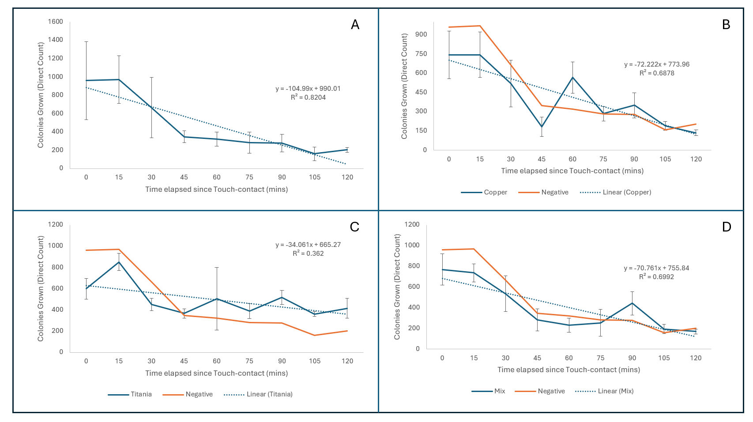
Figure 16 Results showing the average survival rates of A. baumannii on a) uncoated Brushed Steel, b) CuO coated Brushed Steel, c) TiO coated Brushed Steel, d) Cuo + TiO coated Brushed Steel. T=0 starts once the surface has been removed from the inoculated agar following touch contact. Error Bars represent Standard Deviation (SD calculated using 3 replicates of each data point).

Figure 17 Percentage change in A. baumannii recovered from coated steel variants after 15 and 30 minutes of exposure. Positive percentage represents the increase in recovered cells compared to that recovered at the previous timepoint. Negative bars represent uncoated variant.

Table 4.7 Results matrix of p-values from One-Tailed Mann-Whitney analysis of each Coated Surface on Brushed Steel against A. baumannii
 | Negative
Copper Oxide | 0.42858 | Copper Oxide
Titania | 0.10749 | 0.18943 | Titania
Copper Titania Mix | 0.36317 | 0.5 | 0.12507

Similarly, to brushed steel the bacterial transfer results of A. baumannii on borosilicate glass showed high counts of recovered viable cells. Immediate (T=0) transfers showed average recovered viable cells of 659 (1.65 CFU/mm²), 633.33 (1.58 CFU/mm²), 664.33 (1.66 CFU/mm²), and 533.67 (1.33 CFU/mm²) for uncoated (Figure 20a), Copper Oxide (Figure 20b), Titania (Figure 20c), and Copper-Titania coated (Figure 20d) brushed steel. On uncoated and Copper Oxide coated borosilicate glass there was a considerable decline in recovered viable cells after 15 minutes of exposure following their initial touch-inoculation, with reductions of 70.71% and 48.58% respectively. A slightly lower 34.56% reduction was observed on the Titania coating, and a remarkable increase in recovered viable cells on the Copper-Titania coated borosilicate glass, with an average increase of 58.03% (Figure 21). For the uncoated and Titania coated borosilicate glass the lowest average counts of recovered viable cells were 122 CFU (Figure 20a), and 137 CFU (Figure 20c) obtained at T= 120 and T=60 respectively. As for the Copper Oxide and Copper-Titania coated borosilicate glass samples, the lowest average counts of viable A. baumannii cells were 153 CFU (Figure 20b), and 137.33 CFU (Figure 20d) which were both observed after 60 minutes of exposure, however both observations were followed by large increases in recovered cells, with those averages rising to 484.67 CFU (Figure 20a) and 392 CFU (Figure 20d) respectively. Mann-Whitney analysis of A. baumannii on borosilicate glass identified significant differences between uncoated and Titania (p=0.01072), and Copper Oxide and Titania (p=0.02118) (Table 9).

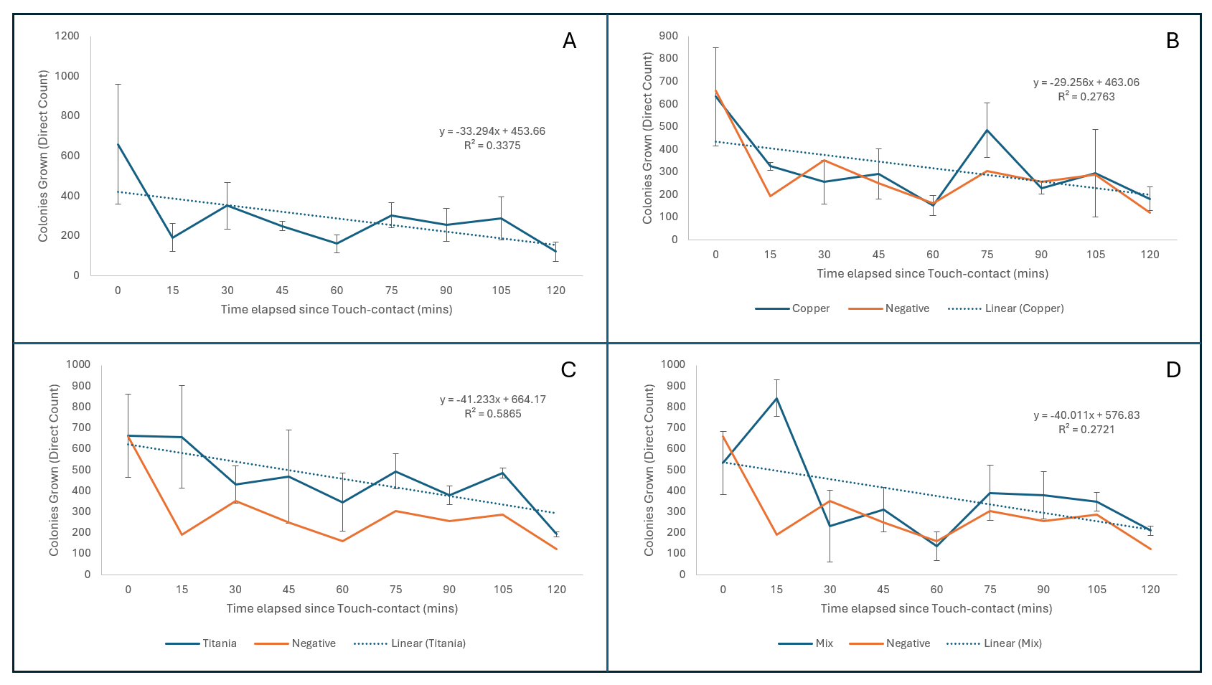
Figure 18 Results showing the average survival rates of A. baumannii on a) uncoated Borosilicate Glass, b) CuO coated Borosilicate Glass, c) TiO coated Borosilicate Glass, d) CuO + TiO coated Borosilicate Glass. T=0 starts once the surface has been removed from the inoculated agar following touch contact. Error Bars represent Standard Deviation (SD calculated using 3 replicates of each data point).

Figure 19 Percentage change in A. baumannii recovered from coated borosilicate glass variants after 15 and 30 minutes of exposure. Positive percentage represents the increase in recovered cells compared to that recovered at the previous timepoint. Negative bars represent uncoated variant.

Table 4.8 Results matrix of p-values from One-Tailed Mann-Whitney analysis of each Coated Surface on Borosilicate Glass against A. baumannii
 | Negative
Copper Oxide | 0.36317 | Copper Oxide
Titania | 0.01072* | 0.02118* | Titania
Copper Titania Mix | 0.12507 | 0.23885 | 0.12507
* p<.05 indicates significance.

P. aeruginosa (ATCC 27853)

(Figure 22a) shows the effect of uncoated brushed steel against P. aeruginosa in 15-minute increments from 0-120. At T=0 an average of 30.33 (0.08 CFU/mm²) viable CFU were recovered from the surface of uncoated brushed steel, at the same timepoint 14.33 (0.035 CFU/mm²), 47 (0.12 CFU/mm²), and 47.33 (0.12 CFU/mm²) CFU were recovered from Copper Oxide (Figure 22b), Titania (Figure 22c), and Copper-Titania coated (Figure 22d) brushed steel surfaces. 15 minutes following the touch inoculation of all surface samples the average recovered viable cells dropped considerably. The average recovered cells on uncoated, Copper Oxide, Titania, and Copper-Titania coated brushed steel dropped by 81.32%, 88.37%, 91.49%, and 98.58% respectively (Figure 23). All the variations of coated brushed steel were observed recovering 0 viable CFU of P. aeruginosa, for the uncoated (Figure 22a), Copper Oxide (Figure 22b), and Titania coated (Figure 22c) brushed steel this occurred at T=90, whereas for the Copper-Titania coated (Figure 22d) brushed steel samples this occurred at T=75. Mann-Whitney (Table 10) and Kruskal-Wallis with Dunn post-hoc analyses found there to be no significant difference between any of the coated surfaces against P. aeruginosa.

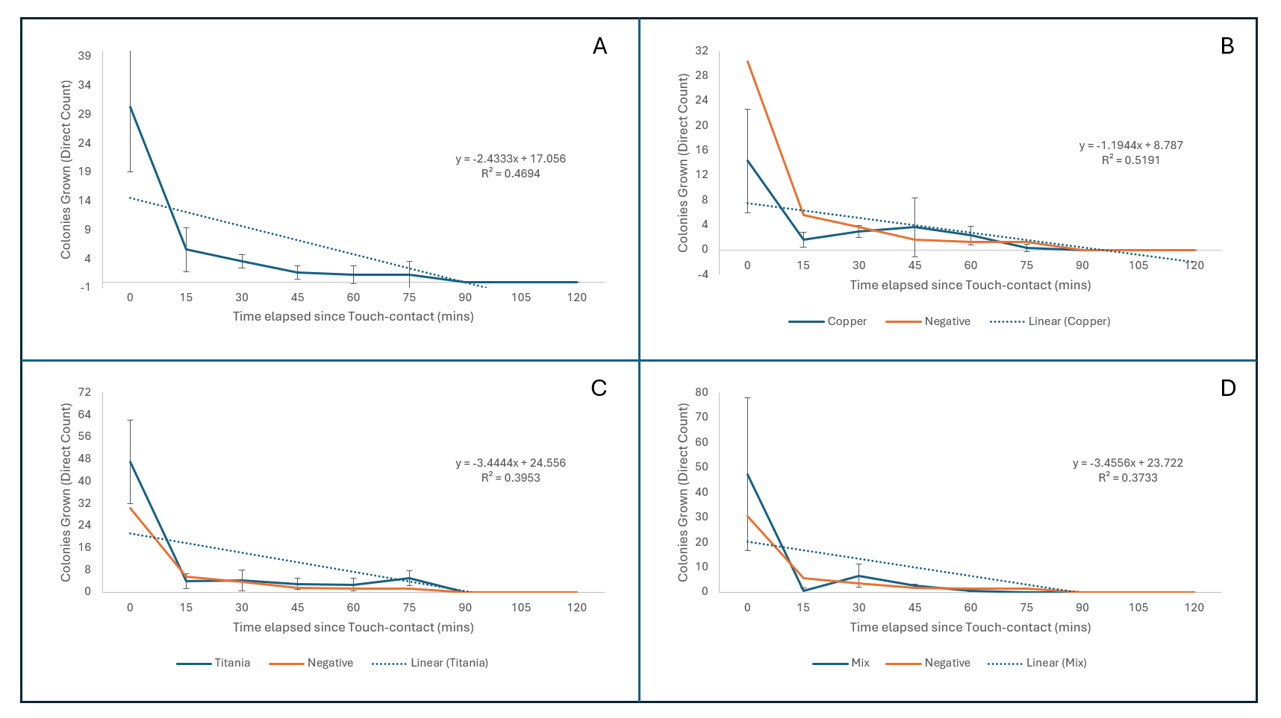
Figure 20 Results showing the average survival rates of P. aeruginosa on a) uncoated Brushed Steel, b) CuO coated Brushed Steel, c) TiO coated Brushed Steel, d) Cuo + TiO coated Brushed Steel. T=0 starts once the surface has been removed from the inoculated agar following touch contact. Error Bars represent Standard Deviation (SD calculated using 3 replicates of each data point).

Figure 21 Percentage change in P. aeruginosa recovered from coated steel variants after 15 and 30 minutes of exposure. Positive percentage represents the increase in recovered cells compared to that recovered at the previous timepoint. Negative bars represent uncoated variant.

Table 4.9 Results matrix of p-values from One-Tailed Mann-Whitney analysis of each Coated Surface on Brushed Steel against P. aeruginosa
 | Negative
Copper Oxide | 0.48405 | Copper Oxide
Titania | 0.31207 | 0.21476 | Titania
Copper Titania Mix | 0.31207 | 0.39743 | 0.25463

The bacterial transfer results for P. aeruginosa on borosilicate glass samples follows a very similar pattern to that of P. aeruginosa on brushed steel. Shown on (Figure 24a) at T=0 uncoated borosilicate glass transferred 23 viable CFU (0.06 CFU/mm²), Figure 24b shows Copper Oxide transferred 9.33 CFU (0.02 CFU/mm²), Figure 24c shows Titania transferred 58 CFU (0.15 CFU/mm²), and Figure 24d shows Copper-Titania coated borosilicate glass samples transferred an average of 33.67 CFU (0.08 CFU/mm²). At T=15 it was seen that Copper Oxide had a reduction of only 7.14%, where uncoated, Titania, and Copper-Titania coated borosilicate glass saw reductions of 65.22%, 70.69%, and 66.67% respectively (Figure 22). Much like the brushed steel variations against P. aeruginosa, the glass variations also managed to have the average number of viable cells recovered reach 0 CFU on all coating types. For uncoated (Figure 24a) and Copper Oxide coated (Figure 24b) borosilicate glass this occurred at T=90, and for Titania (Figure 24c) and Copper-Titania coated (Figure 24d) borosilicate glass this occurred at T=105. Table 11 Results matrix of p-values from One-Tailed Mann-Whitney analysis of each Coated Surface on Borosilicate Glass against P. aeruginosa shows that Mann-Whitney analysis identified a significant difference between Titania and Copper-Titania coated borosilicate glass against P. aeruginosa (p=0.04648), however this was determined not to be significant by Kruskal-Wallis with Dunn post-hoc analysis (p=0.09053).

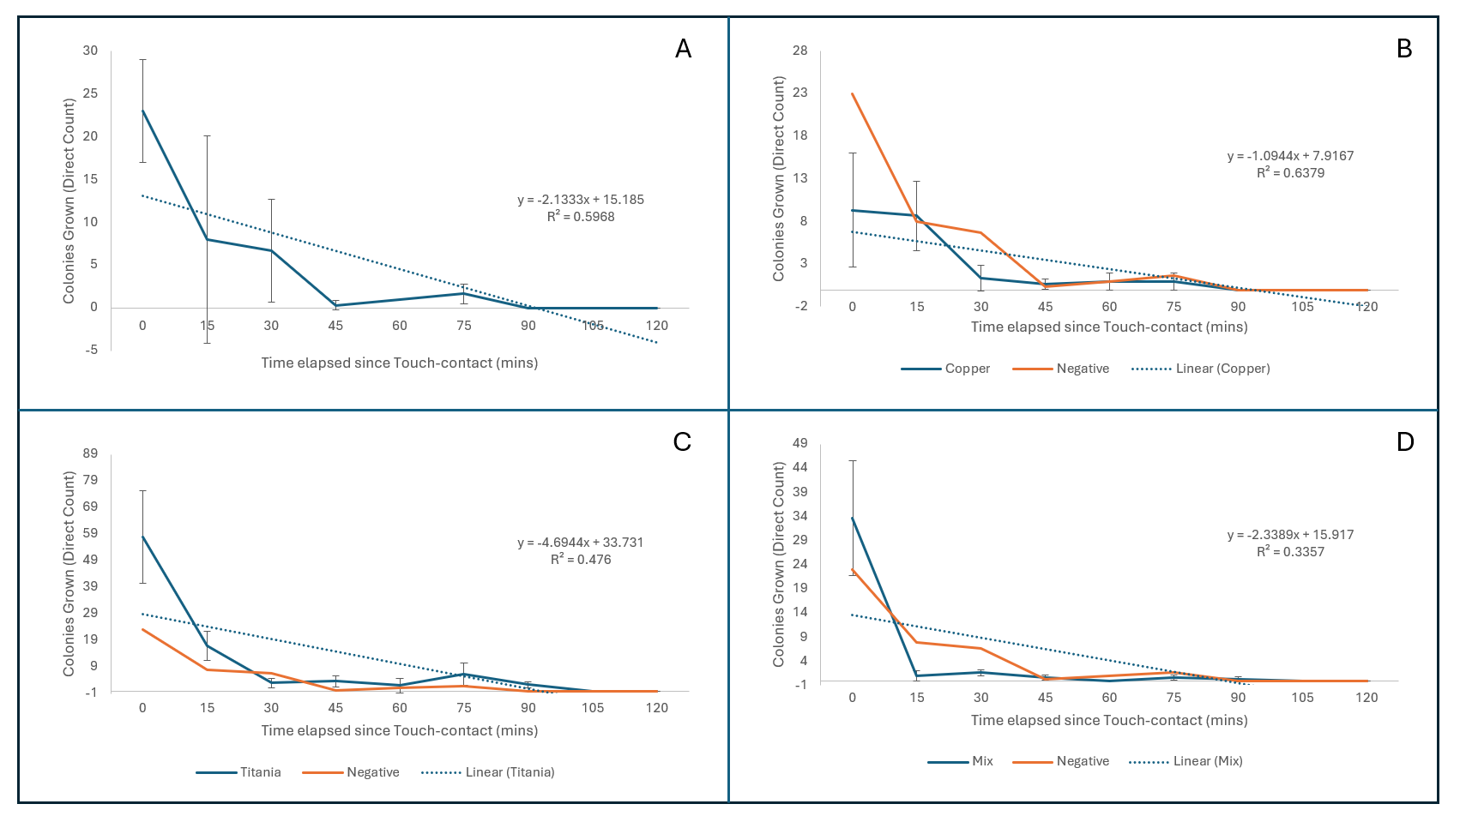
Figure 22 Results showing the average survival rates of P. aeruginosa on a) uncoated Borosilicate Glass, b) CuO coated Borosilicate Glass, c) TiO coated Borosilicate Glass, d) CuO + TiO coated Borosilicate Glass. T=0 starts once the surface has been removed from the inoculated agar following touch contact. Error Bars represent Standard Deviation (SD calculated using 3 replicates of each data point).

Figure 23 Percentage change in P. aeruginosa recovered from coated borosilicate glass variants after 15 and 30 minutes of exposure. Positive percentage represents the increase in recovered cells compared to that recovered at the previous timepoint. Negative bars represent uncoated variant.

Table 4.10 Results matrix of p-values from One-Tailed Mann-Whitney analysis of each Coated Surface on Borosilicate Glass against P. aeruginosa
 | Negative
Copper Oxide | 0.44828 | Copper Oxide
Titania | 0.21476 | 0.09342 | Titania
Copper Titania Mix | 0.32997 | 0.34458 | 0.04648*
* p<.05 indicates significance.

E. cloacae (ATCC 13047)

The immediate transfer results of E. cloacae on brushed steel gave varied results. At T=0 uncoated (Figure 26a) brushed steel transferred an average of 811 viable CFU (2.030.06 CFU/mm²), Copper Oxide (Figure 26b) transferred an average of 635.33 viable CFU (1.590.06 CFU/mm²), Titania (Figure 26c) transferred 343 viable CFU (0.860.06 CFU/mm²), and Copper-Titania (Figure 26d) transferred 917.67 viable CFU (2.290.06 CFU/mm²). 15 minutes after initially being inoculated reductions in the average counts of viable cells recovered from the surfaces were 75.83% on uncoated, 98.16% on Copper Oxide, 85.03% Titania, and 99.93% on Copper-Titania coated brushed steel (Figure 27). Mann-Whitney (Table 12) and Kruskal-Wallis analyses found no significant difference between any of the coatings against E. cloacae.

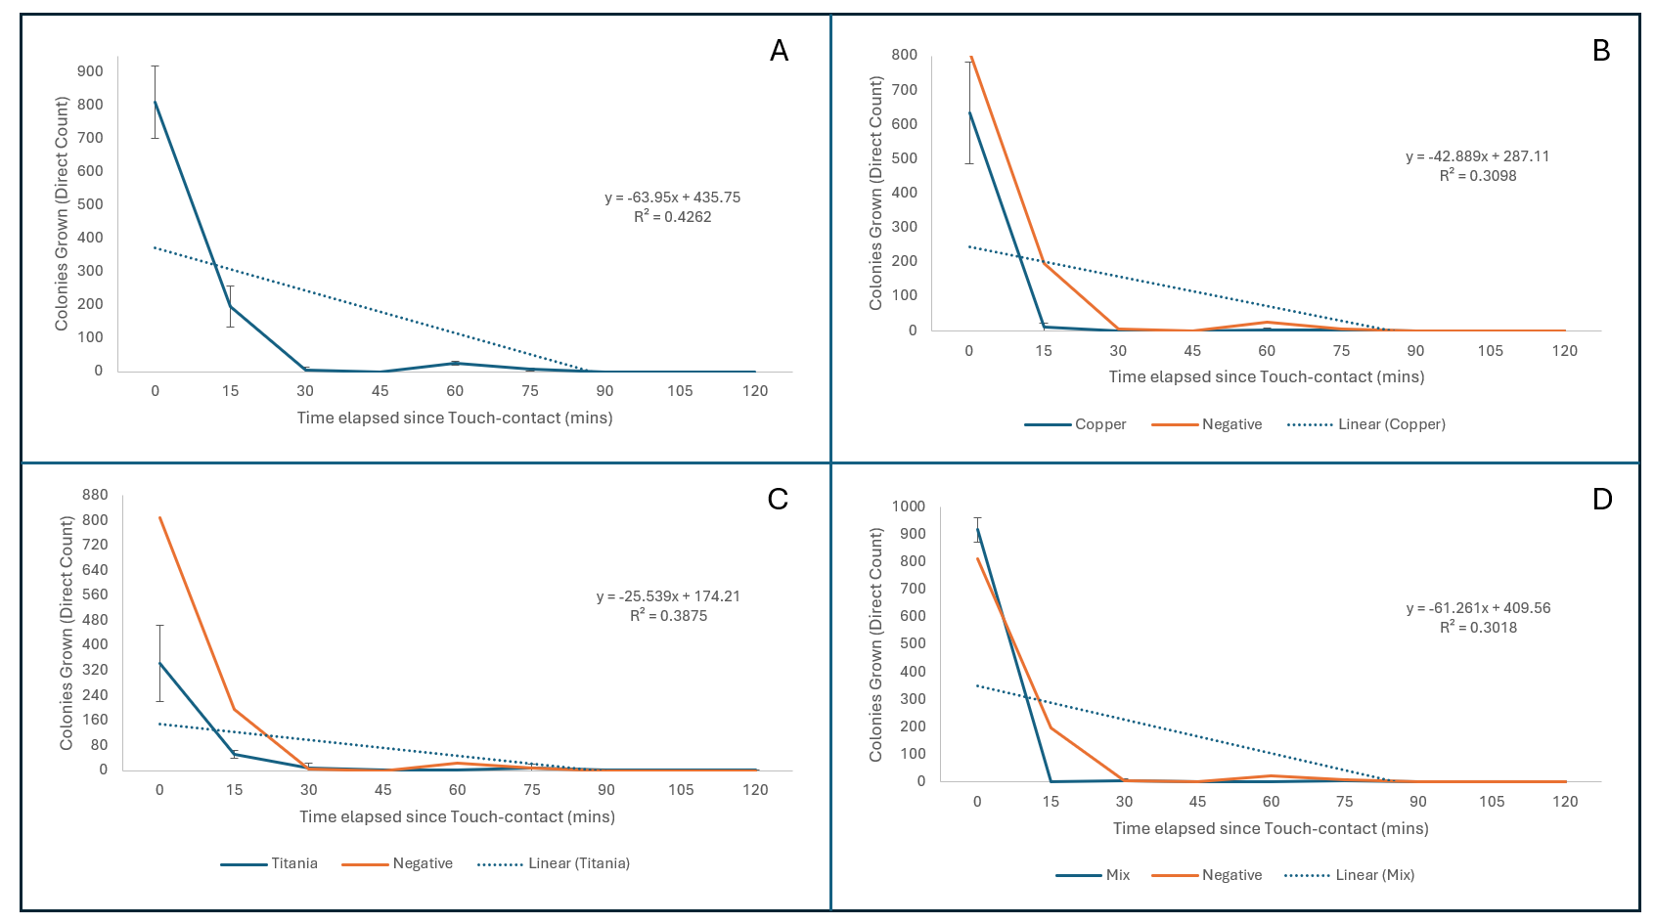
Figure 24 Results showing the average survival rates of E. cloacae on a) uncoated Brushed Steel, b) CuO coated Brushed Steel, c) TiO coated Brushed Steel, d) Cuo + TiO coated Brushed Steel. T=0 starts once the surface has been removed from the inoculated agar following touch contact. Error Bars represent Standard Deviation (SD calculated using 3 replicates of each data point).

Figure 25 Percentage change in E. cloacae recovered from coated steel variants after 15 and 30 minutes of exposure. Positive percentage represents the increase in recovered cells compared to that recovered at the previous timepoint. Negative bars represent uncoated variant.

Table 4.11 Matrix of p-values from One-Tailed Mann-Whitney analysis of each Coated Surface on Brushed Steel against E. cloacae
 | Negative
Copper Oxide | 0.17619 | Copper Oxide
Titania | 0.32997 | 0.10749 | Titania
Copper Titania Mix | 0.32997 | 0.26763 | 0.11702

On the various coated borosilicate glass samples, the average transfer counts of E. cloacae varied quite drastically. At T=0 uncoated (Figure 28a) borosilicate glass had an average count of 601.67 (1.5 CFU/mm²), Copper Oxide (Figure 28b) and Titania (Figure 28c) had similar average transfer counts with 324.67 (0.81 CFU/mm²) and 384 (0.96 CFU/mm²) respectively, and Copper-Titania (Figure 28d) coated borosilicate glass had an average of 163.67 (0.41 CFU/mm²). Irrespective of the variation in initial transfer counts, after 15 minutes of exposure each coated surface had a similar level reduction in average count of viable CFU, those being 89.7% on uncoated, 98.8% on Copper Oxide, 96.1% on Titania, and 97.2% on Copper-Titania coated borosilicate glass (Figure 29). Against E. cloacae all borosilicate glass samples successfully reached an average of 0 CFU, uncoated (Figure 28a) recovered an average of 0 CFU at T=90, Copper Oxide (Figure 28b) at T=30, Titania (Figure 28c) at T=90, and Copper-Titania (Figure 28d) at T=45. Mann-Whitney and Kruskal-Wallis with Dunn post-hoc analyses of these results identified no significant difference between any 2 of the coated surfaces (Table 13).

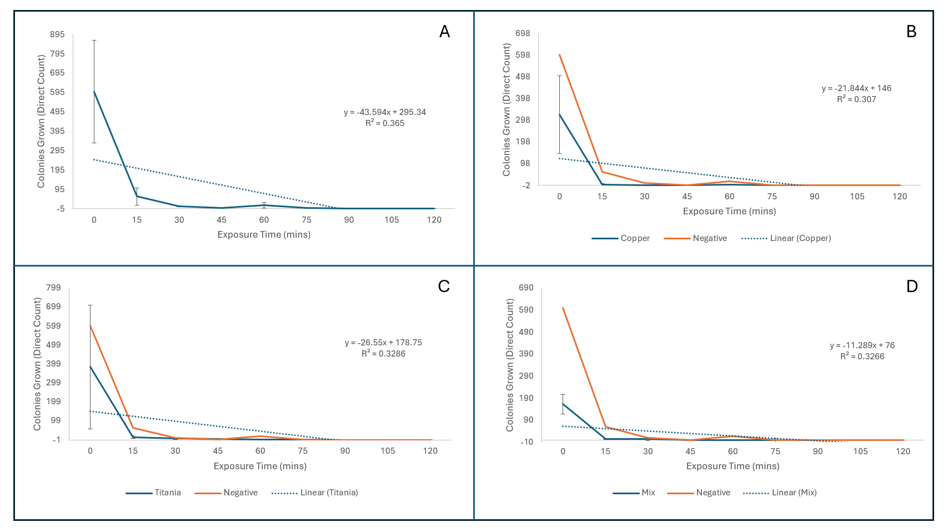
Figure 26 Results showing the average survival rates of E. cloacae on a) uncoated Borosilicate Glass, b) CuO coated Borosilicate Glass, c) TiO coated Borosilicate Glass, d) CuO + TiO coated Borosilicate Glass. T=0 starts once the surface has been removed from the inoculated agar following touch contact. Error Bars represent Standard Deviation (SD calculated using 3 replicates of each data point).

Figure 27 Percentage change in E. cloacae recovered from coated borosilicate glass variants after 15 and 30 minutes of exposure. Positive percentage represents the increase in recovered cells compared to that recovered at the previous timepoint. Negative bars represent uncoated variant.

Table 4.12 Results matrix of p-values from One-Tailed Mann-Whitney analysis of each Coated Surface on Borosilicate Glass against E. cloacae
 | Negative
Copper Oxide | 0.12507 | Copper Oxide
Titania | 0.48405 | 0.05155 | Titania
Copper Titania Mix | 0.16602 | 0.36317 | 0.10749

E. faecalis (ATCC 29212)

At T=0 the number of viable CFU transferred on all coated variants of brushed steel were not drastically different. Uncoated (Figure 30a) brushed steel transferred an average of 542 (1.36 CFU/mm²), Copper Oxide (Figure 30b) transferred an average of 515.33 (1.29 CFU/mm²), Titania (Figure 30c) transferred an average of 649.33 (1.62 CFU/mm²), and Copper-Titania (Figure 30d) had an average transfer of 719 CFU (1.8 CFU/mm²). 15 minutes following the initial touch inoculation of the sample surfaces there were reductions in the average counts of viable recovered CFU of 9.78% on uncoated brushed steel, 18.37% on Copper Oxide, 23.67% on Titania, and 42.47% on Copper-Titania coated brushed steel (Figure 31). All samples of brushed steel against E. faecalis successfully reached an average count of 0 viable recovered CFU, this was achieved after 90 minutes of exposure on all surface types. Mann-Whitney and Kruskal-Wallis analyses of the data collected identified no significant difference between any 2 of the surfaces tested.

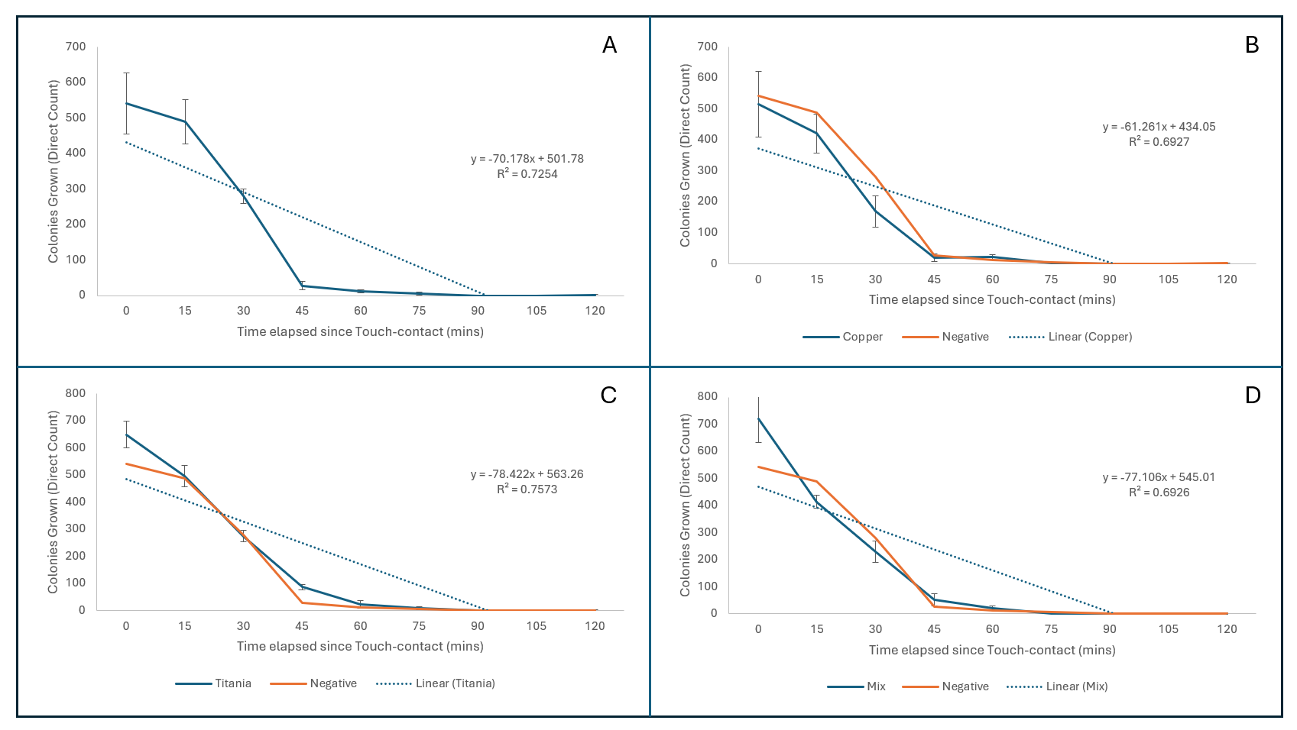
Figure 28 Results showing the average survival rates of E. cloacae on a) uncoated Brushed Steel, b) CuO coated Brushed Steel, c) TiO coated Brushed Steel, d) Cuo + TiO coated Brushed Steel. T=0 starts once the surface has been removed from the inoculated agar following touch contact. Error Bars represent Standard Deviation (SD calculated using 3 replicates of each data point).

Figure 29 Percentage change in E. faecalis recovered from coated steel variants after 15 and 30 minutes of exposure. Negative bars represent uncoated variant.

Table 4.13 Matrix of p-values from One-Tailed Mann-Whitney analysis of each Coated Surface on Brushed Steel against E. faecalis
 | Negative
Copper Oxide | 0.46414 | Copper Oxide
Titania | 0.46414 | 0.39743 | Titania
Copper Titania Mix | 0.46414 | 0.44828 | 0.39743

Against E. faecalis the borosilicate glass samples at T=0 had little variation in the average counts of recovered viable CFU. At T=0 on uncoated (Figure 32a) borosilicate glass the average count of recovered CFU was 482.67 (1.21 CFU/mm²), for Copper Oxide (Figure 32b), Titania (Figure 32c), and Copper-Titania (Figure 32d) coated borosilicate glass at the same timepoint the average counts were 484 (1.21 CFU/mm²), 654.33 (1.64 CFU/mm²), and 561.67 (1.4 CFU/mm²) respectively. After 15 minutes of exposure to the surfaces there were reductions of 22.11% on Copper Oxide, 17.52% on Titania, and 17.63% on Copper-Titania coated borosilicate glass. On the uncoated borosilicate glass however, there was a 4.7% increase in average viable recovered CFU (Figure 33). Versus E. faecalis all borosilicate glass samples successfully reached an average recovered CFU of 0, this occurred for all sample types at T=90. Mann-Whitney and Kruskal-Wallis with Dunn post-hoc analyses of this data identified no significant difference between any 2 groups within this dataset (Table 15).

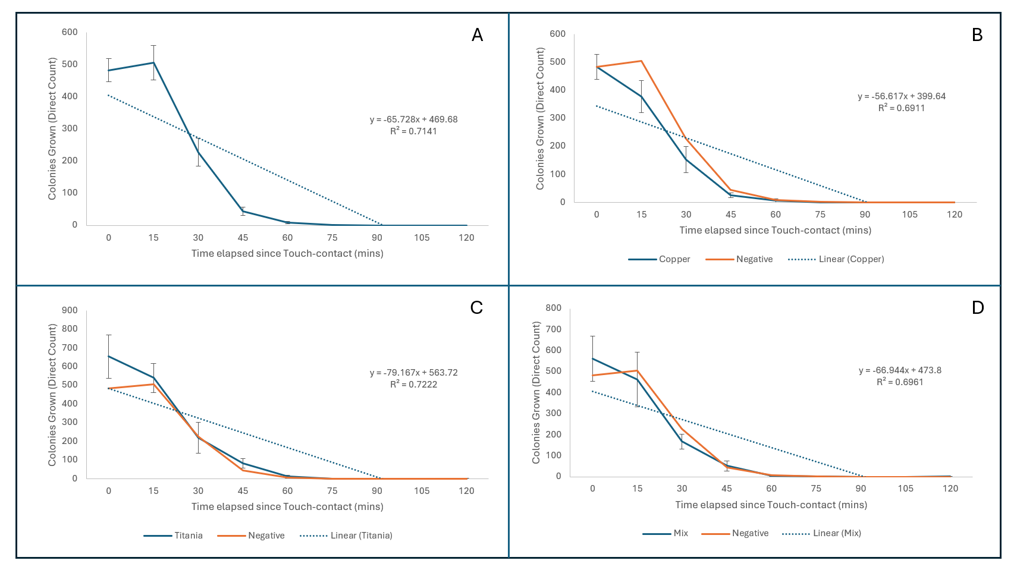
Figure 30 Results showing the average survival rates of E. cloacae on a) uncoated Borosilicate Glass, b) CuO coated Borosilicate Glass, c) TiO coated Borosilicate Glass, d) CuO + TiO coated Borosilicate Glass. T=0 starts once the surface has been removed from the inoculated agar following touch contact. Error Bars represent Standard Deviation (SD calculated using 3 replicates of each data point).

Figure 31 Percentage change in E. faecalis recovered from coated borosilicate glass variants after 15 and 30 minutes of exposure. Positive percentage represents the increase in recovered cells compared to that recovered at the previous timepoint. Negative bars represent uncoated variant.

Table 4.14 Matrix of p-values from One-Tailed Mann-Whitney analysis of each Coated Surface on Borosilicate Glass against E. faecalis.
 | Negative
Copper Oxide | 0.46414 | Copper Oxide
Titania | 0.37828 | 0.32997 | Titania
Copper Titania Mix | 0.46414 | 0.42858 | 0.42858

Graphs Containing Collated Data from Each Bacterial Species

The following graphs contain all the collated data from each bacterial lab strain used to test the antimicrobial activity of CVD coated surfaces created at the University of Salford. All graphs show the cell survival rates from T=0 to T=120 with counts taken in 15-minute increments. Figure 34 and Figure 35 show the bacterial transfer results all lab strains on uncoated brushed steel and borosilicate glass surfaces, Figure 36 and Figure 37 show the bacterial transfer results of all strains on copper oxide coated brushed steel and borosilicate glass surfaces, Figure 38 and Figure 39 show the bacterial transfer results for all lab strains on Titania coated brushed steel and borosilicate glass surfaces, and Figure 40 and Figure 41 show the bacterial transfer results for all lab strains on Copper-Titania coated brushed steel and borosilicate glass surfaces.

Figure 32 Line Graph to show average cell survival rates of all bacterial species on uncoated brushed steel.

Figure 33 Line Graph to show average cell survival rates of all bacterial species on uncoated borosilicate glass.

Figure 34 Line Graph to show average cell survival rates of all bacterial species on copper oxide - coated brushed steel.

Figure 35 Line Graph to show average cell survival rates of all bacterial species on copper oxide - coated borosilicate glass.

Figure 36 Line Graph to show average cell survival rates of all bacterial species on Titania - coated brushed steel.

Figure 37 Line Graph to show average cell survival rates of all bacterial species on Titania - coated borosilicate glass.

Figure 38 Line Graph to show average cell survival rates of all bacterial species on copper oxide and Titania - coated brushed steel.

Figure 39 Line Graph to show average cell survival rates of all bacterial species on copper oxide and Titania - coated borosilicate glass.

Real-World Swab Data

In collaboration with the Salford Podiatry Clinic located at the University of Salford 2 boards located within the clinic were swabbed approximately once per month for 4 months. Table 16 contains all clinical isolate data collected from swabs of the sample board located within a patient booth. Table 17 shows all clinical isolate data collected from swabs of the sample board located in the reception area of the podiatry clinic. Both tables reflect the dates each sample surface was swabbed, the number of each clinical isolate, Gram stain result and a description of cell morphology.

Set 1 – Clinical Isolate data (Patient Booth)

Table 4.15 Table to show the Clinical Isolate data record for Coated Sample board located in a patient booth within the Salford Podiatry Clinic. Negative surface coating refers to the uncoated surface variant.
Isolate Number | Date Collected | Coated Surface | Gram Stain | Cell Shape
5 | 24/07/2023 | Mix | Positive | COCCCUS
6 | 24/07/2023 | Negative
7 | 24/07/2023 | Negative | Positive | COCCCUS
9 | 24/07/2023 | Negative | Positive | COCCCUS
10 | 24/07/2023 | Negative | Positive | COCCCUS
11 | 24/07/2023 | Negative | Positive | COCCCUS
21 | 09/08/2023 | Mix | Positive | COCCCUS
22 | 09/08/2023 | Negative | Positive | BACILLUS
23 | 09/08/2023 | Negative | Negative | BACILLUS
29 | 09/08/2023 | Titania | Negative | BACILLUS
30 | 09/08/2023 | Titania | Positive | COCCCUS
31 | 07/09/2023 | Mix
32 | 07/09/2023 | Mix
33 | 07/09/2023 | Mix
34 | 07/09/2023 | Mix
35 | 07/09/2023 | Mix
36 | 07/09/2023 | Mix
37 | 07/09/2023 | Negative
38 | 07/09/2023 | Negative
39 | 07/09/2023 | Negative
40 | 07/09/2023 | Negative
41 | 07/09/2023 | Negative
42 | 07/09/2023 | Negative
43 | 07/09/2023 | Negative
44 | 07/09/2023 | Negative
45 | 07/09/2023 | Copper
46 | 07/09/2023 | Copper
47 | 07/09/2023 | Copper
48 | 07/09/2023 | Titania
49 | 07/09/2023 | Titania
76 | 13/10/2023 | Negative | Negative | BACILLUS
77 | 13/10/2023 | Titania | Positive | COCCCUS
78 | 13/10/2023 | Titania | Positive | COCCCUS
79 | 13/10/2023 | Titania | Positive | COCCCUS
80 | 13/10/2023 | Titania | Positive | COCCCUS
81 | 13/10/2023 | Titania | Positive | COCCCUS
82 | 13/10/2023 | Mix | Positive | BACILLUS
NB: Isolate Number (IN) 6 and IN 31-49 either dried out on their agar plates or did not regrow after being isolated and were unable to be processed for Gram staining.

Set 2 – Clinical Isolate Data (Clinic Reception)

Table 4.16 Table to show the Clinical Isolate data record for Coated Sample board located in the reception area located within the Salford Podiatry Clinic. Negative surface coating refers to the uncoated surface variant
Isolate Number | Date Collected | Coated Surface | Gram Stain | Cell Shape
1 | 24/07/2023 | Negative | Positive | COCCUS
2 | 24/07/2023 | Negative
3 | 24/07/2023 | Negative | Positive | BACILLUS
4 | 24/07/2023 | Copper | Positive | BACILLUS
8 | 24/07/2023 | Mix | Positive | BACILLUS
12 | 30/06/2023 | Negative | Positive | COCCUS
13 | 30/06/2023 | Negative | Positive | BACILLUS
14 | 30/06/2023 | Titania | Negative | COCCUS
15 | 30/06/2023 | Titania | Positive | COCCUS
16 | 30/06/2023 | Titania | Positive | COCCUS
17 | 30/06/2023 | Copper | Positive | COCCUS
18 | 30/06/2023 | Negative | Negative | BACILLUS
19 | 30/06/2023 | Negative | Positive | COCCUS
20 | 30/06/2023 | Negative | Positive | COCCUS
24 | 09/08/2023 | Copper | Negative | COCCUS
25 | 09/08/2023 | Copper | Positive | COCCUS
26 | 09/08/2023 | Titania | Positive | COCCUS
27 | 09/08/2023 | Titania | Positive | COCCUS
28 | 09/08/2023 | Mix | Positive | COCCUS
50 | 07/09/2023 | Negative | Positive | COCCUS
51 | 07/09/2023 | Negative | Positive | COCCUS
52 | 07/09/2023 | Negative | Positive | COCCUS
53 | 07/09/2023 | Negative | Positive | COCCUS
54 | 07/09/2023 | Negative | Positive | COCCUS
55 | 07/09/2023 | Negative | Positive | COCCUS
56 | 07/09/2023 | Negative | Negative | BACILLUS
57 | 07/09/2023 | Negative | Positive | COCCUS
58 | 07/09/2023 | Negative | Positive | COCCUS
59 | 07/09/2023 | Negative | Negative
60 | 07/09/2023 | Copper | Positive | COCCUS
61 | 07/09/2023 | Copper | Positive | COCCUS
62 | 07/09/2023 | Copper | Positive | COCCUS
63 | 07/09/2023 | Copper | Negative | BACILLUS
64 | 07/09/2023 | Copper | Negative | BACILLUS
65 | 07/09/2023 | Titania | Positive | COCCUS
66 | 07/09/2023 | Titania | Negative | COCCUS
67 | 07/09/2023 | Titania | Negative | BACILLUS
68 | 07/09/2023 | Titania | Positive | COCCUS
69 | 07/09/2023 | Titania | CONTAMINATED
70 | 07/09/2023 | Titania | Positive | COCCUS
71 | 07/09/2023 | Mix | Positive | COCCUS
72 | 07/09/2023 | Mix | Positive | COCCUS
73 | 07/09/2023 | Mix | CONTAMINATED
74 | 07/09/2023 | Mix | Positive | BACILLUS
75 | 07/09/2023 | Mix | CONTAMINATED
84 | 13/10/2023 | Negative | CONTAMINATED
85 | 13/10/2023 | Negative | Negative | BACILLUS
86 | 13/10/2023 | Negative | Positive | COCCUS
87 | 13/10/2023 | Negative | Positive | COCCUS
88 | 13/10/2023 | Negative | Positive | BACILLUS
89 | 13/10/2023 | Negative
90 | 13/10/2023 | Negative | Positive | COCCUS
91 | 13/10/2023 | Negative | Positive | COCCUS
92 | 13/10/2023 | Negative | Positive | COCCUS
93 | 13/10/2023 | Negative
94 | 13/10/2023 | Negative | Positive | BACILLUS
95 | 13/10/2023 | Negative | Positive | COCCUS
96 | 13/10/2023 | Negative | Positive | COCCUS
97 | 13/10/2023 | Negative | Positive | COCCUS
98 | 13/10/2023 | Negative | Positive | COCCUS
99 | 13/10/2023 | Negative | Positive | COCCUS
100 | 13/10/2023 | Negative | Positive | COCCUS
101 | 13/10/2023 | Negative | Positive | COCCUS
102 | 13/10/2023 | Negative | Positive | COCCUS
103 | 13/10/2023 | Negative | Negative | COCCUS
104 | 13/10/2023 | Negative | Positive | COCCUS
105 | 13/10/2023 | Copper | Positive | BACILLUS
106 | 13/10/2023 | Copper | Positive | COCCUS
107 | 13/10/2023 | Copper | Positive | COCCUS
108 | 13/10/2023 | Copper | Positive | COCCUS
109 | 13/10/2023 | Copper | Positive | COCCUS
110 | 13/10/2023 | Copper | Positive | COCCUS
111 | 13/10/2023 | Copper | Positive | COCCUS
112 | 13/10/2023 | Copper | Positive | ?
113 | 13/10/2023 | Copper | Negative | BACILLUS
114 | 13/10/2023 | Copper | Positive | COCCUS
115 | 13/10/2023 | Copper | Positive | COCCUS
116 | 13/10/2023 | Copper | Positive | BACILLUS
117 | 13/10/2023 | Copper | Positive | COCCUS
118 | 13/10/2023 | Copper | Positive | COCCUS
119 | 13/10/2023 | Copper | Positive | BACILLUS
120 | 13/10/2023 | Copper | Positive | BACILLUS
121 | 13/10/2023 | Copper | Positive | COCCUS
122 | 13/10/2023 | Copper | Positive | COCCUS
123 | 13/10/2023 | Copper | Positive | COCCUS
124 | 13/10/2023 | Copper | Negative | BACILLUS
125 | 13/10/2023 | Titania | Positive | BACILLUS
126 | 13/10/2023 | Titania | Positive | COCCUS
127 | 13/10/2023 | Titania | Negative | COCCUS
128 | 13/10/2023 | Titania | Positive | COCCUS
129 | 13/10/2023 | Titania | Positive | COCCUS
130 | 13/10/2023 | Titania | Positive | COCCUS
131 | 13/10/2023 | Titania | Negative | BACILLUS
132 | 13/10/2023 | Titania | Positive | COCCUS
133 | 13/10/2023 | Titania | Positive | COCCUS
134 | 13/10/2023 | Titania | Negative | COCCUS
135 | 13/10/2023 | Titania | Negative | COCCUS
136 | 13/10/2023 | Titania | Positive | COCCUS
137 | 13/10/2023 | Titania | Positive | COCCUS
138 | 13/10/2023 | Titania | Positive | BACILLUS
139 | 13/10/2023 | Titania | Positive | COCCUS
140 | 13/10/2023 | Titania | Positive | COCCUS
141 | 13/10/2023 | Titania | Positive | COCCUS
142 | 13/10/2023 | Titania | Positive | BACILLUS
143 | 13/10/2023 | Titania | Positive | COCCUS
144 | 13/10/2023 | Titania | Positive | COCCUS
145 | 13/10/2023 | Titania | Negative | COCCUS
146 | 13/10/2023 | Titania | Positive | COCCUS
147 | 13/10/2023 | Titania | Positive | COCCUS
148 | 13/10/2023 | Titania | Positive | COCCUS
149 | 13/10/2023 | Titania | Positive | COCCUS
150 | 13/10/2023 | Titania | Positive | COCCUS
151 | 13/10/2023 | Titania | Positive | COCCUS
152 | 13/10/2023 | Titania | Positive | COCCUS
153 | 13/10/2023 | Titania | Positive | COCCUS
154 | 13/10/2023 | Mix | Positive | COCCUS
155 | 13/10/2023 | Mix | Positive | COCCUS
156 | 13/10/2023 | Mix | Positive | COCCUS
157 | 13/10/2023 | Mix | Positive | COCCUS
158 | 13/10/2023 | Mix | Positive | COCCUS
159 | 13/10/2023 | Mix | Positive | BACILLUS
160 | 13/10/2023 | Mix | Positive | COCCUS
161 | 13/10/2023 | Mix | Negative | BACILLUS
162 | 13/10/2023 | Mix | Negative | COCCUS
163 | 13/10/2023 | Mix | Positive | COCCUS
164 | 13/10/2023 | Mix | Positive | COCCUS
165 | 13/10/2023 | Mix | Positive | COCCUS
166 | 13/10/2023 | Mix | Positive | COCCUS
167 | 13/10/2023 | Mix | Positive | COCCUS
168 | 13/10/2023 | Mix | Positive | BACILLUS
169 | 13/10/2023 | Mix | Positive | COCCUS
170 | 13/10/2023 | Mix | Positive | COCCUS
171 | 13/10/2023 | Mix | Positive | COCCUS
172 | 13/10/2023 | Mix | Positive | COCCUS
173 | 13/10/2023 | Mix | Positive | COCCUS
174 | 13/10/2023 | Mix | Positive | COCCUS
175 | 13/10/2023 | Mix | Positive | COCCUS
176 | 13/10/2023 | Mix | Positive | COCCUS
177 | 13/10/2023 | Mix | Positive | COCCUS
178 | 13/10/2023 | Mix | Positive | COCCUS
179 | 13/10/2023 | Mix | Negative | COCCUS
NB: IN 2, 89, and 93 either dried out or did not regrow after being isolated thus were unable to be processed for Gram staining.

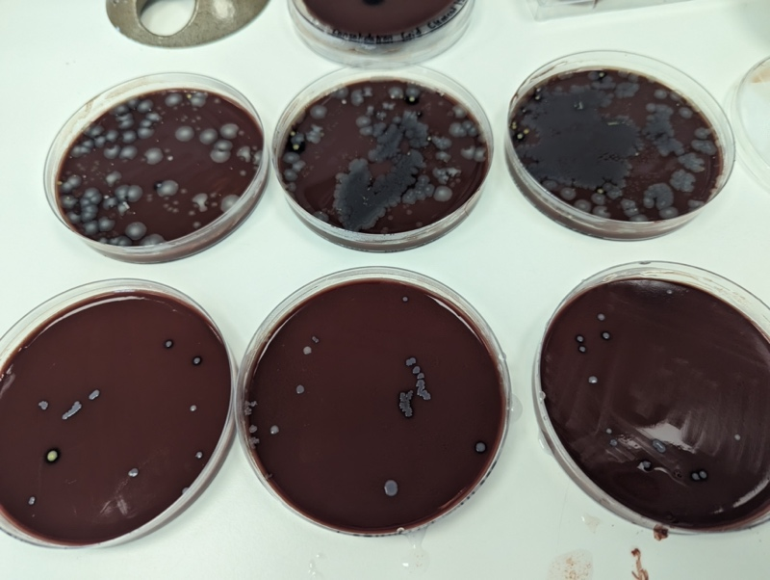

Figure 40Photograph to show the comparison of swab culture plates. Plates at the top were inoculated with swabs collected from the fallen board, swabs at the bottom were collected from the board that remained mounted.

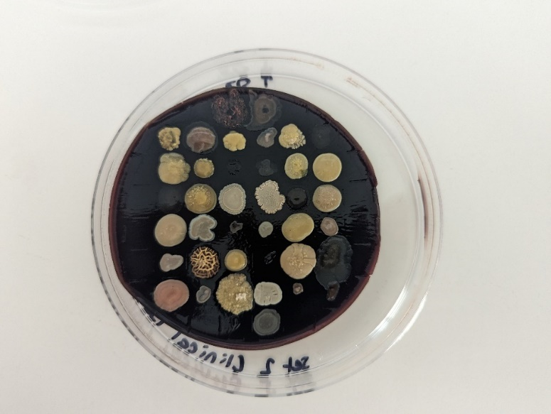
Figure 41 Clinical Isolate grids on Chocolate agar (5% defibrinated horse blood)
NB. Set 2 of Clinic boards was discovered face up of the floor of the clinic after 4 months of swabs, this led to large quantities of previously non-present bacterial species being recovered during swabbing. This made isolating and archiving every single colony cultured from Set 2 an impossible task, from this point approximately 20% of all colonies were isolated, with care given to make sure any unique colonies were given priority.

Overall Distribution of Clinical Isolate Cell Characteristics

Figure 42 shows the changes in isolates collected from Salford Podiatry Clinic (Table 17) over time. Comparisons of Gram status and cell morphology throughout the microbial communities cultured from the coated surfaces tells a visual story of how the communities have evolved over several months. The highest ratio of Cocci : Bacilli (87.2%) was recovered from the TiO coated panel situated in the reception area of the clinic. Similarly, Gram positive bacteria dominated the overall bacterial diversity recovered from the surfaces. The CuO + TiO coated sample on the board located in the reception area supported the greatest quantity of Gram positive : Gram negative (90.3%). Not enough isolates were collected from the coated surfaces located in the Patient Booth within the clinic to make any meaningful or significant comparisons.
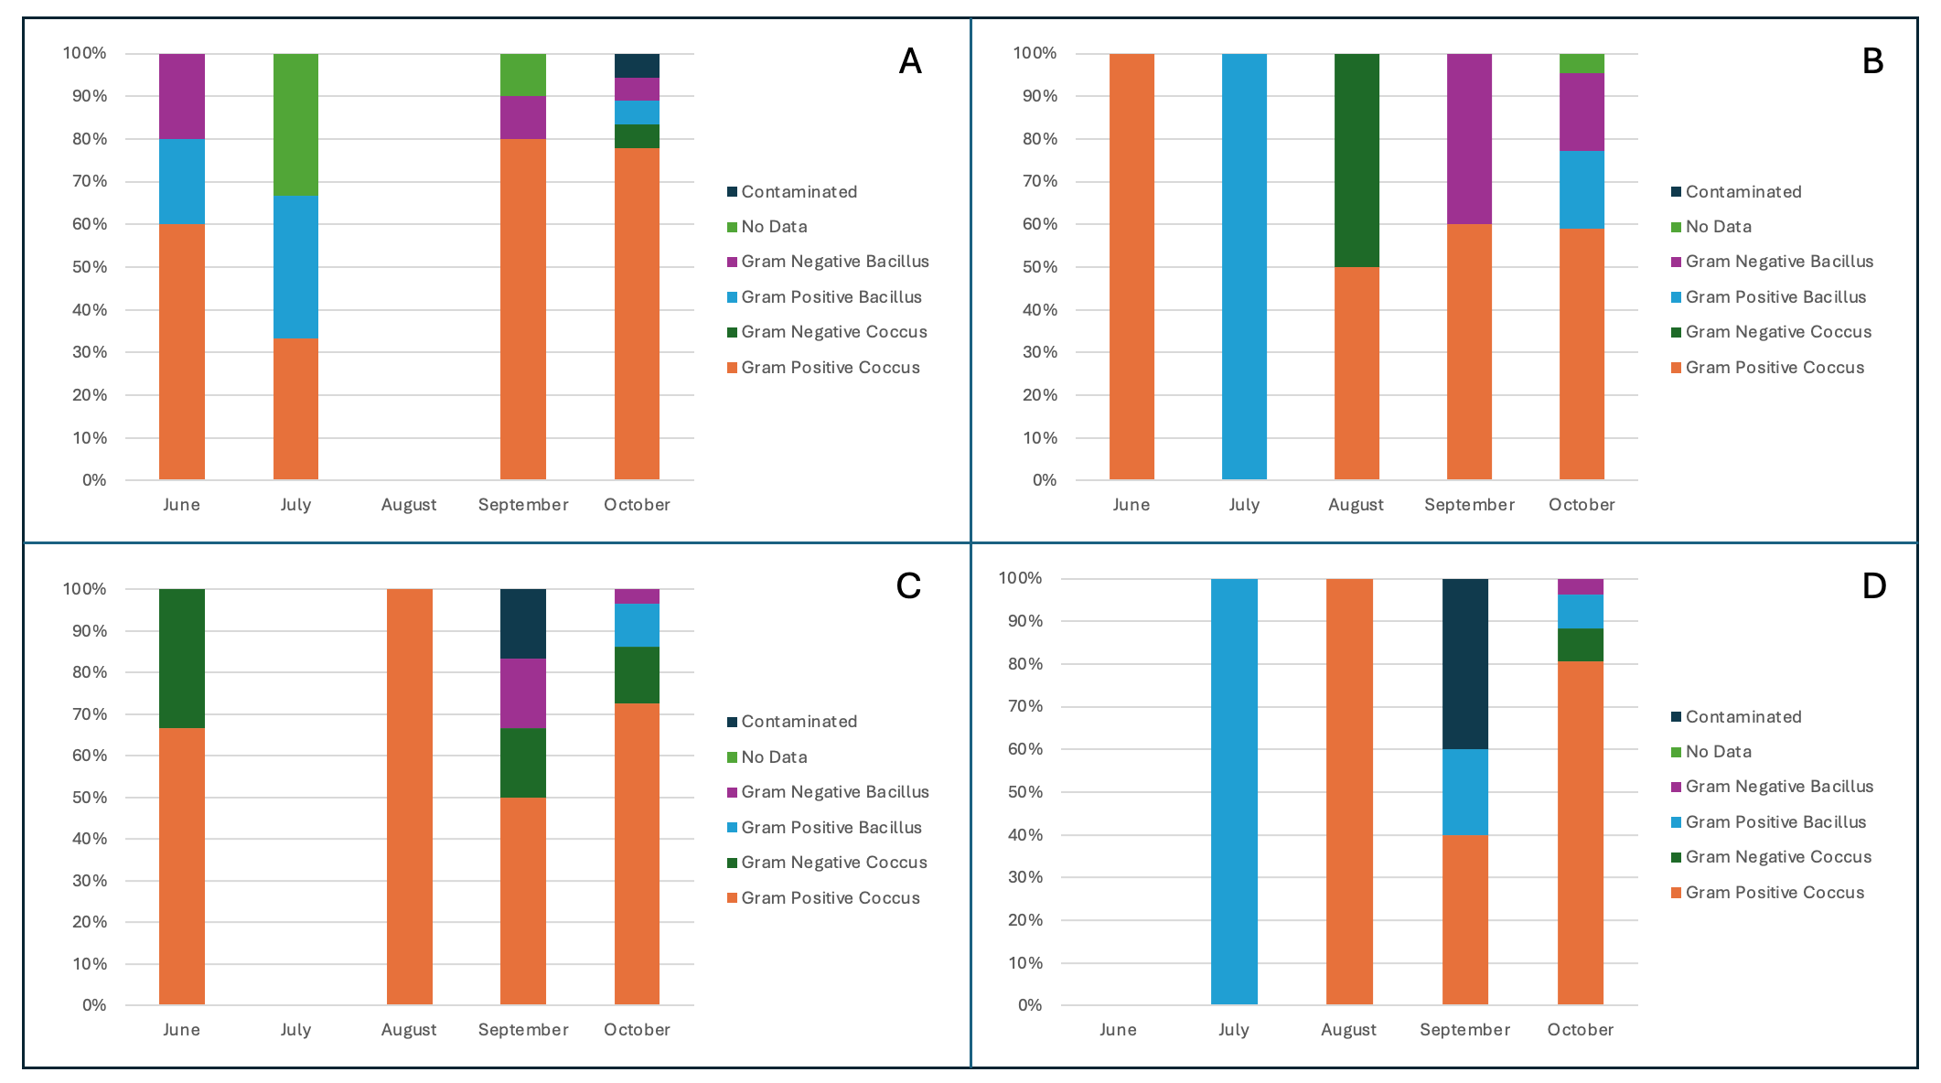
Figure 42 Temporal changes in bacterial communities isolated from coated surface panels in Salford Podiatry Clinic (Reception). A) Uncoated brushed steel, B) Copper Oxide Coated brushed steel, C) Titania coated brushed steel, D) Copper Oxide + Titania coated brushed steel.

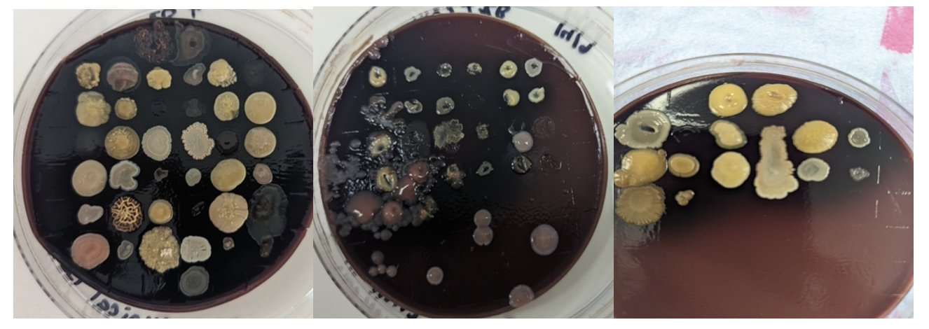Figure 43 Photographs of Clinical Isolates on Chocolate agar supplemented with 5% defibrinated Horse blood .

Considerations and Conclusions

The first official method for infection control in a hospital setting was simple hand washing between patients (Tyagi & Barwal, 2020). This basic hygiene measure is key in infection prevention and control and has been implemented in almost all service industries ranging from healthcare to food and hospitality. In a world where antibiotic resistance is a critical concern and the progress to creating new antibiotics is becoming increasingly slower there needs to be a shifting in focus from the development of novel antibiotics to the implementation of new, operational ways of controlling the transmission of infection, effectively preventing infectious diseases before they can occur. Antimicrobial metals represent a great resource that the scientific community are taking advantage of when researching methods of controlling infections whether that be through impregnating surfaces with nanoparticles or completely coating surfaces with antimicrobial metals. These metals disturb the integrity of any microbes that encounter them, e.g., through disruption of the cell wall, or by creating oxidative stress within the cell (i.e., free radicals) causing cellular death (Frei et al., 2023). Deemed too toxic for use as in vivo treatments, antimicrobial metals can be used in the real world as a means of infection control by preventing survival and transmission of pathogens in the built environment. Though expensive, new thin film deposition methods are enabling cheaper and more sustainable production of antimicrobial coated surfaces (Evans & Kavanagh, 2021; Pohanka, 2019).

This project focused on testing the effectiveness of specific antimicrobial coated surfaces, developed at the University of Salford, as a means of infection control. These surfaces, created through Chemical Vapour Deposition, were based on either brushed steel or borosilicate glass, both bases were initially vigorously tested to quantify the survival of reference strains of representative ESKAPE pathogens (E. coli, S. aureus, K. pneumoniae, A. baumannii, P. aeruginosa, E. faecalis, and E. cloacae). Brushed steel metal-coated surfaces were then implemented in a clinical setting to observe the effect of copper and titania coatings on the diversity of microorganisms that could persist on surfaces in a real-world setting. The longevity of the surfaces, and any potential metal-resistant bacteria were monitored by keeping thorough isolate records which would allow for the identification of persistent microbial populations found on the surfaces across multiple visits.

The empirical data presented in this report suggest that there is potential antimicrobial activity of some of the metal coated surfaces. Particularly the CuO coatings on both brushed steel and borosilicate glass against E. faecalis, both showing reductions of over 59% after 30 minutes of exposure following initial inoculation. However, the evidence suggests no significant difference in antimicrobial activity of the metal-coated surfaces (neither brushed steel or borosilicate glass) compared to the negative controls used in the same setting. This was surprising as published reports on similar coating types have shown significant increased killing effects of the coatings compared to controls within 2 hours. For example, Subramanian et al., 2015 found that thin-film metal-coated glass (including Cu) was effective at reducing the burden of E. coli and S. aureus. Furthermore, Mitra et al., 2020 exposed MRSA to Cu thin film coated surfaces for 2 hours and saw significant reductions in viable cells compared to controls. Perhaps virulence factors such as adhesins that directly affect the transmission of the cells from one surface to another rather than those that increase cell fitness and survival are key in the recovery of cells from the surfaces, or the electrophysiological interactions of the bacterial cells with the metal coated surfaces may impact the cell recovery, the specifics of each potential factor may differ between bacterial strains, therefore results using the same bacterial species but different strains may record different results . Zheng et al., 2021 discuss how the long chain glycans present in the cell membrane of Gram positive bacteria cause the body of the cell to become negatively electrically charged causing the cells to adhere to certain surface types more than others. Jindai et al., 2020 investigated whether cell motility plays a role in adherence to different glass surfaces (hydrophobic and hydrophilic). Focusing on genetically modified E. coli (Wild Type, Flagellated, Flagellated with deficient motility, and deficient chemotaxis) they concluded that motile strains adhered more strongly to hydrophobic surfaces, and non-motile strains adhered more strongly to hydrophilic surfaces, this alongside the impact on adherence electrophysiological charge may incur may to help explain the great variance in recovery rates from identical surfaces across the different species used.

Despite thorough testing there were several limitations that may have affected the outcome of the bacterial transfer investigations. One of the most obvious issues encountered during the bacterial transfers was the presence of air bubbles formed underneath the surfaces when contacting both the inoculated agar and the fresh sterile agar. This was more easily identified with the transparent borosilicate glass squares. The evidence to support this can be seen in (Figure 88), large spaces across the transfer area that were colony free suggest improper surface contact. As air bubbles appeared to be present in all repeats of the borosilicate glass tests (where they were visible through the glass) the assumption was made that they would also be present in the brushed steel tests also. As there was no way to prevent the air bubbles or to determine their presence during the brushed steel tests it was decided that all data collected with bubbles present was to be used in the statistical analyses portion of the project. Although it was possible to accurately exclude them from the borosilicate glass analyses, this would unfairly skew the results against brushed steel as excluding results that “appeared” to have bubbles present wouldn’t give the same accuracy.

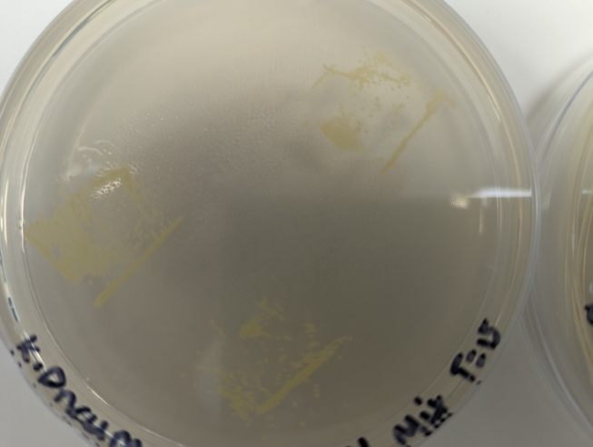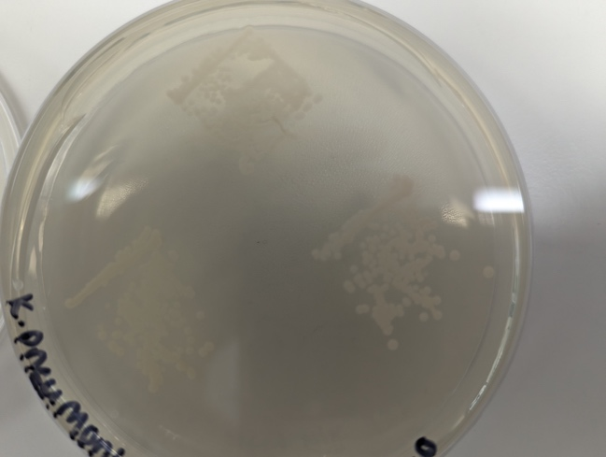
Figure 44 Photographs to show the improper contact of coated surfaces after bacterial transfers were completed.

Another potential limitation of this project questions the longevity of the surface coatings directly. Microscopic imaging analysis showed microscopic crevices across the coated surfaces where small accumulations of the coating materials had built up (H. Yates personal communication, 2023). These crevices were not visible to the naked eye, therefore improper cleaning of the re-cycled surfaces could have created areas large enough for clusters of bacterial cells to collect and persist.

Francone et al., 2021 discusses how surface topography plays a role in the efficiency of antimicrobial activity. They investigated how patterned surfaces behave in contrast to unpatterned surfaces using micro and nano structures to combat the inefficiencies observed from nanostructure-only surface coatings and found significantly greater antimicrobial activity from the micro/nano patterned surface in comparison to other test surfaces. An investigation into the antimicrobial properties of Cu-Ti thin film surface coatings by Wojcieszak et al., 2015 concludes that certain properties of the surface topography may actually promote bacterial cellular adhesion to the surface, alongside this they conclude that Cu thin films are unstable when in contact with materials such as nutrient agars and do not show much resistance to wear and tear from environmental exposure. Furthermore, it has been concluded that rough, unpolished surfaces have surface imperfections such as grooves, crevices, and microscopic scratches (especially those of similar size to bacterial cells) that facilitate the adhesion of bacterial cells to the surface (Bento de Carvalho et al., 2024). Such characteristics were evident around the edges of the coated surface samples used in this study (Figure 87). Moreover, visible oxidation of the steel surfaces was visible. Further work is needed to investigate the implications of microscopic crevices and oxidation on both antimicrobial properties and stability of such materials before they could be considered for long term public use. Due to the lengthy time it took to produce the CVD surfaces, coupled with cost it was determined that reusing the surfaces until visibly blemished was the best way to proceed, if production time and cost of producing the surfaces wasn’t an issue, fresh surfaces should be used for each individual bacterial transfer test.
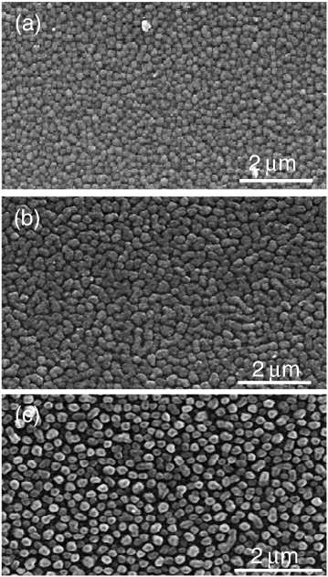
Figure 45 SEM of Copper Oxide film coated surface created by CVD – provided by H. Yates, 2024. Image shows the distribution of deposited Copper Oxide creating a film across the surface of borosilicate glass.

A final limitation to the bacterial transfer investigations was observed during the stages of exposure. Whilst coated surfaces were left to stand in the class II hood following touch exposure to bacteria, they were observed to dry out within seconds. Moisture is known to play a critical role in the antimicrobial activity of these types of surfaces (Cunliffe et al., 2021; Redfern et al., 2018). Therefore, the rapid decline in bacterial numbers observed on the surfaces used in this study is likely due to rapid drying that may have masked any antimicrobial activity of the thin-film copper oxide coatings. Overall, the first part of this study suggested that there was no significant difference in the antimicrobial activity of any metal-coated surface (on borosilicate glass or brushed steel) against any of the 7 lab strains they were tested against in comparison to reference brushed steel and borosilicate glass controls. There were a few unforeseen extraneous variables that impacted the outcome of the bacterial transfers which at the time were not something we could control, for example, keeping the surfaces moist following inoculation for the duration of the bacterial exposure and the improper contact between the test surfaces and agar surfaces due to trapped air between the two. Although it could be argued that the method developed for this study is more representative of real-world transmission via touch, it does not support well controlled empirical comparisons. On reflection, use of the ISO protocol alongside the newly developed method would have been of value.
The role of moisture and environmental regulation on in vitro experimentation using antimicrobial coated surfaces has been explored by others (Ojeil et al., 2013; Redfern et al., 2018). Redfern et al., (2018) developed a self-enclosed unit which allows the user to control temperature and humidity via heating pads and salt chambers using an Arduino circuit and software developed at Manchester Metropolitan University (Redfern et al., 2018). It would be interesting to evaluate the antimicrobial properties of our thin-film coated test surfaces using this testing unit. We have already begun discussions on this and initiated the 3D-printing of the unit in collaboration with the team at MMU when access to the clinical setting was not possible. However, time constraints limited further progression with this once access to the podiatry clinic was granted.

The current study highlights the major question of how best to evaluate the antimicrobial activity of surfaces. Specific experimental set up is required in ISO protocols to ensure even surface contact and moisture; conditions that do not represent real-world scenarios. In attempting to create more realistic touch inoculation, the fundamental properties of the coatings were not realised. An alternative approach was employed to investigate the microbial diversity that accumulated on the prototype coated surfaces in situ in a podiatry clinic over a 6-month period.

Isolates were collected by swabbing each test surface throughout the 6 months for a comprehensive look at the types of bacterial cells that persisted on the surfaces. It was hypothesised that the surface colonisation of different species may impact the diversity of persisting microbial communities through competition or cooperation. It was evident that recoverable microbial communities from all surface types were dominated coccus-shaped bacteria. Generally, there was ubiquitous domination of Gram-positive cocci across all surface types, this fall in line with claims made by Cobrado et al., (2017) that the most common pathogens found on hospital surfaces are S. aureus, Vancomycin Resistant Enterococci, and Clostridium difficile. Time limitations meant that it was not possible to further investigate the identity of the bacteria recovered from each surface type. With more time, a range of techniques could have been applied to better characterise the diversity. Replica plating onto a range of selective media could have been used, including Pseudomonas selective agar, Mannitol Salt agar and MacConkey’s agar to determine key metabolic and resistance properties. These could have been used to guide a choice of Analytical Profile Index (API) testing or other rapid phenotypic tests to determine e.g. oxidase, catalase and coagulase production to distinguish likely species. Further genetic approaches could also have been applied including 16S rRNA sequencing of each isolate or metagenomic sequencing of pooled plate sweeps to determine relative diversity of genus types found on each surface type. In the absence of information about species identities, Figure 42 shows a qualitative representation of temporal shifts in microbial density, it could be postulated that the present and dominating microbes (generally Gram positive cocci) likely originated from the skin, such as S. aureus, E. faecalis, Clostridium difficile and Staphylococcus epidermidis among others due to their presence on surfaces in clinical settings and how often they are the causative agents of many hospital-acquired infections (Dancer, 2008; Martinez et al., 2003; Weaver et al., 2008). Despite the unfortunate event of one of the clinical boards being found on the floor, the boom in recovered clinical isolated from then on allows for the representation of a “dirty” environment and highlights the importance of proper sanitation in all healthcare related settings.

Despite considerable disruption of this study due to NHS administrative delays, limited access, fallen test boards and timing issues, a biobank of temporal isolates has been collated for future studies to identify the persistent species and further investigate any metal and antibiotic cross-resistance that may have been selected for. Further investigative studies involving metagenomics of current and evolving microbial communities found on the surfaces may deepen the understanding of microbial cooperation under environmental stressors. On high touch surfaces and medical equipment microbes have been observed surviving from a few hours to several months after initial contact with the surface therefore long-term studies of bacterial survival on self-cleaning surfaces or surfaces with antimicrobial coatings will help us understand the physiological changes the persistent cells are undergoing and how interspecies interactions may improve the survival and overall fitness of the pathogens (Cobrado et al., 2017; Shobo et al., 2020).

Bibliography

Abdi, S. N., Ghotaslou, R., Ganbarov, K., Mobed, A., Tanomand, A., Yousefi, M., Asgharzadeh, M., & Kafil, H. S. (2020). Acinetobacter baumannii Efflux Pumps and Antibiotic Resistance. Infection and Drug Resistance, 13, 423. https://doi.org/10.2147/IDR.S228089
Almasaudi, S. B. (2018). Acinetobacter spp. as nosocomial pathogens: Epidemiology and resistance features. Saudi Journal of Biological Sciences, 25(3), 586. https://doi.org/10.1016/J.SJBS.2016.02.009
Antibiotics - NHS. (n.d.). Retrieved November 27, 2023, from https://www.nhs.uk/conditions/antibiotics/
Asif, M., Alvi, I. A., & Ur Rehman, S. (2018). Insight into Acinetobacter baumannii: pathogenesis, global resistance, mechanisms of resistance, treatment options, and alternative modalities. Infection and Drug Resistance, 11, 1249. https://doi.org/10.2147/IDR.S166750
Baddour, L. M., Wilson, W. R., Bayer, A. S., Vance G. Fowler, J., Bolger, A. F., Levison, M. E., Ferrieri, P., Gerber, M. A., Tani, L. Y., Gewitz, M. H., Tong, D. C., Steckelberg, J. M., Baltimore, R. S., Shulman, S. T., Burns, J. C., Falace, D. A., Newburger, J. W., Pallasch, T. J., Takahashi, M., & Taubert, K. A. (2005). Infective Endocarditis. Circulation, 111(23). https://doi.org/10.1161/CIRCULATIONAHA.105.165564
Beganovic, M., Luther, M. K., Rice, L. B., Arias, C. A., Rybak, M. J., & Laplante, K. L. (2018). A Review of Combination Antimicrobial Therapy for Enterococcus faecalis Bloodstream Infections and Infective Endocarditis. Clinical Infectious Diseases: An Official Publication of the Infectious Diseases Society of America, 67(2), 303. https://doi.org/10.1093/CID/CIY064
Bengtsson-Palme, J., Kristiansson, E., & Larsson, D. G. J. (2018). Environmental factors influencing the development and spread of antibiotic resistance. FEMS Microbiology Reviews, 42(1), 68–80. https://doi.org/10.1093/FEMSRE/FUX053
Bento de Carvalho, T., Barbosa, J. B., & Teixeira, P. (2024). Assessing Antimicrobial Efficacy on Plastics and Other Non-Porous Surfaces: A Closer Look at Studies Using the ISO 22196:2011 Standard. Biology, 13(1). https://doi.org/10.3390/BIOLOGY13010059
Bianco, A., Quirino, A., Giordano, M., Marano, V., Rizzo, C., Liberto, M. C., Focà, A., & Pavia, M. (2016). Control of carbapenem-resistant Acinetobacter baumannii outbreak in an intensive care unit of a teaching hospital in Southern Italy. BMC Infectious Diseases, 16(1). https://doi.org/10.1186/S12879-016-2036-7
Chen, M., Yu, Q., & Sun, H. (2013). Novel Strategies for the Prevention and Treatment of Biofilm Related Infections. International Journal of Molecular Sciences, 14(9), 18488. https://doi.org/10.3390/IJMS140918488
Cobrado, L., Silva-Dias, A., Azevedo, M. M., & Rodrigues, A. G. (2017). High-touch surfaces: microbial neighbours at hand. European Journal of Clinical Microbiology & Infectious Diseases, 36(11), 2053. https://doi.org/10.1007/S10096-017-3042-4
Cunliffe, A. J., Askew, P. D., Stephan, I., Iredale, G., Cosemans, P., Simmons, L. M., Verran, J., & Redfern, J. (2021). How Do We Determine the Efficacy of an Antibacterial Surface? A Review of Standardised Antibacterial Material Testing Methods. Antibiotics, 10(9). https://doi.org/10.3390/ANTIBIOTICS10091069
Dancer, S. J. (2008). Importance of the environment in meticillin-resistant Staphylococcus aureus acquisition: the case for hospital cleaning. The Lancet Infectious Diseases, 8(2), 101–113. https://doi.org/10.1016/S1473-3099(07)70241-4
Das, D., Nath, B. C., Phukon, P., & Dolui, S. K. (2013). Synthesis and evaluation of antioxidant and antibacterial behavior of CuO nanoparticles. Colloids and Surfaces B: Biointerfaces, 101, 430–433. https://doi.org/10.1016/J.COLSURFB.2012.07.002
Davies, J., & Davies, D. (2010). Origins and Evolution of Antibiotic Resistance. Microbiology and Molecular Biology Reviews : MMBR, 74(3), 417. https://doi.org/10.1128/MMBR.00016-10
Davin-Regli, A., & Pagès, J. M. (2015). Enterobacter aerogenes and Enterobacter cloacae; versatile bacterial pathogens confronting antibiotic treatment. Frontiers in Microbiology, 6(MAY). https://doi.org/10.3389/FMICB.2015.00392
De Oliveira, D. M. P., Forde, B. M., Kidd, T. J., Harris, P. N. A., Schembri, M. A., Beatson, S. A., Paterson, D. L., & Walker, M. J. (2020). Antimicrobial Resistance in ESKAPE Pathogens. Clinical Microbiology Reviews, 33(3). https://doi.org/10.1128/CMR.00181-19
Dehbashi, S., Tahmasebi, H., Alikhani, M. Y., Keramat, F., & Arabestani, M. R. (2020). Distribution of Class B and Class A β-Lactamases in Clinical Strains of Pseudomonas aeruginosa: Comparison of Phenotypic Methods and High-Resolution Melting Analysis (HRMA) Assay. Infection and Drug Resistance, 13, 2037. https://doi.org/10.2147/IDR.S255292
Di Rosa, R., Creti, R., Venditti, M., D’Amelio, R., Arciola, C., Montanaro, L., & Baldassarri, L. (2006). Relationship between biofilm formation, the enterococcal surface protein (Esp) and gelatinase in clinical isolates of Enterococcus faecalis and Enterococcus faecium. FEMS Microbiology Letters, 256(1), 145–150. https://doi.org/10.1111/J.1574-6968.2006.00112.X
Duprè, I., Zanetti, S., Schito, A. M., Fadda, G., & Sechi, L. A. (2003). Incidence of virulence determinants in clinical Enterococcus faecium and Enterococcus faecalis isolates collected in Sardinia (Italy). Journal of Medical Microbiology, 52(6), 491–498. https://doi.org/10.1099/JMM.0.05038-0/CITE/REFWORKS
eucast: AST of bacteria. (n.d.). Retrieved June 10, 2024, from https://www.eucast.org/ast_of_bacteria
Evans, A., & Kavanagh, K. A. (2021). Evaluation of metal-based antimicrobial compounds for the treatment of bacterial pathogens. Journal of Medical Microbiology, 70(5), 1363. https://doi.org/10.1099/JMM.0.001363
Formation of Reactive Oxygen Species and Cellular Damage – The Alcohol Pharmacology Education Partnership. (n.d.). Retrieved November 22, 2023, from https://sites.duke.edu/apep/module-5-alcohol-and-babies/biology-and-chemistry-connections/formation-of-reactive-oxygen-species-and-cellular-damage/
Foster, T. J. (2019). Surface Proteins of Staphylococcus aureus . Microbiology Spectrum, 7(4). https://doi.org/10.1128/MICROBIOLSPEC.GPP3-0046-2018/ASSET/6B76DC1F-6A18-4373-903D-41E4F0699097/ASSETS/GRAPHIC/GPP3-0046-2018-FIG9.GIF
Fournier, P. E., & Richet, H. (2006). The epidemiology and control of Acinetobacter baumannii in health care facilities. Clinical Infectious Diseases, 42(5), 692–699. https://doi.org/10.1086/500202/2/42-5-692-TBL003.GIF
Francone, A., Merino, S., Retolaza, A., Ramiro, J., Alves, S. A., de Castro, J. V., Neves, N. M., Arana, A., Marimon, J. M., Torres, C. M. S., & Kehagias, N. (2021). Impact of surface topography on the bacterial attachment to micro- and nano-patterned polymer films. Surfaces and Interfaces, 27, 101494. https://doi.org/10.1016/J.SURFIN.2021.101494
Frei, A., Verderosa, A. D., Elliott, A. G., Zuegg, J., & Blaskovich, M. A. T. (2023). Metals to combat antimicrobial resistance. Nature Reviews. Chemistry, 7(3), 202. https://doi.org/10.1038/S41570-023-00463-4
Ghosh, D., Veeraraghavan, B., Elangovan, R., & Vivekanandan, P. (2020). Antibiotic Resistance and Epigenetics: More to It than Meets the Eye. Antimicrobial Agents and Chemotherapy, 64(2). https://doi.org/10.1128/AAC.02225-19
Gibert, M., Jiménez, C. J., Comas, J., Zechner, E. L., Madrid, C., & Balsalobre, C. (2022). In Situ Monitoring and Quantitative Determination of R27 Plasmid Conjugation. Life, 12(8). https://doi.org/10.3390/LIFE12081212
Harding, C. M., Hennon, S. W., & Feldman, M. F. (2018). Uncovering the mechanisms of Acinetobacter baumannii virulence. Nature Reviews. Microbiology, 16(2), 91. https://doi.org/10.1038/NRMICRO.2017.148
Harrison, J. J., Ceri, H., Stremick, C. A., & Turner, R. J. (2004). Biofilm susceptibility to metal toxicity. Environmental Microbiology, 6(12), 1220–1227. https://doi.org/10.1111/J.1462-2920.2004.00656.X
Hasegawa, H., Suzuki, E., & Maeda, S. (2018). Horizontal Plasmid Transfer by Transformation in Escherichia coli: Environmental Factors and Possible Mechanisms. Frontiers in Microbiology, 9(OCT). https://doi.org/10.3389/FMICB.2018.02365
Henrichfreise, B., Wiegand, I., Pfister, W., & Wiedemann, B. (2007). Resistance Mechanisms of Multiresistant Pseudomonas aeruginosa Strains from Germany and Correlation with Hypermutation. Antimicrobial Agents and Chemotherapy, 51(11), 4062. https://doi.org/10.1128/AAC.00148-07
Hutchings, M., Truman, A., & Wilkinson, B. (2019). Antibiotics: past, present and future. Current Opinion in Microbiology, 51, 72–80. https://doi.org/10.1016/J.MIB.2019.10.008
Idris, F. N., & Nadzir, M. M. (2023). Multi-drug resistant ESKAPE pathogens and the uses of plants as their antimicrobial agents. Archives of Microbiology, 205(4), 115. https://doi.org/10.1007/S00203-023-03455-6
ISO 22196:2011 - Measurement of antibacterial activity on plastics and other non-porous surfaces. (n.d.). Retrieved June 13, 2024, from https://www.iso.org/standard/54431.html
Jindai, K., Nakade, K., Masuda, K., Sagawa, T., Kojima, H., Shimizu, T., Shingubara, S., & Ito, T. (2020). Adhesion and bactericidal properties of nanostructured surfaces dependent on bacterial motility. RSC Advances, 10(10), 5673. https://doi.org/10.1039/C9RA08282D
Jurado-Martín, I., Sainz-Mejías, M., & McClean, S. (2021). Pseudomonas aeruginosa: An Audacious Pathogen with an Adaptable Arsenal of Virulence Factors. International Journal of Molecular Sciences, 22(6), 1–37. https://doi.org/10.3390/IJMS22063128
Khatoon, Z., McTiernan, C. D., Suuronen, E. J., Mah, T. F., & Alarcon, E. I. (2018). Bacterial biofilm formation on implantable devices and approaches to its treatment and prevention. Heliyon, 4(12), e01067. https://doi.org/10.1016/J.HELIYON.2018.E01067
Kulanthaivel, L., Jeyaraman, J., Biswas, A., Subbaraj, G. K., & Santhoshkumar, S. (2018). Identification of potential inhibitors for Penicillinbinding protein (PBP) from Staphylococcus aureus. Bioinformation, 14(9), 471. https://doi.org/10.6026/97320630014471
Kyriakidis, I., Vasileiou, E., Pana, Z. D., & Tragiannidis, A. (2021). Acinetobacter baumannii Antibiotic Resistance Mechanisms. Pathogens, 10(3). https://doi.org/10.3390/PATHOGENS10030373
Langendonk, R. F., Neill, D. R., & Fothergill, J. L. (2021). The Building Blocks of Antimicrobial Resistance in Pseudomonas aeruginosa: Implications for Current Resistance-Breaking Therapies. Frontiers in Cellular and Infection Microbiology, 11. https://doi.org/10.3389/FCIMB.2021.665759
Lee, C. R., Lee, J. H., Park, M., Park, K. S., Bae, I. K., Kim, Y. B., Cha, C. J., Jeong, B. C., & Lee, S. H. (2017). Biology of Acinetobacter baumannii: Pathogenesis, Antibiotic Resistance Mechanisms, and Prospective Treatment Options. Frontiers in Cellular and Infection Microbiology, 7(MAR), 55. https://doi.org/10.3389/FCIMB.2017.00055
Lerminiaux, N. A., & Cameron, A. D. S. (2019). Horizontal transfer of antibiotic resistance genes in clinical environments. Canadian Journal of Microbiology, 65(1), 34–44. https://doi.org/10.1139/CJM-2018-0275/ASSET/IMAGES/CJM-2018-0275TAB1.GIF
Lery, L. M. S., Frangeul, L., Tomas, A., Passet, V., Almeida, A. S., Bialek-Davenet, S., Barbe, V., Bengoechea, J. A., Sansonetti, P., Brisse, S., & Tournebize, R. (2014). Comparative analysis of Klebsiella pneumoniae genomes identifies a phospholipase D family protein as a novel virulence factor. BMC Biology, 12, 41. https://doi.org/10.1186/1741-7007-12-41
Liu, L., Ye, M., Li, X., Li, J., Deng, Z., Yu-Feng Yao, & Ou, H. Y. (2017). Identification and characterization of an antibacterial type VI secretion System in the carbapenem-resistant strain Klebsiella pneumoniae HS11286. Frontiers in Cellular and Infection Microbiology, 7(OCT), 442. https://doi.org/10.3389/FCIMB.2017.00442/PDF
Magiorakos, A. P., Srinivasan, A., Carey, R. B., Carmeli, Y., Falagas, M. E., Giske, C. G., Harbarth, S., Hindler, J. F., Kahlmeter, G., Olsson-Liljequist, B., Paterson, D. L., Rice, L. B., Stelling, J., Struelens, M. J., Vatopoulos, A., Weber, J. T., & Monnet, D. L. (2012). Multidrug-resistant, extensively drug-resistant and pandrug-resistant bacteria: An international expert proposal for interim standard definitions for acquired resistance. Clinical Microbiology and Infection, 18(3), 268–281. https://doi.org/10.1111/j.1469-0691.2011.03570.x
Makarov, D. A., Ivanova, O. E., Pomazkova, A. V., Egoreva, M. A., Prasolova, O. V., Lenev, S. V., Gergel, M. A., Bukova, N. K., & Karabanov, S. Y. (2022). Antimicrobial resistance of commensal Enterococcus faecalis and Enterococcus faecium from food-producing animals in Russia. Veterinary World, 15(3), 611. https://doi.org/10.14202/VETWORLD.2022.611-621
Mancuso, G., Midiri, A., Gerace, E., & Biondo, C. (2021). Bacterial antibiotic resistance: the most critical pathogens. Pathogens, 10(10). https://doi.org/10.3390/PATHOGENS10101310/S1
Marraffini, L. A., & Sontheimer, E. J. (2008). CRISPR Interference Limits Horizontal Gene Transfer in Staphylococci by Targeting DNA. Science (New York, N.Y.), 322(5909), 1843. https://doi.org/10.1126/SCIENCE.1165771
Martin, R. M., & Bachman, M. A. (2018). Colonization, Infection, and the Accessory Genome of Klebsiella pneumoniae. Frontiers in Cellular and Infection Microbiology, 8(JAN). https://doi.org/10.3389/FCIMB.2018.00004
Martinez, J. A., Ruthazer, R., Hansjosten, K., Barefoot, L., & Snydman, D. R. (2003). Role of Environmental Contamination as a Risk Factor for Acquisition of Vancomycin-Resistant Enterococci in Patients Treated in a Medical Intensive Care Unit. Archives of Internal Medicine, 163(16), 1905–1912. https://doi.org/10.1001/ARCHINTE.163.16.1905
Matle, I., Atanda, A. C., Pierneef, R., Magwedere, K., & Mafuna, T. (2023). Resistome, mobilome, virulome analysis and phylogenomics of Enterococcus faecalis isolated from raw muscle foods of beef origin in Gauteng, South Africa. Genomics, 115(6), 110742. https://doi.org/10.1016/J.YGENO.2023.110742
Meini, S., Tascini, C., Cei, M., Sozio, E., & Rossolini, G. M. (2019). AmpC β-lactamase-producing Enterobacterales: what a clinician should know. Infection, 47(3), 363–375. https://doi.org/10.1007/S15010-019-01291-9/METRICS
Mezzatesta, M. L., Gona, F., & Stefani, S. (2012). Enterobacter cloacae complex: clinical impact and emerging antibiotic resistance. Http://Dx.Doi.Org/10.2217/Fmb.12.61, 7(7), 887–902. https://doi.org/10.2217/FMB.12.61
Miro, J. M., Pericas, J. M., & Del Rio, A. (2013). A New Era for Treating Enterococcus faecalis Endocarditis. Circulation, 127(17), 1763–1766. https://doi.org/10.1161/CIRCULATIONAHA.113.002431
Mitra, D., Kang, E. T., & Neoh, K. G. (2020). Antimicrobial Copper-Based Materials and Coatings: Potential Multifaceted Biomedical Applications. ACS Applied Materials and Interfaces, 12(19), 21159–21182. https://doi.org/10.1021/ACSAMI.9B17815/ASSET/IMAGES/LARGE/AM9B17815_0014.JPEG
Mulani, M. S., Kamble, E. E., Kumkar, S. N., Tawre, M. S., & Pardesi, K. R. (2019). Emerging Strategies to Combat ESKAPE Pathogens in the Era of Antimicrobial Resistance: A Review. Frontiers in Microbiology, 10(APR), 539. https://doi.org/10.3389/FMICB.2019.00539
Nakai, K., & Tsuruta, D. (2021). What Are Reactive Oxygen Species, Free Radicals, and Oxidative Stress in Skin Diseases? International Journal of Molecular Sciences, 22(19). https://doi.org/10.3390/IJMS221910799
Navon-Venezia, S., Kondratyeva, K., & Carattoli, A. (2017). Klebsiella pneumoniae: a major worldwide source and shuttle for antibiotic resistance. FEMS Microbiology Reviews, 41(3), 252–275. https://doi.org/10.1093/FEMSRE/FUX013
NHS England » Antimicrobial resistance (AMR). (n.d.). Retrieved November 27, 2023, from https://www.england.nhs.uk/ourwork/prevention/antimicrobial-resistance-amr/
Nies, D. H. (1999). Microbial heavy-metal resistance. Applied Microbiology and Biotechnology, 51(6), 730–750. https://doi.org/10.1007/S002530051457/METRICS
Ojeil, M., Jermann, C., Holah, J., Denyer, S. P., & Maillard, J. Y. (2013). Evaluation of new invitro efficacy test for antimicrobial surface activity reflecting UK hospital conditions. Journal of Hospital Infection, 85(4), 274–281. https://doi.org/10.1016/j.jhin.2013.08.007
Partridge, S. R., Kwong, S. M., Firth, N., & Jensen, S. O. (2018). Mobile Genetic Elements Associated with Antimicrobial Resistance. Clinical Microbiology Reviews, 31(4). https://doi.org/10.1128/CMR.00088-17
Pohanka, M. (2019). Copper and copper nanoparticles toxicity and their impact on basic functions in the body. Bratislava Medical Journal, 120(6), 397–409. https://doi.org/10.4149/BLL_2019_065
Potera, C. (2010). ANTIBIOTIC RESISTANCE: Biofilm Dispersing Agent Rejuvenates Older Antibiotics. Environmental Health Perspectives, 118(7), A288. /pmc/articles/PMC2920928/
Ramirez, M. S., Nikolaidis, N., & Tolmasky, M. E. (2013). Rise and dissemination of aminoglycoside resistance: the aac(6′)-Ib paradigm. Frontiers in Microbiology, 4(MAY). https://doi.org/10.3389/FMICB.2013.00121
Rather, M. A., Gupta, K., & Mandal, M. (2021). Microbial biofilm: formation, architecture, antibiotic resistance, and control strategies. Brazilian Journal of Microbiology, 52(4), 1701. https://doi.org/10.1007/S42770-021-00624-X
Recio, R., Mancheño, M., Viedma, E., Villa, J., Orellana, M. a. A., Lora-Tamayo, J., & Chaves, F. (2020). Predictors of Mortality in Bloodstream Infections Caused by Pseudomonas aeruginosa and Impact of Antimicrobial Resistance and Bacterial Virulence. Antimicrobial Agents and Chemotherapy, 64(2). https://doi.org/10.1128/AAC.01759-19
Redfern, J., Tucker, J., Simmons, L. M., Askew, P., Stephan, I., & Verran, J. (2018). Environmental and Experimental Factors Affecting Efficacy Testing of Nonporous Plastic Antimicrobial Surfaces. Methods and Protocols, 1(4), 1–10. https://doi.org/10.3390/MPS1040036
Roy, R., Tiwari, M., Donelli, G., & Tiwari, V. (2018). Strategies for combating bacterial biofilms: A focus on anti-biofilm agents and their mechanisms of action. Virulence, 9(1), 522. https://doi.org/10.1080/21505594.2017.1313372
Shobo, C. O., Alisoltani, A., Abia, A. L. K., Mtshali, P. S., Ismail, A., Zishiri, O., Horn, J. D., Brysiewicz, P., Essack, S. Y., & Bester, L. A. (2020). Bacterial diversity and functional profile of microbial populations on surfaces in public hospital environments in South Africa: A high throughput metagenomic analysis. Science of The Total Environment, 719, 137360. https://doi.org/10.1016/J.SCITOTENV.2020.137360
Soares, G. M. S., Figueiredo, L. C., Faveri, M., Cortelli, S. C., Duarte, P. M., & Feres, M. (2012). Mechanisms of action of systemic antibiotics used in periodontaltreatment and mechanisms of bacterial resistance to these drugs. Journal of Applied Oral Science, 20(3), 295. https://doi.org/10.1590/S1678-77572012000300002
Subramanian, B., Maruthamuthu, S., & Rajan, S. T. (2015). Biocompatibility evaluation of sputtered zirconium-based thin film metallic glass-coated steels. International Journal of Nanomedicine, 10(Suppl 1), 17. https://doi.org/10.2147/IJN.S79977
Sun, K., Peng, F., Xu, K., Liu, Y., Zhou, X., Shang, N., & Li, C. (2024). A novel multivariate logistic model for predicting risk factors of failed treatment with carbapenem-resistant Acinetobacter baumannii ventilator-associated pneumonia. Frontiers in Public Health, 12, 1385118. https://doi.org/10.3389/FPUBH.2024.1385118/BIBTEX
Tong, S. Y. C., Davis, J. S., Eichenberger, E., Holland, T. L., & Fowler, V. G. (2015). Staphylococcus aureus Infections: Epidemiology, Pathophysiology, Clinical Manifestations, and Management. Clinical Microbiology Reviews, 28(3), 603. https://doi.org/10.1128/CMR.00134-14
Tyagi, U., & Barwal, K. C. (2020). Ignac Semmelweis—Father of Hand Hygiene. The Indian Journal of Surgery, 276(3), 276. https://doi.org/10.1007/S12262-020-02386-6
Vernardou, D., Stratakis, E., Kenanakis, G., Yates, H. M., Couris, S., Pemble, M. E., Koudoumas, E., & Katsarakis, N. (2009). One pot direct hydrothermal growth of photoactive TiO2 films on glass. Journal of Photochemistry and Photobiology A: Chemistry, 202(2–3), 81–85. https://doi.org/10.1016/J.JPHOTOCHEM.2008.11.015
Wang, G., Zhao, G., Chao, X., Xie, L., & Wang, H. (2020). The Characteristic of Virulence, Biofilm and Antibiotic Resistance of Klebsiella pneumoniae. International Journal of Environmental Research and Public Health, 17(17), 1–17. https://doi.org/10.3390/IJERPH17176278
Wang, X., Zhang, Y., Li, C., Li, G., Wu, D., Li, T., Qu, Y., Deng, W., He, Y., Penttinen, P., Zhang, H., Huang, Y., Zhao, K., & Zou, L. (2022). Antimicrobial resistance of Escherichia coli, Enterobacter spp., Klebsiella pneumoniae and Enterococcus spp. isolated from the feces of giant panda. BMC Microbiology, 22(1). https://doi.org/10.1186/S12866-022-02514-0
Weaver, L., Michels, H. T., & Keevil, C. W. (2008). Survival of Clostridium difficile on copper and steel: futuristic options for hospital hygiene. Journal of Hospital Infection, 68(2), 145–151. https://doi.org/10.1016/j.jhin.2007.11.011
Wojcieszak, D., Kaczmarek, D., Antosiak, A., Mazur, M., Rybak, Z., Rusak, A., Osekowska, M., Poniedzialek, A., Gamian, A., & Szponar, B. (2015). Influence of Cu–Ti thin film surface properties on antimicrobial activity and viability of living cells. Materials Science and Engineering: C, 56, 48–56. https://doi.org/10.1016/J.MSEC.2015.06.013
Xue, C., Wu, J., Lan, F., Liu, W., Yang, X., Zeng, F., & Xu, H. (2010). Nano titanium dioxide induces the generation of ROS and potential damage in HaCaT cells under UVA irradiation. Journal of Nanoscience and Nanotechnology, 10(12), 8500–8507. https://doi.org/10.1166/JNN.2010.2682
Yan, Y., Zhao, C. W., Zhang, Y. Z., Zhang, Z. H., Pan, G. L., Liu, W. W., Ma, Q. Y., Hou, R., & Tan, X. M. (2012). Draft Genome Sequence of Enterobacter cloacae subsp. cloacae Strain 08XA1, a Fecal Bacterium of Giant Pandas. Journal of Bacteriology, 194(24), 6928. https://doi.org/10.1128/JB.01790-12
Yates, H. M., Brook, L. A., Sheel, D. W., Ditta, I. B., Steele, A., & Foster, H. A. (2008). The growth of copper oxides on glass by flame assisted chemical vapour deposition. Thin Solid Films, 517(2), 517–521. https://doi.org/10.1016/J.TSF.2008.06.071
Zheng, S., Bawazir, M., Dhall, A., Kim, H. E., He, L., Heo, J., & Hwang, G. (2021). Implication of Surface Properties, Bacterial Motility, and Hydrodynamic Conditions on Bacterial Surface Sensing and Their Initial Adhesion. Frontiers in Bioengineering and Biotechnology, 9. https://doi.org/10.3389/FBIOE.2021.643722

Table 0.1 E. coli (ATCC 25922) survival rates on CVD coated borosilicate glass surfaces using modified x ISO protocol
Coating Type | Length of Exposure (minutes) | Repeat  1 | Repeat  2 | Repeat  3 | Average | SD
Negative¹ | 0 | 168 | 231 | 209 | 202.67 | 31.97
Negative¹ | 15 | 87 | 11 | 16 | 38.00 | 42.51
Negative¹ | 30 | 90 | 72 | 59 | 73.67 | 15.57
Negative¹ | 45 | 21 | 6 | 13 | 13.33 | 7.51
Negative¹ | 60 | 18 | 1 | 15 | 11.33 | 9.07
Negative¹ | 75 | 18 | 26 | 8 | 17.33 | 9.02
Negative¹ | 90 | 14 | 9 | 1 | 8.00 | 6.56
Negative¹ | 105 | 9 | 9 | 0 | 6.00 | 5.20
Negative¹ | 120 | 12 | 4 | 7 | 7.67 | 4.04
Copper Oxide¹ | 0 | 132 | 177 | 201 | 170.00 | 35.03
Copper Oxide¹ | 15 | 30 | 12 | 28 | 23.33 | 9.87
Copper Oxide¹ | 30 | 42 | 28 | 33 | 34.33 | 7.09
Copper Oxide¹ | 45 | 2 | 2 | 4 | 2.67 | 1.15
Copper Oxide¹ | 60 | 12 | 3 | 3 | 6.00 | 5.20
Copper Oxide¹ | 75 | 6 | 3 | 13 | 7.33 | 5.13
Copper Oxide¹ | 90 | 7 | 4 | 19 | 10.00 | 7.94
Copper Oxide¹ | 105 | 1 | 1 | 0 | 0.67 | 0.58
Copper Oxide¹ | 120 | 1 | 1 | 2 | 1.33 | 0.58
Titania¹ | 0 | 212 | 306 | 187 | 235.00 | 62.75
Titania¹ | 15 | 73 | 76 | 57 | 68.67 | 10.21
Titania¹ | 30 | 37 | 111 | 102 | 83.33 | 40.38
Titania¹ | 45 | 89 | 38 | 1 | 42.67 | 44.19
Titania¹ | 60 | 19 | 13 | 7 | 13.00 | 6.00
Titania¹ | 75 | 43 | 31 | 23 | 32.33 | 10.07
Titania¹ | 90 | 7 | 49 | 0 | 18.67 | 26.50
Titania¹ | 105 | 4 | 2 | 9 | 5.00 | 3.61
Titania¹ | 120 | 0 | 3 | 5 | 2.67 | 2.52
Mix¹ | 0 | 41 | 140 | 161 | 114.00 | 64.09
Mix¹ | 15 | 45 | 19 | 31 | 31.67 | 13.01
Mix¹ | 30 | 0 | 33 | 8 | 13.67 | 17.21
Mix¹ | 45 | 36 | 68 | 25 | 43.00 | 22.34
Mix¹ | 60 | 6 | 3 | 0 | 3.00 | 3.00
Mix¹ | 75 | 28 | 41 | 13 | 27.33 | 14.01
Mix¹ | 90 | 21 | 11 | 22 | 18.00 | 6.08
Mix¹ | 105 | 2 | 1 | 0 | 1.00 | 1.00
Mix¹ | 120 | 11 | 1 | 0 | 4.00 | 6.08
¹ Initial absorbance reading of 0.086 @625nm

Table 0.2 S. aureus (ATCC 29213) survival rates on CVD coated brushed steel surfaces using modified x ISO protocol
Coating Type | Length of Exposure (minutes) | Repeat  1 | Repeat  2 | Repeat  3 | Average | SD
Negative² | 0 | 662 | 487 | 421 | 523.33 | 124.54
Negative² | 15 | 465 | 214 | 260 | 313.00 | 133.63
Negative² | 30 | 282 | 251 | 166 | 233.00 | 60.06
Negative³ | 45 | 343 | 406 | 333 | 360.67 | 39.58
Negative³ | 60 | 266 | 407 | 320 | 331.00 | 71.14
Negative² | 75 | 209 | 203 | 131 | 181.00 | 43.41
Negative³ | 90 | 278 | 226 | 80 | 194.67 | 102.65
Negative³ | 105 | 199 | 176 | 149 | 174.67 | 25.03
Negative² | 120 | 67 | 302 | 234 | 201.00 | 120.93
Copper Oxide² | 0 | 251 | 346 | 212 | 269.67 | 68.92
Copper Oxide² | 15 | 107 | 346 | 292 | 248.33 | 125.34
Copper Oxide² | 30 | 476 | 265 | 166 | 302.33 | 158.34
Copper Oxide³ | 45 | 256 | 210 | 244 | 236.67 | 23.86
Copper Oxide³ | 60 | 309 | 242 | 365 | 305.33 | 61.58
Copper Oxide² | 75 | 201 | 241 | 310 | 250.67 | 55.14
Copper Oxide³ | 90 | 266 | 115 | 191 | 190.67 | 75.50
Copper Oxide³ | 105 | 107 | 160 | 115 | 127.33 | 28.57
Copper Oxide² | 120 | 226 | 193 | 147 | 188.67 | 39.68
Titania² | 0 | 125 | 287 | 302 | 238.00 | 98.15
Titania² | 15 | 403 | 383 | 375 | 387.00 | 14.42
Titania² | 30 | 258 | 304 | 269 | 277.00 | 24.02
Titania³ | 45 | 403 | 392 | 439 | 411.33 | 24.58
Titania³ | 60 | 376 | 359 | 155 | 296.67 | 122.98
Titania² | 75 | 761 | 526 | 325 | 537.33 | 218.22
Titania³ | 90 | 396 | 327 | 216 | 313.00 | 90.81
Titania³ | 105 | 168 | 218 | 309 | 231.67 | 71.49
Titania² | 120 | 299 | 229 | 169 | 232.33 | 65.06
Mix² | 0 | 322 | 411 | 291 | 341.33 | 62.29
Mix² | 15 | 216 | 201 | 241 | 219.33 | 20.21
Mix² | 30 | 241 | 166 | 176 | 194.33 | 40.72
Mix³ | 45 | 345 | 401 | 386 | 377.33 | 28.99
Mix³ | 60 | 369 | 310 | 278 | 319.00 | 46.16
Mix² | 75 | 624 | 210 | 192 | 342.00 | 244.38
Mix³ | 90 | 176 | 168 | 185 | 176.33 | 8.50
Mix³ | 105 | 228 | 152 | 237 | 205.67 | 46.69
Mix² | 120 | 227 | 237 | 121 | 195.00 | 64.28
² Initial absorbance reading of 0.1 @625nm
³ Initial absorbance reading of 0.091 @625nm

Table 0.3 S. aureus (ATCC 29213) survival rates on CVD coated borosilicate glass surfaces using modified x ISO protocol
Coating Type | Length of Exposure (minutes) | Repeat  1 | Repeat  2 | Repeat  3 | Average | SD
Negative² | 0 | 361 | 290 | 312 | 321.00 | 36.35
Negative² | 15 | 169 | 305 | 319 | 264.33 | 82.86
Negative² | 30 | 2 | 459 | 362 | 274.33 | 240.78
Negative³ | 45 | 542 | 491 | 517 | 516.67 | 25.50
Negative³ | 60 | 297 | 291 | 129 | 239.00 | 95.31
Negative² | 75 | 371 | 178 | 158 | 235.67 | 117.63
Negative³ | 90 | 261 | 289 | 311 | 287.00 | 25.06
Negative³ | 105 | 250 | 263 | 316 | 276.33 | 34.96
Negative² | 120 | 282 | 447 | 306 | 345.00 | 89.15
Copper Oxide² | 0 | 299 | 271 | 305 | 291.67 | 18.15
Copper Oxide² | 15 | 142 | 170 | 109 | 140.33 | 30.53
Copper Oxide² | 30 | 216 | 135 | 202 | 184.33 | 43.29
Copper Oxide³ | 45 | 264 | 208 | 200 | 224.00 | 34.87
Copper Oxide³ | 60 | 177 | 200 | 236 | 204.33 | 29.74
Copper Oxide² | 75 | 496 | 188 | 189 | 291.00 | 177.54
Copper Oxide³ | 90 | 145 | 172 | 140 | 152.33 | 17.21
Copper Oxide³ | 105 | 195 | 164 | 155 | 171.33 | 20.98
Copper Oxide² | 120 | 177 | 168 | 143 | 162.67 | 17.62
Titania² | 0 | 366 | 454 | 431 | 417.00 | 45.64
Titania² | 15 | 301 | 198 | 226 | 241.67 | 53.26
Titania² | 30 | 296 | 223 | 177 | 232.00 | 60.01
Titania³ | 45 | 343 | 358 | 190 | 297.00 | 92.97
Titania³ | 60 | 258 | 301 | 262 | 273.67 | 23.76
Titania² | 75 | 518 | 546 | 377 | 480.33 | 90.58
Titania³ | 90 | 205 | 222 | 305 | 244.00 | 53.51
Titania³ | 105 | 296 | 262 | 256 | 271.33 | 21.57
Titania² | 120 | 406 | 386 | 301 | 364.33 | 55.75
Mix² | 0 | 404 | 326 | 345 | 358.33 | 40.67
Mix² | 15 | 248 | 155 | 204 | 202.33 | 46.52
Mix² | 30 | 295 | 220 | 183 | 232.67 | 57.06
Mix³ | 45 | 378 | 278 | 219 | 291.67 | 80.38
Mix³ | 60 | 172 | 245 | 288 | 235.00 | 58.64
Mix² | 75 | 486 | 284 | 259 | 343.00 | 124.47
Mix³ | 90 | 107 | 218 | 124 | 149.67 | 59.79
Mix³ | 105 | 186 | 248 | 122 | 185.33 | 63.00
Mix² | 120 | 232 | 102 | 218 | 184.00 | 71.36
² Initial absorbance reading of 0.1 @625nm
³ Initial absorbance reading of 0.091 @625nm

Table 0.4 K. pneumoniae (ATCC 700603) survival rates on CVD coated brushed steel surfaces using modified x ISO protocol
Coating Type | Length of Exposure (minutes) | Repeat  1 | Repeat  2 | Repeat  3 | Average | SD
Negative⁴ | 0 | 180 | 139 | 145 | 154.67 | 22.14
Negative⁴ | 15 | 7 | 10 | 8 | 8.33 | 1.53
Negative⁴ | 30 | 8 | 15 | 7 | 10.00 | 4.36
Negative⁵ | 45 | 5 | 1 | 0 | 2.00 | 2.65
Negative⁵ | 60 | 1 | 1 | 1 | 1.00 | 0.00
Negative⁴ | 75 | 1 | 0 | 20 | 7.00 | 11.27
Negative⁵ | 90 | 0 | 0 | 0 | 0.00 | 0.00
Negative⁵ | 105 | 0 | 0 | 0 | 0.00 | 0.00
Negative⁴ | 120 | 1 | 0 | 0 | 0.33 | 0.58
Copper Oxide⁴ | 0 | 89 | 62 | 96 | 82.33 | 17.95
Copper Oxide⁴ | 15 | 4 | 2 | 2 | 2.67 | 1.15
Copper Oxide⁴ | 30 | 1 | 2 | 3 | 2.00 | 1.00
Copper Oxide⁵ | 45 | 3 | 1 | 0 | 1.33 | 1.53
Copper Oxide⁵ | 60 | 0 | 0 | 0 | 0.00 | 0.00
Copper Oxide⁴ | 75 | 0 | 0 | 0 | 0.00 | 0.00
Copper Oxide⁵ | 90 | 0 | 0 | 0 | 0.00 | 0.00
Copper Oxide⁵ | 105 | 0 | 0 | 0 | 0.00 | 0.00
Copper Oxide⁴ | 120 | 0 | 0 | 0 | 0.00 | 0.00
Titania⁴ | 0 | 187 | 81 | 156 | 141.33 | 54.50
Titania⁴ | 15 | 10 | 32 | 77 | 39.67 | 34.15
Titania⁴ | 30 | 5 | 1 | 5 | 3.67 | 2.31
Titania⁵ | 45 | 1 | 2 | 2 | 1.67 | 0.58
Titania⁵ | 60 | 1 | 0 | 0 | 0.33 | 0.58
Titania⁴ | 75 | 0 | 0 | 0 | 0.00 | 0.00
Titania⁵ | 90 | 1 | 0 | 0 | 0.33 | 0.58
Titania⁵ | 105 | 0 | 0 | 0 | 0.00 | 0.00
Titania⁴ | 120 | 0 | 0 | 0 | 0.00 | 0.00
Mix⁴ | 0 | 177 | 100 | 129 | 135.33 | 38.89
Mix⁴ | 15 | 1 | 7 | 7 | 5.00 | 3.46
Mix⁴ | 30 | 1 | 6 | 3 | 3.33 | 2.52
Mix⁵ | 45 | 0 | 0 | 0 | 0.00 | 0.00
Mix⁵ | 60 | 1 | 1 | 0 | 0.67 | 0.58
Mix⁴ | 75 | 0 | 0 | 0 | 0.00 | 0.00
Mix⁵ | 90 | 0 | 0 | 0 | 0.00 | 0.00
Mix⁵ | 105 | 0 | 0 | 0 | 0.00 | 0.00
Mix⁴ | 120 | 0 | 0 | 1 | 0.33 | 0.58
⁴ Initial absorbance reading of 0.081 @625nm
⁵ Initial absorbance reading of 0.086 @625nm

Table 0.5 K. pneumoniae (ATCC 700603) survival rates on CVD coated borosilicate glass surfaces using modified x ISO protocol
Coating Type | Length of Exposure (minutes) | Repeat  1 | Repeat  2 | Repeat  3 | Average | SD
Negative⁴ | 0 | 183 | 200 | 165 | 182.67 | 17.50
Negative⁴ | 15 | 2 | 16 | 0 | 6.00 | 8.72
Negative⁴ | 30 | 7 | 0 | 3 | 3.33 | 3.51
Negative⁵ | 45 | 1 | 0 | 0 | 0.33 | 0.58
Negative⁵ | 60 | 1 | 0 | 0 | 0.33 | 0.58
Negative⁴ | 75 | 0 | 0 | 1 | 0.33 | 0.58
Negative⁵ | 90 | 0 | 0 | 0 | 0.00 | 0.00
Negative⁵ | 105 | 0 | 0 | 0 | 0.00 | 0.00
Negative⁴ | 120 | 0 | 0 | 1 | 0.33 | 0.58
Copper Oxide⁴ | 0 | 76 | 125 | 113 | 104.67 | 25.54
Copper Oxide⁴ | 15 | 5 | 3 | 0 | 2.67 | 2.52
Copper Oxide⁴ | 30 | 1 | 1 | 0 | 0.67 | 0.58
Copper Oxide⁵ | 45 | 1 | 0 | 0 | 0.33 | 0.58
Copper Oxide⁵ | 60 | 0 | 0 | 0 | 0.00 | 0.00
Copper Oxide⁴ | 75 | 0 | 0 | 0 | 0.00 | 0.00
Copper Oxide⁵ | 90 | 0 | 0 | 0 | 0.00 | 0.00
Copper Oxide⁵ | 105 | 0 | 0 | 1 | 0.33 | 0.58
Copper Oxide⁴ | 120 | 0 | 0 | 1 | 0.33 | 0.58
Titania⁴ | 0 | 169 | 31 | 193 | 131.00 | 87.43
Titania⁴ | 15 | 15 | 2 | 1 | 6.00 | 7.81
Titania⁴ | 30 | 6 | 0 | 0 | 2.00 | 3.46
Titania⁵ | 45 | 1 | 20 | 0 | 7.00 | 11.27
Titania⁵ | 60 | 1 | 5 | 0 | 2.00 | 2.65
Titania⁴ | 75 | 2 | 0 | 1 | 1.00 | 1.00
Titania⁵ | 90 | 1 | 0 | 0 | 0.33 | 0.58
Titania⁵ | 105 | 2 | 0 | 0 | 0.67 | 1.15
Titania⁴ | 120 | 2 | 0 | 0 | 0.67 | 1.15
Mix⁴ | 0 | 121 | 75 | 93 | 96.33 | 23.18
Mix⁴ | 15 | 1 | 2 | 0 | 1.00 | 1.00
Mix⁴ | 30 | 1 | 0 | 0 | 0.33 | 0.58
Mix⁵ | 45 | 0 | 0 | 0 | 0.00 | 0.00
Mix⁵ | 60 | 0 | 0 | 0 | 0.00 | 0.00
Mix⁴ | 75 | 1 | 0 | 0 | 0.33 | 0.58
Mix⁵ | 90 | 0 | 0 | 0 | 0.00 | 0.00
Mix⁵ | 105 | 1 | 0 | 0 | 0.33 | 0.58
Mix⁴ | 120 | 0 | 0 | 1 | 0.33 | 0.58
⁴ Initial absorbance reading of 0.081 @625nm
⁵ Initial absorbance reading of 0.086 @625nm

Table 0.6 A. baumannii (ATCC 19606) survival rates on CVD coated brushed steel surfaces using modified x ISO protocol.
Coating Type | Length of Exposure (minutes) | Repeat  1  (CFU/square) | Repeat  2 | Repeat  3 | Average | SD
Negative⁶ | 0 | 1344 | 1036 | 502 | 960.67 | 426.03
Negative⁶ | 15 | 1151 | 1090 | 671 | 970.67 | 261.31
Negative⁶ | 30 | 285 | 827 | 881 | 664.33 | 329.62
Negative⁷ | 45 | 306 | 311 | 421 | 346.00 | 65.00
Negative⁷ | 60 | 402 | 248 | 312 | 320.67 | 77.36
Negative⁶ | 75 | 246 | 412 | 189 | 282.33 | 115.85
Negative⁷ | 90 | 381 | 261 | 191 | 277.67 | 96.09
Negative⁷ | 105 | 84 | 160 | 236 | 160.00 | 76.00
Negative⁶ | 120 | 173 | 207 | 229 | 203.00 | 28.21
Copper Oxide⁶ | 0 | 722 | 940 | 570 | 744.00 | 185.98
Copper Oxide⁶ | 15 | 682 | 606 | 945 | 744.33 | 177.89
Copper Oxide⁶ | 30 | 351 | 497 | 712 | 520.00 | 181.60
Copper Oxide⁷ | 45 | 126 | 150 | 268 | 181.33 | 76.01
Copper Oxide⁷ | 60 | 665 | 604 | 429 | 566.00 | 122.50
Copper Oxide⁶ | 75 | 349 | 263 | 240 | 284.00 | 57.45
Copper Oxide⁷ | 90 | 304 | 284 | 462 | 350.00 | 97.51
Copper Oxide⁷ | 105 | 152 | 204 | 217 | 191.00 | 34.39
Copper Oxide⁶ | 120 | 113 | 135 | 157 | 135.00 | 22.00
Titania⁶ | 0 | 512 | 579 | 705 | 598.67 | 97.99
Titania⁶ | 15 | 772 | 933 | 847 | 850.67 | 80.56
Titania⁶ | 30 | 511 | 398 | 443 | 450.67 | 56.89
Titania⁷ | 45 | 319 | 408 | 371 | 366.00 | 44.71
Titania⁷ | 60 | 504 | 801 | 210 | 505.00 | 295.50
Titania⁶ | 75 | 465 | 372 | 328 | 388.33 | 69.95
Titania⁷ | 90 | 444 | 544 | 570 | 519.33 | 66.52
Titania⁷ | 105 | 336 | 368 | 378 | 360.67 | 21.94
Titania⁶ | 120 | 337 | 391 | 518 | 415.33 | 92.92
Mix⁶ | 0 | 609 | 798 | 904 | 770.33 | 149.43
Mix⁶ | 15 | 775 | 799 | 636 | 736.67 | 88.00
Mix⁶ | 30 | 698 | 356 | 554 | 536.00 | 171.71
Mix⁷ | 45 | 207 | 238 | 405 | 283.33 | 106.50
Mix⁷ | 60 | 221 | 167 | 305 | 231.00 | 69.54
Mix⁶ | 75 | 406 | 170 | 187 | 254.33 | 131.62
Mix⁷ | 90 | 573 | 366 | 390 | 443.00 | 113.22
Mix⁷ | 105 | 142 | 224 | 216 | 194.00 | 45.21
Mix⁶ | 120 | 151 | 162 | 196 | 169.67 | 23.46
⁶ Initial absorbance reading of 0.095 @625nm
⁷ Initial absorbance reading of 0.083 @625nm

Table 0.7 A. baumannii (ATCC 19606) survival rates on CVD coated borosilicate glass surfaces using modified x ISO protocol
Coating Type | Length of Exposure (minutes) | Repeat  1 | Repeat  2 | Repeat  3 | Average | SD
Negative⁶ | 0 | 912 | 738 | 327 | 659.00 | 300.39
Negative⁶ | 15 | 122 | 260 | 197 | 193.00 | 69.09
Negative⁶ | 30 | 308 | 262 | 484 | 351.33 | 117.17
Negative⁷ | 45 | 277 | 231 | 241 | 249.67 | 24.19
Negative⁷ | 60 | 197 | 174 | 112 | 161.00 | 43.97
Negative⁶ | 75 | 357 | 322 | 233 | 304.00 | 63.93
Negative⁷ | 90 | 321 | 284 | 164 | 256.33 | 82.08
Negative⁷ | 105 | 218 | 233 | 414 | 288.33 | 109.09
Negative⁶ | 120 | 67 | 147 | 152 | 122.00 | 47.70
Copper Oxide⁶ | 0 | 864 | 435 | 601 | 633.33 | 216.32
Copper Oxide⁶ | 15 | 311 | 344 | 322 | 325.67 | 16.80
Copper Oxide⁶ | 30 | 365 | 217 | 186 | 256.00 | 95.66
Copper Oxide⁷ | 45 | 175 | 302 | 396 | 291.00 | 110.91
Copper Oxide⁷ | 60 | 117 | 138 | 204 | 153.00 | 45.40
Copper Oxide⁶ | 75 | 602 | 490 | 362 | 484.67 | 120.09
Copper Oxide⁷ | 90 | 209 | 261 | 221 | 230.33 | 27.23
Copper Oxide⁷ | 105 | 126 | 253 | 507 | 295.33 | 194.00
Copper Oxide⁶ | 120 | 166 | 139 | 240 | 181.67 | 52.29
Titania⁶ | 0 | 881 | 620 | 492 | 664.33 | 198.25
Titania⁶ | 15 | 903 | 413 | 660 | 658.67 | 245.00
Titania⁶ | 30 | 334 | 510 | 449 | 431.00 | 89.37
Titania⁷ | 45 | 706 | 433 | 265 | 468.00 | 222.57
Titania⁷ | 60 | 241 | 503 | 295 | 346.33 | 138.34
Titania⁶ | 75 | 400 | 561 | 519 | 493.33 | 83.51
Titania⁷ | 90 | 342 | 367 | 429 | 379.33 | 44.79
Titania⁷ | 105 | 512 | 482 | 466 | 486.67 | 23.35
Titania⁶ | 120 | 199 | 181 | 203 | 194.33 | 11.72
Mix⁶ | 0 | 530 | 430 | 641 | 533.67 | 105.55
Mix⁶ | 15 | 1105 | 808 | 617 | 843.33 | 245.91
Mix⁶ | 30 | 144 | 180 | 377 | 233.67 | 125.43
Mix⁷ | 45 | 245 | 282 | 406 | 311.00 | 84.33
Mix⁷ | 60 | 4 | 188 | 220 | 137.33 | 116.57
Mix⁶ | 75 | 597 | 281 | 298 | 392.00 | 177.74
Mix⁷ | 90 | 340 | 285 | 517 | 380.67 | 121.23
Mix⁷ | 105 | 268 | 291 | 486 | 348.33 | 119.78
Mix⁶ | 120 | 222 | 177 | 234 | 211.00 | 30.05
⁶ Initial absorbance reading of 0.095 @625nm
⁷ Initial absorbance reading of 0.083 @625nm

Table 0.8 P. aeruginosa (ATCC 27853) survival rates on CVD coated brushed steel surfaces using modified x ISO protocol
Coating Type | Length of Exposure (minutes) | Repeat  1 | Repeat  2 | Repeat  3 | Average | SD
Negative⁸ | 0 | 33 | 40 | 18 | 30.33 | 11.24
Negative⁸ | 15 | 4 | 3 | 10 | 5.67 | 3.79
Negative⁸ | 30 | 3 | 3 | 5 | 3.67 | 1.15
Negative⁹ | 45 | 1 | 1 | 3 | 1.67 | 1.15
Negative⁹ | 60 | 1 | 3 | 0 | 1.33 | 1.53
Negative⁸ | 75 | 0 | 0 | 4 | 1.33 | 2.31
Negative⁹ | 90 | 0 | 0 | 0 | 0.00 | 0.00
Negative⁹ | 105 | 0 | 0 | 0 | 0.00 | 0.00
Negative⁸ | 120 | 0 | 0 | 0 | 0.00 | 0.00
Copper Oxide⁸ | 0 | 17 | 21 | 5 | 14.33 | 8.33
Copper Oxide⁸ | 15 | 1 | 1 | 3 | 1.67 | 1.15
Copper Oxide⁸ | 30 | 2 | 4 | 3 | 3.00 | 1.00
Copper Oxide⁹ | 45 | 0 | 2 | 9 | 3.67 | 4.73
Copper Oxide⁹ | 60 | 2 | 4 | 1 | 2.33 | 1.53
Copper Oxide⁸ | 75 | 1 | 0 | 0 | 0.33 | 0.58
Copper Oxide⁹ | 90 | 0 | 0 | 0 | 0.00 | 0.00
Copper Oxide⁹ | 105 | 0 | 0 | 0 | 0.00 | 0.00
Copper Oxide⁸ | 120 | 0 | 0 | 0 | 0.00 | 0.00
Titania⁸ | 0 | 49 | 31 | 61 | 47.00 | 15.10
Titania⁸ | 15 | 2 | 3 | 7 | 4.00 | 2.65
Titania⁸ | 30 | 7 | 6 | 0 | 4.33 | 3.79
Titania⁹ | 45 | 1 | 5 | 3 | 3.00 | 2.00
Titania⁹ | 60 | 4 | 4 | 0 | 2.67 | 2.31
Titania⁸ | 75 | 3 | 8 | 4 | 5.00 | 2.65
Titania⁹ | 90 | 0 | 0 | 0 | 0.00 | 0.00
Titania⁹ | 105 | 0 | 0 | 0 | 0.00 | 0.00
Titania⁸ | 120 | 0 | 0 | 0 | 0.00 | 0.00
Mix⁸ | 0 | 57 | 72 | 13 | 47.33 | 30.66
Mix⁸ | 15 | 2 | 0 | 0 | 0.67 | 1.15
Mix⁸ | 30 | 4 | 4 | 12 | 6.67 | 4.62
Mix⁹ | 45 | 3 | 3 | 2 | 2.67 | 0.58
Mix⁹ | 60 | 1 | 1 | 0 | 0.67 | 0.58
Mix⁸ | 75 | 0 | 0 | 0 | 0.00 | 0.00
Mix⁹ | 90 | 0 | 0 | 0 | 0.00 | 0.00
Mix⁹ | 105 | 0 | 0 | 0 | 0.00 | 0.00
Mix⁸ | 120 | 0 | 0 | 0 | 0.00 | 0.00
⁸ Initial absorbance reading of 0.082 @625nm
⁹ Initial absorbance reading of 0.1 @625nm

Table 0.9 P. aeruginosa (ATCC 27853) survival rates on CVD coated borosilicate glass surfaces using modified x ISO protocol
Coating Type | Length of Exposure (minutes) | Repeat  1 | Repeat  2 | Repeat  3 | Average | SD
Negative⁸ | 0 | 29 | 17 | 23 | 23.00 | 6.00
Negative⁸ | 15 | 1 | 1 | 22 | 8.00 | 12.12
Negative⁸ | 30 | 6 | 13 | 1 | 6.67 | 6.03
Negative⁹ | 45 | 0 | 0 | 1 | 0.33 | 0.58
Negative⁹ | 60 | 1 | 1 | 1 | 1.00 | 0.00
Negative⁸ | 75 | 1 | 1 | 3 | 1.67 | 1.15
Negative⁹ | 90 | 0 | 0 | 0 | 0.00 | 0.00
Negative⁹ | 105 | 0 | 0 | 0 | 0.00 | 0.00
Negative⁸ | 120 | 0 | 0 | 0 | 0.00 | 0.00
Copper Oxide⁸ | 0 | 15 | 11 | 2 | 9.33 | 6.66
Copper Oxide⁸ | 15 | 4 | 11 | 11 | 8.67 | 4.04
Copper Oxide⁸ | 30 | 0 | 1 | 3 | 1.33 | 1.53
Copper Oxide⁹ | 45 | 0 | 1 | 1 | 0.67 | 0.58
Copper Oxide⁹ | 60 | 1 | 2 | 0 | 1.00 | 1.00
Copper Oxide⁸ | 75 | 0 | 1 | 2 | 1.00 | 1.00
Copper Oxide⁹ | 90 | 0 | 0 | 0 | 0.00 | 0.00
Copper Oxide⁹ | 105 | 0 | 0 | 0 | 0.00 | 0.00
Copper Oxide⁸ | 120 | 0 | 0 | 0 | 0.00 | 0.00
Titania⁸ | 0 | 70 | 66 | 38 | 58.00 | 17.44
Titania⁸ | 15 | 18 | 11 | 22 | 17.00 | 5.57
Titania⁸ | 30 | 5 | 2 | 2 | 3.00 | 1.73
Titania⁹ | 45 | 2 | 6 | 3 | 3.67 | 2.08
Titania⁹ | 60 | 1 | 0 | 5 | 2.00 | 2.65
Titania⁸ | 75 | 3 | 5 | 11 | 6.33 | 4.16
Titania⁹ | 90 | 3 | 3 | 1 | 2.33 | 1.15
Titania⁹ | 105 | 0 | 0 | 0 | 0.00 | 0.00
Titania⁸ | 120 | 0 | 0 | 0 | 0.00 | 0.00
Mix⁸ | 0 | 47 | 24 | 30 | 33.67 | 11.93
Mix⁸ | 15 | 1 | 2 | 0 | 1.00 | 1.00
Mix⁸ | 30 | 2 | 2 | 1 | 1.67 | 0.58
Mix⁹ | 45 | 1 | 0 | 1 | 0.67 | 0.58
Mix⁹ | 60 | 0 | 0 | 0 | 0.00 | 0.00
Mix⁸ | 75 | 1 | 1 | 0 | 0.67 | 0.58
Mix⁹ | 90 | 1 | 0 | 0 | 0.33 | 0.58
Mix⁹ | 105 | 0 | 0 | 0 | 0.00 | 0.00
Mix⁸ | 120 | 0 | 0 | 0 | 0.00 | 0.00
⁸ Initial absorbance reading of 0.082 @625nm
⁹ Initial absorbance reading of 0.1 @625nm

Table 0.10 E. cloacae (ATCC 13047) survival rates on CVD coated brushed steel surfaces using modified x ISO protocol
Coating Type | Length of Exposure (minutes) |  | Repeat  1 | Repeat  2 | Repeat  3 | Average | SD
Negative¹⁰ | 0 | 912 |  | 825 | 696 | 811.00 | 108.68
Negative¹⁰ | 15 | 264 |  | 177 | 147 | 196.00 | 60.77
Negative¹⁰ | 30 | 3 |  | 1 | 13 | 5.67 | 6.43
Negative¹¹ | 45 | 1 |  | 0 | 0 | 0.33 | 0.58
Negative¹¹ | 60 | 21 |  | 21 | 31 | 24.33 | 5.77
Negative¹⁰ | 75 | 2 |  | 7 | 11 | 6.67 | 4.51
Negative¹¹ | 90 | 0 |  | 0 | 0 | 0.00 | 0.00
Negative¹¹ | 105 | 0 |  | 0 | 0 | 0.00 | 0.00
Negative¹⁰ | 120 | 0 |  | 0 | 0 | 0.00 | 0.00
Copper Oxide¹⁰ | 0 | 586 |  | 801 | 519 | 635.33 | 147.33
Copper Oxide¹⁰ | 15 | 0 |  | 20 | 15 | 11.67 | 10.41
Copper Oxide¹⁰ | 30 | 0 |  | 0 | 0 | 0.00 | 0.00
Copper Oxide¹¹ | 45 | 0 |  | 0 | 0 | 0.00 | 0.00
Copper Oxide¹¹ | 60 | 0 |  | 3 | 9 | 4.00 | 4.58
Copper Oxide¹⁰ | 75 | 2 |  | 3 | 4 | 3.00 | 1.00
Copper Oxide¹¹ | 90 | 0 |  | 0 | 0 | 0.00 | 0.00
Copper Oxide¹¹ | 105 | 0 |  | 0 | 0 | 0.00 | 0.00
Copper Oxide¹⁰ | 120 | 0 |  | 0 | 0 | 0.00 | 0.00
Titania¹⁰ | 0 | 214 |  | 460 | 355 | 343.00 | 123.44
Titania¹⁰ | 15 | 65 |  | 50 | 39 | 51.33 | 13.05
Titania¹⁰ | 30 | 1 |  | 0 | 26 | 9.00 | 14.73
Titania¹¹ | 45 | 4 |  | 1 | 2 | 2.33 | 1.53
Titania¹¹ | 60 | 3 |  | 1 | 2 | 2.00 | 1.00
Titania¹⁰ | 75 | 1 |  | 22 | 6 | 9.67 | 10.97
Titania¹¹ | 90 | 1 |  | 0 | 0 | 0.33 | 0.58
Titania¹¹ | 105 | 1 |  | 0 | 0 | 0.33 | 0.58
Titania¹⁰ | 120 | 1 |  | 1 | 0 | 0.67 | 0.58
Mix¹⁰ | 0 | 958 |  | 926 | 869 | 917.67 | 45.08
Mix¹⁰ | 15 | 2 |  | 0 | 0 | 0.67 | 1.15
Mix¹⁰ | 30 | 13 |  | 0 | 0 | 4.33 | 7.51
Mix¹¹ | 45 | 1 |  | 0 | 0 | 0.33 | 0.58
Mix¹¹ | 60 | 0 |  | 3 | 0 | 1.00 | 1.73
Mix¹⁰ | 75 | 0 |  | 0 | 15 | 5.00 | 8.66
Mix¹¹ | 90 | 0 |  | 0 | 0 | 0.00 | 0.00
Mix¹¹ | 105 | 1 |  | 0 | 0 | 0.33 | 0.58
Mix¹⁰ | 120 | 0 |  | 0 | 0 | 0.00 | 0.00
¹⁰ Initial absorbance reading of 0.088 @625nm
¹¹ Initial absorbance reading of 0.92 @625n

Table 0.11 E. cloacae (ATCC 13047) survival rates on CVD coated borosilicate glass surfaces using modified x ISO protocol
Coating Type | Length of Exposure (minutes) | Repeat  1 |  | Repeat  2 | Repeat  3 | Average | SD
Negative¹⁰ | 0 | 329 | 620 |  | 856 | 601.67 | 263.98
Negative¹⁰ | 15 | 28 | 45 |  | 113 | 62.00 | 44.98
Negative¹⁰ | 30 | 8 | 15 |  | 12 | 11.67 | 3.51
Negative¹¹ | 45 | 1 | 3 |  | 0 | 1.33 | 1.53
Negative¹¹ | 60 | 2 | 26 |  | 26 | 18.00 | 13.86
Negative¹⁰ | 75 | 3 | 1 |  | 1 | 1.67 | 1.15
Negative¹¹ | 90 | 0 | 0 |  | 0 | 0.00 | 0.00
Negative¹¹ | 105 | 0 | 0 |  | 0 | 0.00 | 0.00
Negative¹⁰ | 120 | 0 | 0 |  | 0 | 0.00 | 0.00
Copper Oxide¹⁰ | 0 | 487 | 132 |  | 355 | 324.67 | 179.43
Copper Oxide¹⁰ | 15 | 2 | 0 |  | 10 | 4.00 | 5.29
Copper Oxide¹⁰ | 30 | 0 | 0 |  | 0 | 0.00 | 0.00
Copper Oxide¹¹ | 45 | 0 | 0 |  | 0 | 0.00 | 0.00
Copper Oxide¹¹ | 60 | 1 | 3 |  | 3 | 2.33 | 1.15
Copper Oxide¹⁰ | 75 | 0 | 0 |  | 0 | 0.00 | 0.00
Copper Oxide¹¹ | 90 | 0 | 0 |  | 0 | 0.00 | 0.00
Copper Oxide¹¹ | 105 | 0 | 0 |  | 0 | 0.00 | 0.00
Copper Oxide¹⁰ | 120 | 0 | 0 |  | 0 | 0.00 | 0.00
Titania¹⁰ | 0 | 109 | 298 |  | 745 | 384.00 | 326.61
Titania¹⁰ | 15 | 11 | 12 |  | 22 | 15.00 | 6.08
Titania¹⁰ | 30 | 11 | 0 |  | 8 | 6.33 | 5.69
Titania¹¹ | 45 | 1 | 4 |  | 6 | 3.67 | 2.52
Titania¹¹ | 60 | 5 | 2 |  | 0 | 2.33 | 2.52
Titania¹⁰ | 75 | 3 | 3 |  | 0 | 2.00 | 1.73
Titania¹¹ | 90 | 0 | 0 |  | 0 | 0.00 | 0.00
Titania¹¹ | 105 | 1 | 0 |  | 0 | 0.33 | 0.58
Titania¹⁰ | 120 | 1 | 0 |  | 0 | 0.33 | 0.58
Mix¹⁰ | 0 | 108 | 127 |  | 256 | 163.67 | 80.53
Mix¹⁰ | 15 | 0 | 1 |  | 13 | 4.67 | 7.23
Mix¹⁰ | 30 | 4 | 2 |  | 13 | 6.33 | 5.86
Mix¹¹ | 45 | 0 | 0 |  | 0 | 0.00 | 0.00
Mix¹¹ | 60 | 0 | 0 |  | 0 | 0.00 | 0.00
Mix¹⁰ | 75 | 0 | 0 |  | 0 | 0.00 | 0.00
Mix¹¹ | 90 | 0 | 0 |  | 0 | 0.00 | 0.00
Mix¹¹ | 105 | 4 | 0 |  | 0 | 1.33 | 2.31
Mix¹⁰ | 120 | 0 | 0 |  | 0 | 0.00 | 0.00
¹⁰ Initial absorbance reading of 0.088 @625nm
¹¹ Initial absorbance reading of 0.92 @625nm

Table 0.12 E. faecalis (ATCC 29212) survival rates on CVD coated brushed steel surfaces using modified x ISO protocol
Coating Type | Length of Exposure (minutes) | Repeat  1 | Repeat  2 | Repeat  3 | Average | SD
Negative¹² | 0 | 451 | 622 | 553 | 542.00 | 86.03
Negative¹² | 15 | 452 | 454 | 561 | 489.00 | 62.36
Negative¹² | 30 | 285 | 298 | 257 | 280.00 | 20.95
Negative¹³ | 45 | 30 | 38 | 16 | 28.00 | 11.14
Negative¹³ | 60 | 10 | 17 | 8 | 11.67 | 4.73
Negative¹² | 75 | 0 | 10 | 7 | 5.67 | 5.13
Negative¹³ | 90 | 0 | 0 | 0 | 0.00 | 0.00
Negative¹³ | 105 | 0 | 0 | 0 | 0.00 | 0.00
Negative¹² | 120 | 1 | 4 | 0 | 1.67 | 2.08
Copper Oxide¹² | 0 | 409 | 621 | 516 | 515.33 | 106.00
Copper Oxide¹² | 15 | 353 | 431 | 478 | 420.67 | 63.14
Copper Oxide¹² | 30 | 200 | 197 | 110 | 169.00 | 51.12
Copper Oxide¹³ | 45 | 35 | 14 | 12 | 20.33 | 12.74
Copper Oxide¹³ | 60 | 12 | 30 | 21 | 21.00 | 9.00
Copper Oxide¹² | 75 | 3 | 3 | 1 | 2.33 | 1.15
Copper Oxide¹³ | 90 | 0 | 0 | 0 | 0.00 | 0.00
Copper Oxide¹³ | 105 | 0 | 1 | 0 | 0.33 | 0.58
Copper Oxide¹² | 120 | 2 | 0 | 0 | 0.67 | 1.15
Titania¹² | 0 | 660 | 596 | 692 | 649.33 | 48.88
Titania¹² | 15 | 538 | 489 | 460 | 495.67 | 39.43
Titania¹² | 30 | 298 | 272 | 254 | 274.67 | 22.12
Titania¹³ | 45 | 76 | 97 | 87 | 86.67 | 10.50
Titania¹³ | 60 | 40 | 16 | 13 | 23.00 | 14.80
Titania¹² | 75 | 4 | 9 | 16 | 9.67 | 6.03
Titania¹³ | 90 | 0 | 0 | 0 | 0.00 | 0.00
Titania¹³ | 105 | 0 | 0 | 0 | 0.00 | 0.00
Titania¹² | 120 | 3 | 1 | 0 | 1.33 | 1.53
Mix¹² | 0 | 618 | 777 | 762 | 719.00 | 87.79
Mix¹² | 15 | 441 | 396 | 404 | 413.67 | 24.01
Mix¹² | 30 | 192 | 227 | 270 | 229.67 | 39.07
Mix¹³ | 45 | 78 | 35 | 42 | 51.67 | 23.07
Mix¹³ | 60 | 10 | 24 | 27 | 20.33 | 9.07
Mix¹² | 75 | 1 | 1 | 0 | 0.67 | 0.58
Mix¹³ | 90 | 0 | 0 | 0 | 0.00 | 0.00
Mix¹³ | 105 | 0 | 1 | 0 | 0.33 | 0.58
Mix¹² | 120 | 0 | 0 | 0 | 0.00 | 0.00
¹² Initial absorbance reading of 0.097 @625nm
¹³ Initial absorbance reading of 0.90 @625nm

Table 0.13 E. faecalis (ATCC 29212) survival rates on CVD coated borosilicate glass surfaces using modified x ISO protocol
Coating Type | Length of Exposure (minutes) | Repeat  1 | Repeat  2 | Repeat  3 | Average | SD
Negative¹² | 0 | 463 | 524 | 461 | 482.67 | 35.81
Negative¹² | 15 | 458 | 495 | 563 | 505.33 | 53.26
Negative¹² | 30 | 262 | 179 | 241 | 227.33 | 43.15
Negative¹³ | 45 | 56 | 30 | 46 | 44.00 | 13.11
Negative¹³ | 60 | 4 | 10 | 11 | 8.33 | 3.79
Negative¹² | 75 | 1 | 3 | 1 | 1.67 | 1.15
Negative¹³ | 90 | 0 | 0 | 0 | 0.00 | 0.00
Negative¹³ | 105 | 0 | 0 | 0 | 0.00 | 0.00
Negative¹² | 120 | 0 | 0 | 0 | 0.00 | 0.00
Copper Oxide¹² | 0 | 452 | 535 | 465 | 484.00 | 44.64
Copper Oxide¹² | 15 | 312 | 418 | 401 | 377.00 | 56.93
Copper Oxide¹² | 30 | 111 | 202 | 146 | 153.00 | 45.90
Copper Oxide¹³ | 45 | 20 | 36 | 23 | 26.33 | 8.50
Copper Oxide¹³ | 60 | 8 | 13 | 1 | 7.33 | 6.03
Copper Oxide¹² | 75 | 1 | 2 | 0 | 1.00 | 1.00
Copper Oxide¹³ | 90 | 0 | 0 | 0 | 0.00 | 0.00
Copper Oxide¹³ | 105 | 0 | 0 | 0 | 0.00 | 0.00
Copper Oxide¹² | 120 | 0 | 1 | 0 | 0.33 | 0.58
Titania¹² | 0 | 688 | 750 | 525 | 654.33 | 116.22
Titania¹² | 15 | 450 | 598 | 571 | 539.67 | 78.82
Titania¹² | 30 | 263 | 125 | 270 | 219.33 | 81.77
Titania¹³ | 45 | 100 | 93 | 53 | 82.00 | 25.36
Titania¹³ | 60 | 7 | 9 | 22 | 12.67 | 8.14
Titania¹² | 75 | 4 | 0 | 1 | 1.67 | 2.08
Titania¹³ | 90 | 0 | 0 | 0 | 0.00 | 0.00
Titania¹³ | 105 | 0 | 0 | 0 | 0.00 | 0.00
Titania¹² | 120 | 0 | 0 | 4 | 1.33 | 2.31
Mix¹² | 0 | 442 | 595 | 648 | 561.67 | 106.97
Mix¹² | 15 | 447 | 599 | 342 | 462.67 | 129.21
Mix¹² | 30 | 207 | 136 | 160 | 167.67 | 36.12
Mix¹³ | 45 | 78 | 35 | 42 | 51.67 | 23.07
Mix¹³ | 60 | 1 | 5 | 9 | 5.00 | 4.00
Mix¹² | 75 | 1 | 0 | 6 | 2.33 | 3.21
Mix¹³ | 90 | 0 | 0 | 0 | 0.00 | 0.00
Mix¹³ | 105 | 0 | 0 | 0 | 0.00 | 0.00
Mix¹² | 120 | 1 | 0 | 1 | 0.67 | 0.58

Lawn Plate and CFU Transmission Yield Calculations

A series of lawn plates were cultured for each of the lab strains to ascertain the CFU/mL within the accepted OD ranges (0.08-0.1) @625nm.

E. coli (0.08) = 1.71*10⁷ CFU/mL
S. aureus (0.095) = 1.2*10⁸ CFU/mL
K. pneumoniae (0.091) = 1.35*10⁸ CFU/mL
A. baumannii (0.094) = 1.62*10⁷ CFU/mL
P. aeruginosa (0.083) = 5.7*10⁷ CFU/mL
E. faecalis (0.087) = 1.03*10⁸ CFU/mL
E. cloacae (0.098) = 1.47*10⁸ CFU/mL

The surface area of the agar plates was calculated using $A=πr^{2}$. Where r=45mm,
A = 6361.725mm².

The surface area of the coated squares used to transfer the bacteria = 400mm².

E. coli 1000UL =1.71*10⁷
1:10 Dilution =1.71*10⁶
100UL =1.71*10⁵

1.71*10⁵/ 6361.725 = 26.88CFU/mm²
400*26.88 = 10751.8 Potential Transmissible Cells/ Square

Average Transferred Cells by each Square (T=0)

Steel Negative = 297 = 2.76% yield
Glass Negative = 202.67 = 1.89% yield
Steel Copper = 237 = 2.20% yield
Glass Copper = 170 = 1.58% yield
Steel Titania = 229 = 2.13% yield
Glass Titania = 235 = 2.19% yield
Steel Mix = 175.67 = 1.63% yield
Glass Mix = 114 = 1.06% yield

S. aureus 1000UL =1.2*10⁸
1:10 Dilution =1.2*10⁷
100UL =1.2*10⁶

1.2*10⁶/ 6361.725 = 188.63 CFU/mm²
400*188.63 = 75452 Potential Transmissible Cells/ Square

Average Transferred Cells by each Square (T=0)

Steel Negative = 523.3 = 0.069% yield
Glass Negative = 321 = 0.43% yield
Steel Copper = 269.67 = 0.36% yield
Glass Copper = 291.67 = 0.39% yield
Steel Titania = 238 = 0.32% yield
Glass Titania = 417 = 0.55% yield
Steel Mix = 341.3 = 0.45% yield
Glass Mix = 358.3 = 0.47% yield

K. pneumoniae 1000UL =1.35*10⁸
1:10 Dilution =1.35*10⁷
100UL =1.35*10⁶

1.35*10⁶/ 6361.725 = 212.21CFU/mm²
400*212.21 = 84884 Potential Transmissible Cells/ Square

Average Transferred Cells by each Square (T=0)

Steel Negative = 154.67 = 0.18% yield
Glass Negative = 182.7 = 0.22% yield
Steel Copper = 82.3 = 0.01% yield
Glass Copper = 104.7 = 0.12% yield
Steel Titania = 141.3 = 0.16% yield
Glass Titania = 131 = 0.15% yield
Steel Mix = 135.3 = 0.16% yield
Glass Mix = 96.3 = 0.11% yield

A. baumannii 1000UL =1.62*10⁷
1:10 Dilution =1.62*10⁶
100UL =1.62*10⁵

1.62*10⁵/ 6361.725 = 25.46CFU/mm²
400*25.46 = 10184 Potential Transmissible Cells/ Coated Square

Average Transferred Cells by each Coated Square (T=0)

Steel Negative = 960.67 = 9.43% yield
Glass Negative = 659 = 6.47% yield
Steel Copper = 744 = 7.31% yield
Glass Copper = 633.3 = 6.22% yield
Steel Titania = 598.67 = 5.88% yield
Glass Titania = 664.3 = 6.52% yield
Steel Mix = 770.3 = 7.56% yield
Glass Mix = 533.7 = 5.24% yield

P. aeruginosa 1000UL =5.7*10⁷
1:10 Dilution =5.7*10⁶
100UL =5.7*10⁵

5.7*10⁵/ 6361.725 = 89.6CFU/mm²
400*89.6 = 35840 Potential Transmissible Cells/ Coated Square

Average Transferred Cells by each Coated Square (T=0)

Steel Negative = 30.3 = 0.085% yield
Glass Negative = 23 = 0.064% yield
Steel Copper = 14.3 = 0.04% yield
Glass Copper = 9.3 = 0.03% yield
Steel Titania = 47 = 0.13% yield
Glass Titania = 58 = 0.16% yield
Steel Mix = 47.3 = 0.13% yield
Glass Mix = 33.67 = 0.09% yield

E. faecalis 1000UL =1.03*10⁸
1:10 Dilution =1.03*10⁷
100UL =1.03*10⁶

1.03*10⁶/ 6361.725 = 161.91CFU/mm²
400*161.91 = 64764 Potential Transmissible Cells/ Coated Square

Average Transferred Cells by each Coated Square (T=0)

Steel Negative = 542 = 0.8% yield
Glass Negative = 482.67 = 0.7% yield
Steel Copper = 515.3 = 0.8% yield
Glass Copper = 484 = 0.75% yield
Steel Titania = 649.3 = 1% yield
Glass Titania = 654.3 = 1% yield
Steel Mix = 719 = 1.1% yield
Glass Mix = 561.67 = 0.8% yield

E. cloacae 1000UL =1.47*10⁸
1:10 Dilution =1.47*10⁷
100UL =1.47*10⁶

1.47*10⁶/ 6361.725 = 231.1CFU/mm²
400*231.1 = 92440 Potential Transmissible Cells/ Coated Square

Average Transferred Cells by each Coated Square (T=0)

Steel Negative = 811 = 0.87% yield
Glass Negative = 601.67 = 0.65% yield
Steel Copper = 635.3 = 0.69% yield
Glass Copper = 324.67 = 0.35% yield
Steel Titania = 343 = 0.37% yield
Glass Titania = 384 = 0.42% yield
Steel Mix = 917.67 = 0.99% yield
Glass Mix = 163.67 = 0.17% yield

