Young, gifted and punk: my mad days with Rik Mayall
June 18, 2014 6.03am BST
The untimely death of me old mucker Rik Mayall last week has prompted a plethora of obituaries in the press and on television and radio. However, as someone who “nearly” grew up with Rik at Manchester University in the mid-1970s (we never quite made the leap to post-adolescence) his premature death has been a devastating personal blow – as it has, I’m sure, to all those who knew him.
As the youngest of the 1975 intake – Rik was only 56 years old when he died – his passing not only uncomfortably reminds us all of our own mortality but has invoked the glorious memories of an age of creative experiment and glorious mayhem.
As an undergraduate studying Drama at Manchester University, I first met Rik when both housed in the Manchester University Hall’s of Residence at Owen’s Park, Fallowfield. What united us from the off was our love of the absurd, the irreverent and the cheap burgers from the so-called Armpit – the nearby Canadian Charcoal Pit take-away. Also we both had a penchant for pulling faces, putting on silly voices and like many of our generation, quoting large sections of Monty Python sketches, which were seen as de rigeur for “coolness” in the mid-1970s. He was a fascinating life-force, not least because he could stick the top of his ear into the hole.
The living was easy at that time with generous student grants to ease the squalor of student life – or rather to propagate it. The artistic atmosphere of the University’s drama department was indeed rich with innovative talent and certainly contributed to a general atmosphere of invincibility and experiment – a “we can do anything” attitude. This was not the usual empty student arrogance – many of these students subsequently made big splashes in the performance and media industries. The zeitgeist was certainly anarchy and anti-establishment; the Sex Pistols had only just played Manchester in June 1976.
But it was not until our second year when Rik and I moved from halls into our new home – Lime Cottage, Wilmslow Road in the increasingly fashionable East Didsbury – that the seeds of our “wacky and zany” (that most toe-curling of 70’s descriptors) improvisatory troupe 20th Century Coyote were sown. The cottage entered student mythology as the HQ for anarchic meetings and wild parties, the template for The Young Ones set.
Two of Rik’s former school pals from the King’s School, Worcester – Mike Redfern and Mark Dewison – had just enrolled to study Drama at Manchester University and were frequent visitors. As we were of like comedic mind, they were also enlisted to join the embryonic comedy band that was to become 20th Century Coyote – named mainly because I possessed the 20th Century Fox theme music on vinyl. The music became the signature tune that opened and closed all Coyote shows. Needless to say, copyright was not cleared. As “Wick” might have put it: “This was dangerous ‘alternative comedy’ before the term was invented, matey.”
Fellow second year drama student Ade Edmondson was recruited late in the day, in October 1976. This lateness was mainly due to a suspicion that his humour was a little too refined for the group’s anarchy: his favourite comedy inspiration at that time was alleged to be Tom Stoppard. However, he had a ripped red, corduroy jacket, Lennon glasses and a motorbike, so he was forgiven.
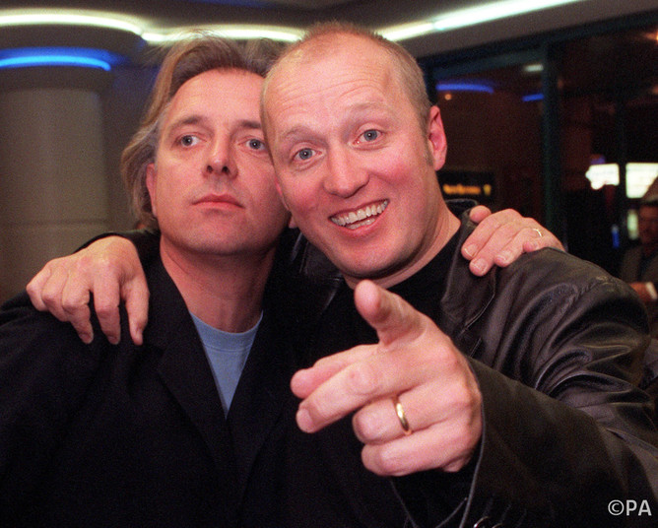Bosom pals: with Adrian Edmondson. Justin Williams/PA Archive
Anarchic parties, unwashed dishes and Ade’s motorcycle being driven up staircases all figured in the lives of the residents of The Cottage and formed the basis of future stage and television storylines. As Mike Redfern said, “it really was living in filth, living in squalor, living a party life and fitting studying around it”. This was principally due to the fact that it was our first time away from home and we didn’t know how to look after ourselves. The relationships and comedy business we established were akin to a continual long-form improvisation – highly amusing to those involved, quite tiresome to those who were not (including our lecturers). But spontaneous, intuitive improvisation takes a lot of rehearsal.

Fete worse than death
The respected, if slightly dilapidated, jazz venue Band on the Wall in Swan Street was home to 20th Century Coyote’s improvised, fractured farces with titles such as Dead Funny, The Tpying Error, Where is Dick Treacle? and The Church Bizzarre – a Fete worse than Death.
It should be noted that the idea of visiting a pub or club to watch theatre, not to mention comedy, was a rare and imaginative alternative-use concept in the mid-seventies. The marketing of comedy as the “new rock and roll” was an unthinkably distant notion. But at the time this was less about establishing a radical counter-culture – more of a fruitless attempt to gain our equity union cards through the less stringent variety route.
The “alternative comedy” boom has been well documented in TV specials, books and articles, if not always accurately. But not so well known were the anarchic film collaborations: for example, a non-naturalistic adaptation of The Velvet Underground’s off-beat verse song The Gift in 1980 that I directed featured Ade as shmuck Waldo and Rik as groping boyfriend Bill. It was scheduled to be screened on BBC2 in the 1980s but was pulled due to being considered too “punk” by the producer. Rik also appeared in a film entitled Le Chat in the Loo in 1980, a parody I adapted from Bunuel/Dali’s surreal masterpiece Un Chien Andalou (1929).
Rik and I last worked together for the recording of my Radio 4 play: A Higher Education. He appeared as the corrupt professor Don Crookfield, at a failing drama department. This off-beat satire, that also features Helen Lederer and Philip Glenister, owes much to those Coyote days combining heightened character types with a farcical, pantomimic performance style. Also like Coyote shows of the past, and unusually for radio drama, some scenes were improvised “live” when recorded. We were never sure what version of the words Rik was going to deliver – even when he was supposed to be reading from a script.
It goes without saying that Rik dominates every scene with energy and inspired timing. The play was nominated for an award and has been repeated many times most recently on Radio 4 Extra in May 2014. I talked to Rik about adapting the scenario and characters for screen and stage only last month. It hardly needs emphasising, if proof were needed, of the longevity of Coyote – but especially the Rik Mayall legacy.
All sympathies go to Rik’s wife Barbara, his children and family.

